Envisioning Statesboro's Future
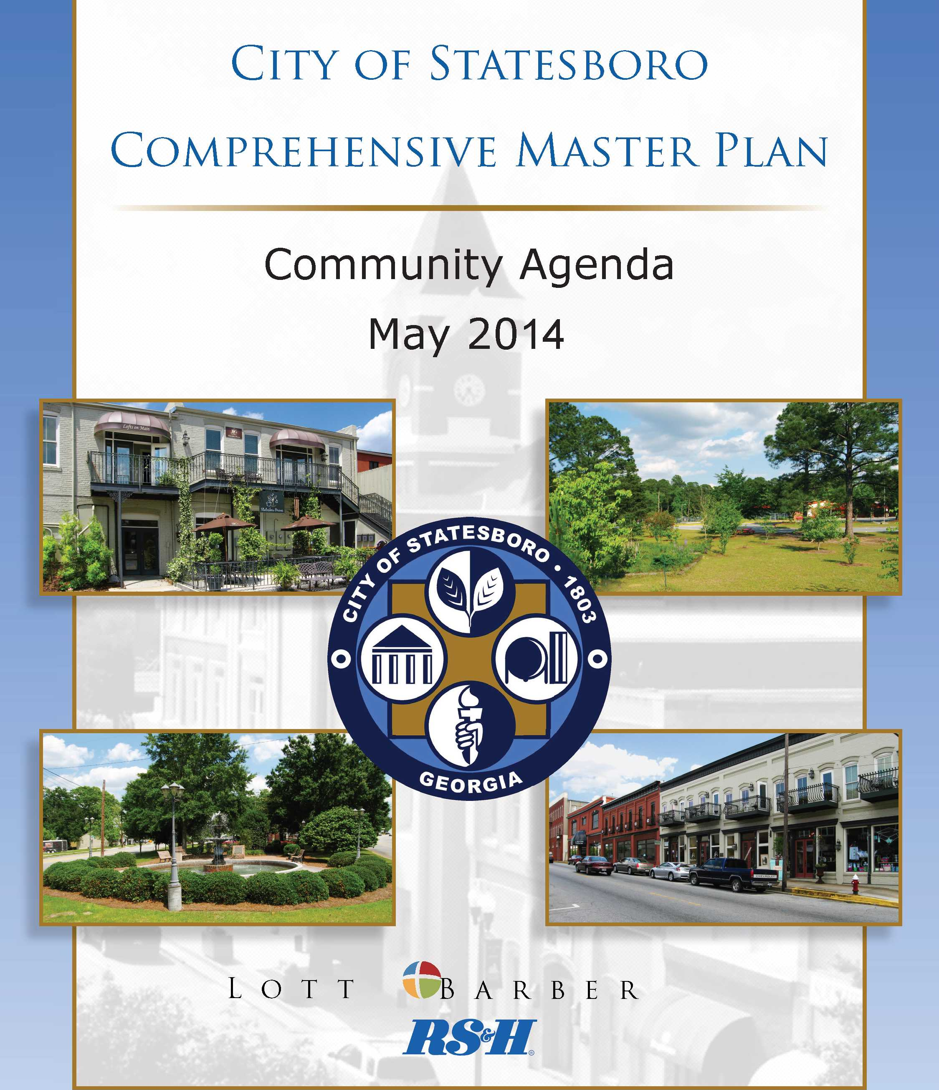
2009 Plan
Community Agenda
June 2014

CITY OF STATESBORO
Comprehensive Updated Master Plan

Community Agenda
June 2009
Community Agenda Update
City of Statesboro Staff & Governing Body
June 2014

CITY COUNCIL PLANNING COMMISSION
Jan J. Moore, Mayor Nick Propps, Chair
Will Britt, Mayor Pro Tem Holmes Ramsey
Phil Boyum R. Jeremy Ragan
John Riggs Jim Benton
Travis Chance April R. Stafford
Gary Lewis Rick Barr
Rev. E. Charles Lee

City Manager
Frank C. Parker, III

Table of Contents
introduction 3
Purpose 3
VISION STATEMENT 4
City of Statesboro Vision Statement 4
FUTURE DEVELOPMENT MAP & DEFINING NARRATIVE 6
Introduction 6
Future Development Map Narrative 6
Future Development Map 9
Character Areas 11
Character Area Overlays 22
Connectivity Map 28
Quality Community Objectives 29
ISSUES & OPPORTUNITIES 33
Population 34
Economic Development 34
Natural and Cultural Resources 36
Community Facilities and Services 38
Housing 39
Land Use 41
Transportation 43
Intergovernmental Cooperation 44
Quality of Life 46
IMPLEMENTATION PROGRAM 47
Introduction 47
Community Goals 48
Short Term Work Program 55
Policies 69
Conclusion 75
Our product is the quality of Life for our citizens – The City of Statesboro
Our Product is the Quality of Life for Our Citizens –

The City of Statesboro
INTRODUCTION TO 2014
Comprehensive plan update
This document reflects the 2014 update to the City of Statesboro Comprehensive Master Plan adopted by the City of Statesboro in 2009. 2014 is an important update time for a number of significant reasons. In addition to the update at this time mandated by the rules and regulations of the Georgia Department of Community Affairs there are also newly adopted planning requirements imposed on Georgia cities effective January 1, 2014. However, there is also wisdom in this review. Since the plan was last adopted, significant changes in both the local administration and the national, state, and local economic climates give reason to reexamine the vision of the City of Statesboro; to question whether this vision is indeed the right path for our community; and to examine whether we are actively taking the necessary and proper steps to achieve this vision.

The taxpayers of the City of Statesboro paid approximately $170,000.00 for the 2009 plan that serves as the foundation of this update. The Community Assessment portion of the original plan has been retained and the 2009 Community Agenda is reflected in this update in black ink. This update, however, was drafted with the local knowledge and care that only a local governing body and staff can bring to its community and is reflected in red ink. This 2014 update addresses Needs & Opportunities; Community Goals; Governing Policies; and an Implementation Program in critical areas such as Population Growth, Economic Development, Community Work Program, Community Facilities, Natural Resources, Land Use, Quality of Life, and Financial Stewardship and Administration.

We believe that the combination of the 2009 consultant's professional expertise and the knowledge and love of community brought in this 2014 update will result in a document that can truly serve as a guiding bedrock for the growth and development of the City of Statesboro for the years to come. I want to personally thank all of those that contributed to this update.

Sincerely,

Frank Parker
City Manager
June 30, 2014

INTRODUCTION TO 2009 PLAN

Purpose
The 1989 Georgia Planning Act requires that each community and county in Georgia prepare and
adopt a local Comprehensive Plan. The requirements for a Comprehensive Plan are established
by the Georgia Department of Community Affairs (DCA), effective May 1, 2005. The Plan is
comprised of three main components: the Community Assessment, Community Participation
Plan, and Community Agenda. This document is the Community Agenda portion of the City of
Statesboro Comprehensive Plan.
The purpose of the Community Agenda is to lay out a road map for the community's future,
developed through a public process of involving community leaders, stakeholders and the public.
The Community Agenda is the most important part of the plan, as it includes the community's
vision for the future, key issues and opportunities it chooses to address during the planning
period, and its implementation program for achieving this vision and addressing the identified
issues and opportunities. The Community Agenda is intended to generate local pride and
enthusiasm about the future of the community, thereby ensuring that citizens are involved with
the implementation of the plan.
The Community Agenda is comprised of the following components:
- Community Vision, which includes the:
o Vision Statement
o Future Development Map
o Defining Narrative
- Community Issues & Opportunities
- Implementation Program, which includes the:
o Short Term Work Program
o Policies
o Long-range or Ongoing Activities
The Community Agenda was prepared with public and stakeholder involvement as specified in
the Community Participation Program. The result is a concise, user-friendly document for
decision-making by community leaders as they work toward achieving the desired future goals
of the community.
VISION STATEMENT

City of Statesboro Vision Statement
Our community's neighborhood-oriented atmosphere will continue to evolve into an increasingly
attractive destination for new residents, businesses, and commerce. Our community will
preserve its history and environment, and will become a regional leader in quality growth and
development.
To achieve this, our community will:
- Be the hub of economic development for the region, and will proactively and strategically
initiate business attraction, retention and expansion activities designed to strengthen and
diversify our economy while advancing the quality of life for all. We will work together
to market the community to appropriate industries and small businesses, appropriate
service sector employers, and a mix of grocers, restaurants, and other entertainment
establishments. Our educated workforce will attract clean industries and quality jobs, and
our home grown businesses and entrepreneurs will continue to flourish.
- Embrace collaboration to promote sustainable, quality growth and stewardship, including
wise management of our infrastructure, natural resources, education, recreation, and
economic development.
- Promote the idea that all residents have a right to quality housing regardless of socio-
economic standing. We will monitor housing needs, and will continue to emphasize
walkability and interconnectedness in our neighborhoods. Our community will value the
integrity of our historic neighborhoods and embrace innovation in providing diverse
housing options to meet the needs of the community.
- Lead collaborative efforts with the county, universities, and other entities and agencies to
present a unified front in the face of economic and resource protection challenges. Our
city and countywide agencies will work closely together and with other stakeholders,
forming a seamless approach to local government management.
- Develop and implement a balanced and forward thinking land use policy that provides for
a sustainable community of thriving neighborhoods, business areas, and civic places that
comprise an outstanding quality of life and physical environment. The City will expand
in a manner which conserves the natural land resources and integrates new development
in ways which minimize negative impacts and provides for a healthy ecosystem. Walkable, neighborhood commercial areas will be supported; pedestrian and bike
connections will be emphasized; office and business development will be a priority.
Citizen participation and informed decision-making will be a hallmark of our
community's land use planning.
- Value preservation of natural habitat and historical features, and will carefully evaluate
land use decisions and plan the transportation network with regard to natural, cultural and
historic preservation. New or infill development will be designed to have minimal
impact on natural, cultural and historic resources. Our community will provide diverse
open space and park amenities to protect our natural resources and provide human access
to nature. Trees and landscaping will soften urban development, providing shade,
comfort, health benefits, and beauty.
- Have a comprehensive transportation network which places equal importance on all
modes of transportation. The interconnected transportation network will serve to
minimize traffic congestion and provide safe, well-maintained facilities for bikes and
pedestrians. Public transportation will be integrated and provided for all users.
- Be a regional education center, from PreK-12 through university. Our excellent educational
system will attract newcomers who seek opportunities to engage with the community,
thus perpetuating the high quality of life in Statesboro.
- Value and promote our thriving downtown as the cultural, business, and lifestyle leader
in the region. A variety of retail, dining, and entertainment venues will enhance an active
daytime office and business community, providing a day and evening destination, with
activities for young adults, retirees, families, residents, and visitors.
The City of Statesboro will continue to maintain a strong voice as the area's education, business,
healthcare, and economic leader and promote a spirit of cooperation, collaboration, and unity.

CITY OF STATESBORO 2014 VISION STATEMENT
The City of Statesboro readopts its 2009 vision and adds the following to it:
- Serve as a leader and model of effective, efficient local government service delivery; an example of responsible stewardship in fiscal policies; and an innovator in implementing enterprise based revenue streams that serve the public and relieve the tax burden on the local property owner.
- Demonstrate respect for and adherence to the Constitution of the United States of America and the State of Georgia, particularly in respecting the proper role of government and the rights of the citizens. Governments often abuse their power. However, Statesboro is committed to respecting the right of all citizens.
- We will govern diligently and well informed. We will acknowledge the difficulty in achieving the delicate balances needed in preservation of natural resources and economic growth; and in providing quality of life amenities without over burdening the tax payer.
- To become the best City in the best State in the Nation to locate and conduct business.
- We will provide quality and professional customer centric operations and service delivery.

FUTURE DEVELOPMENT MAP & DEFINING NARRATIVE
Introduction
The Future Development Map represents the boundaries of character areas and corridors
throughout the community. The basis of these areas is the Recommended Character Areas found
in the Community Assessment. The city originally identified unique areas within their
community as well as those areas which contain, or are likely to undergo, certain kinds of
development. The character areas found in the Community Agenda have been updated based on
public review and comments from the steering committees, which now form the basis of the
Future Development Map.
The Defining Narrative includes a specific vision and description for each character area, as well
as recommended implementation measures to achieve the vision for each area. The written
descriptions for each character area, along with accompanying images, make it clear what types,
forms, styles, and patterns of development are to be encouraged within the area.
This information, along with the accompanying character area descriptions and vision
statements, is meant to help guide development policies as they relate to natural and cultural
resources, land use, transportation, housing, and facilities and services. The final section of the
Community Agenda - the Implementation Program - contains specific policy suggestions that
build on this and other portions of the Comprehensive Plan.
Future Development Map Narrative
The following narrative accompanies the Future Development Map for the City of Statesboro
and provides guidance for the preferred development patterns within each area. Boundaries of
the character areas are intended to be general in nature, not parcel-specific. Interpretation of the
boundaries will depend on closer analysis of existing conditions in the immediate area and the
proposed development. Major changes in the location of character area boundaries should be
accompanied by an amendment to the future development map.
In addition to these descriptions for each area, strong public support has been demonstrated for
certain characteristics throughout the city, regardless of location. The following are general
strategies which should be considered throughout the city, regardless of character area.
• Transportation Alternatives
Throughout this process, the Statesboro community has expressed very strong support for
pedestrian and bicycle facilities. Mobility for pedestrians and cyclists should be given
equal consideration as automobiles in both long-range planning and site design of new
developments. Pedestrian facilities may include sidewalks, trails, mixed-use paths, or
any combination. Bicycle facilities may include shared roadways, wide shoulders, on-
street bike lanes, multi-purpose paths, or any combination. Bike racks should also be
considered as part of this infrastructure network. As the community grows, education
programs for bike and pedestrian safety may need to be considered.
In addition to bike and pedestrian facilities, the community has also expressed support for
transit. In the near future, both students and residents would like to see the Georgia
Southern transit system provide more support to students off-campus, providing service
to activity centers, such as downtown and Statesboro Mall. In addition to university-
based service, many residents also support the establishment of a city transit system as
well to provide service to the community as a whole.
• Protection of Existing Neighborhoods
As a university town, Statesboro struggles with the
impact of students living in historically owner-
occupied, single-family neighborhoods. The
community strongly supports the preservation of these
neighborhoods through code enforcement,
maintenance of properties, controlling parking and
other steps to minimize the impact of rental properties
and overcrowding. This issue will be discussed in
more detail in the Implementation Program, but
preservation of existing single-family residential neighborhoods should remain a high priority.
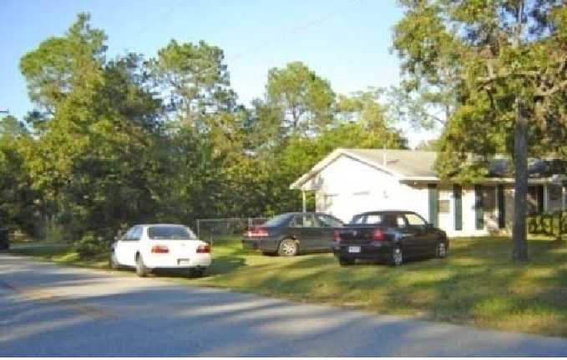
Parking issues are one of the concerns
commonly associated with students living in
traditionally single-family neighborhoods.
Commercial encroachment into residential neighborhoods seems to be less of a current
concern, but as Statesboro continues to grow, the potential for this conflict increases.
Commercial, retail, and office uses can co-exist compatibly in residential areas if the
design of the establishment is properly considered. The conversion of former homes to
professional offices along Zettrower provides a model for how to accommodate non-
residential uses as streets begin to carry more traffic and residential uses become less
desirable. Whenever possible, existing structures should be preserved and/or renovated
to accommodate changing land uses in order to protect both the neighborhood and overall
community character. Any new structures should be located on the lot with similar
setbacks as surrounding development and designed in a way which complements the
existing immediate area.
- Tree protection
In a variety of settings, images with abundant trees consistently ranked higher than those
without. Overwhelming support has been expressed throughout the process for the
protection of existing trees as well as the establishment of new trees.
- Mixed use
Throughout this document, mixed use is listed as a
preferred development strategy. True mixed use
developments place a high priority on scale and design to
create places which encourage pedestrian activity through
relationships between buildings, interesting streetscapes,
and appropriate treatment of parking. Simply placing one
use next to another does not constitute mixed use. The
components must be evaluated in context with their surroundings for mixed use to be successful.

- Annexations
The future annexation area illustrated on the map located southeast of the city is currently
a "Capital Cost Recovery Area." This allows the City to provide water and sewer
infrastructure and indicates that the County will support future annexation in this area
subject to the adopted intergovernmental agreement. It is anticipated that additional annexations
within this area will occur in the coming years. The City and County should continue to
review and amend their intergovernmental agreements to include clear direction of the
type of development intended, identification of major thoroughfares, and adoption of
policies and/or ordinance amendments needed to address design features, especially as
related to facilities such as the S & S Greenway.
It is anticipated that the City of Statesboro will annex additional properties (yet to be
determined) within the timeframe addressed by this plan. This plan recommends the
establishment of an annexation policy which would guide these decisions based upon pre-
determined criteria and requirements. A component of the annexation policy should be to
identify the appropriate character area for the newly annexed property. Generally, the
proposed character area should be consistent with the character area of adjacent
properties. However, this should be determined on an individual basis per annexation
and viewed in light of how the annexation will impact the character of the City as a
whole.
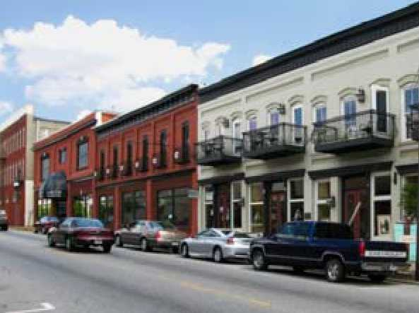
Downtown Statesboro provides a great
example of successful mixed use and the
importance of scale and design.

• Visual Clutter
Statesboro residents have expressed dissatisfaction with a variety of features in the community which clutter streetscapes and obstruct natural landscape features -particularly on major corridors entering and exiting the community. While City leadership has acknowledged the need to comprehensively update land development regulations to holistically address aesthetic concerns, there exist a number of individual topics which can be addressed by ordinance amendments in the short-term.
Signs (attached and detached) should be managed by incorporating uniform design features, and by restricting billboards and other off-premise signage which distract from traffic control signage and compete with local and other on-site businesses. Lighting should be managed to reduce glare onto the roadway and neighboring properties. Reduction of pavement surfaces and increases in pervious areas can also reduce glare - particularly in severe weather. In reducing visual clutter, the City should also partner with utility companies to gradually relocate utilities underground. These and other topic- specific adjustments can gradually improve corridor safety and result in a more attractive and inviting community.
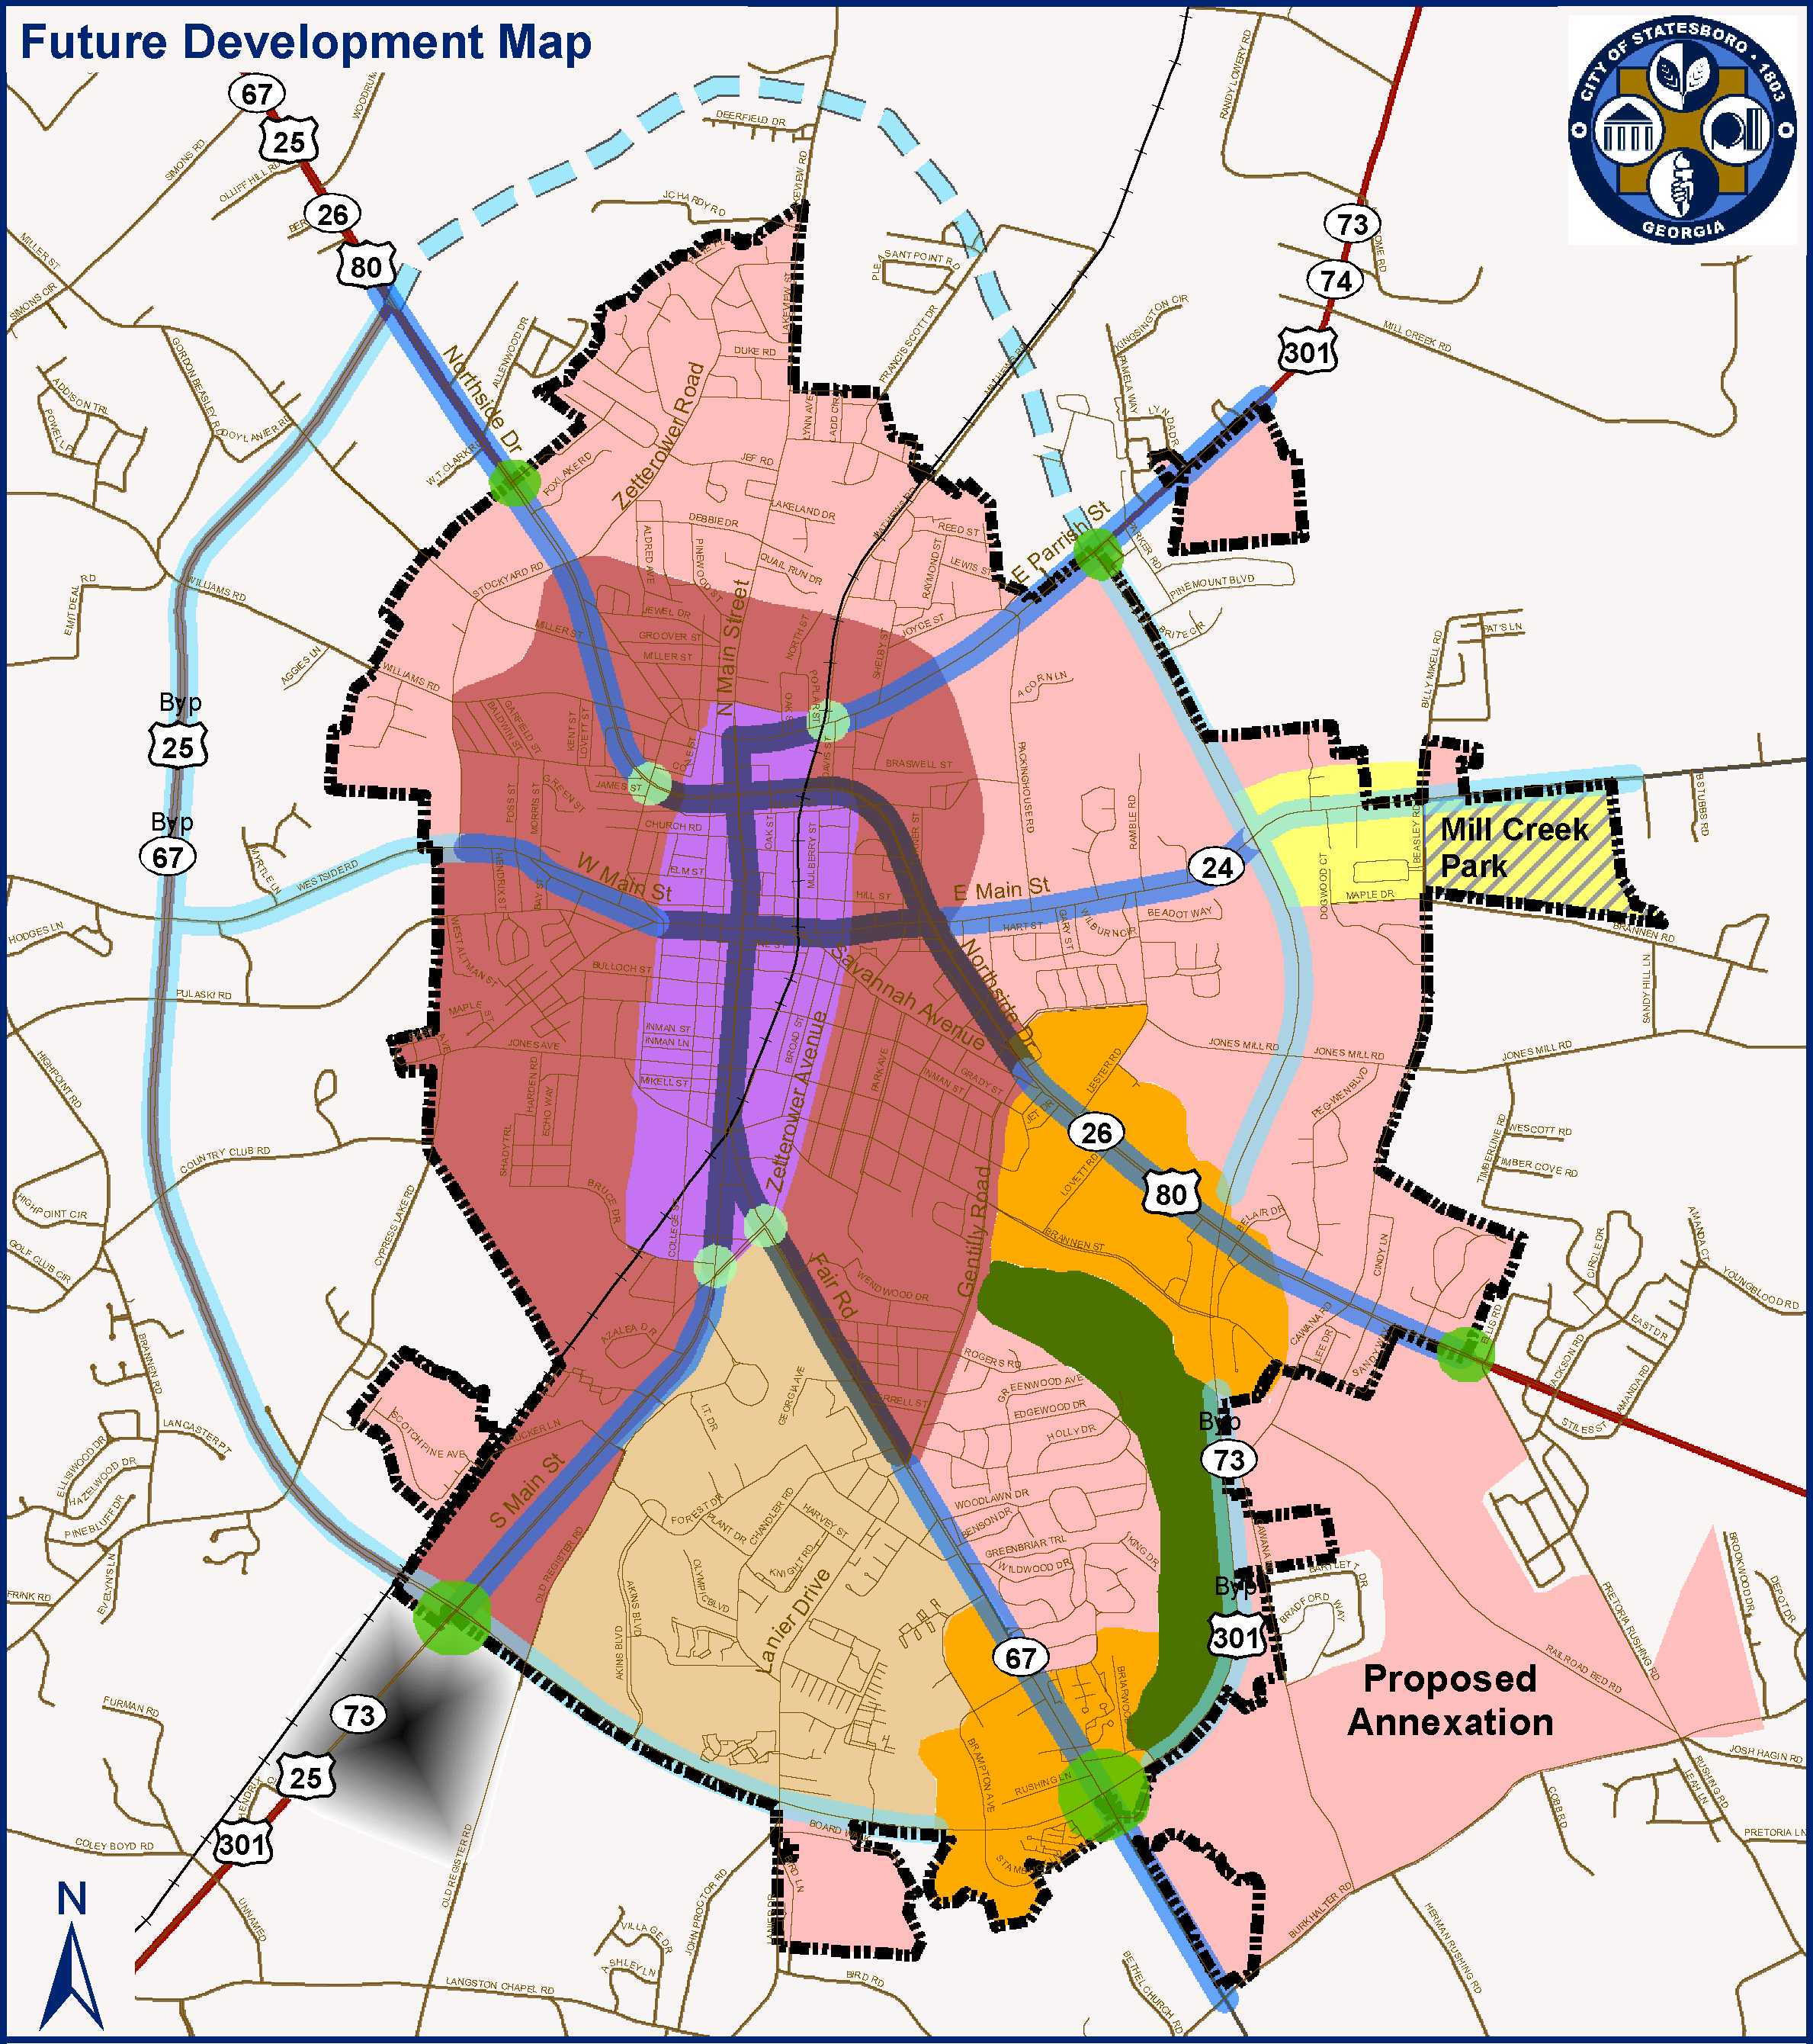
Miles
0
2
Activity Centers
Emerging Activity Ctr
Green Space
Emerging Business
0.5
1
1.5
Source: Bulloch County, City of Statesboro, Lott + Barber, RS&H
Character Area Overlays Character Areas
Urban Core Gateway Urban Core
City Limit Gateway Established
Major Corridor Overlays Developing
Urban Corridor University District
Transitional Corridor
Access Corridor
CITY OF STATESBORO
2009 Comprehensive Plan

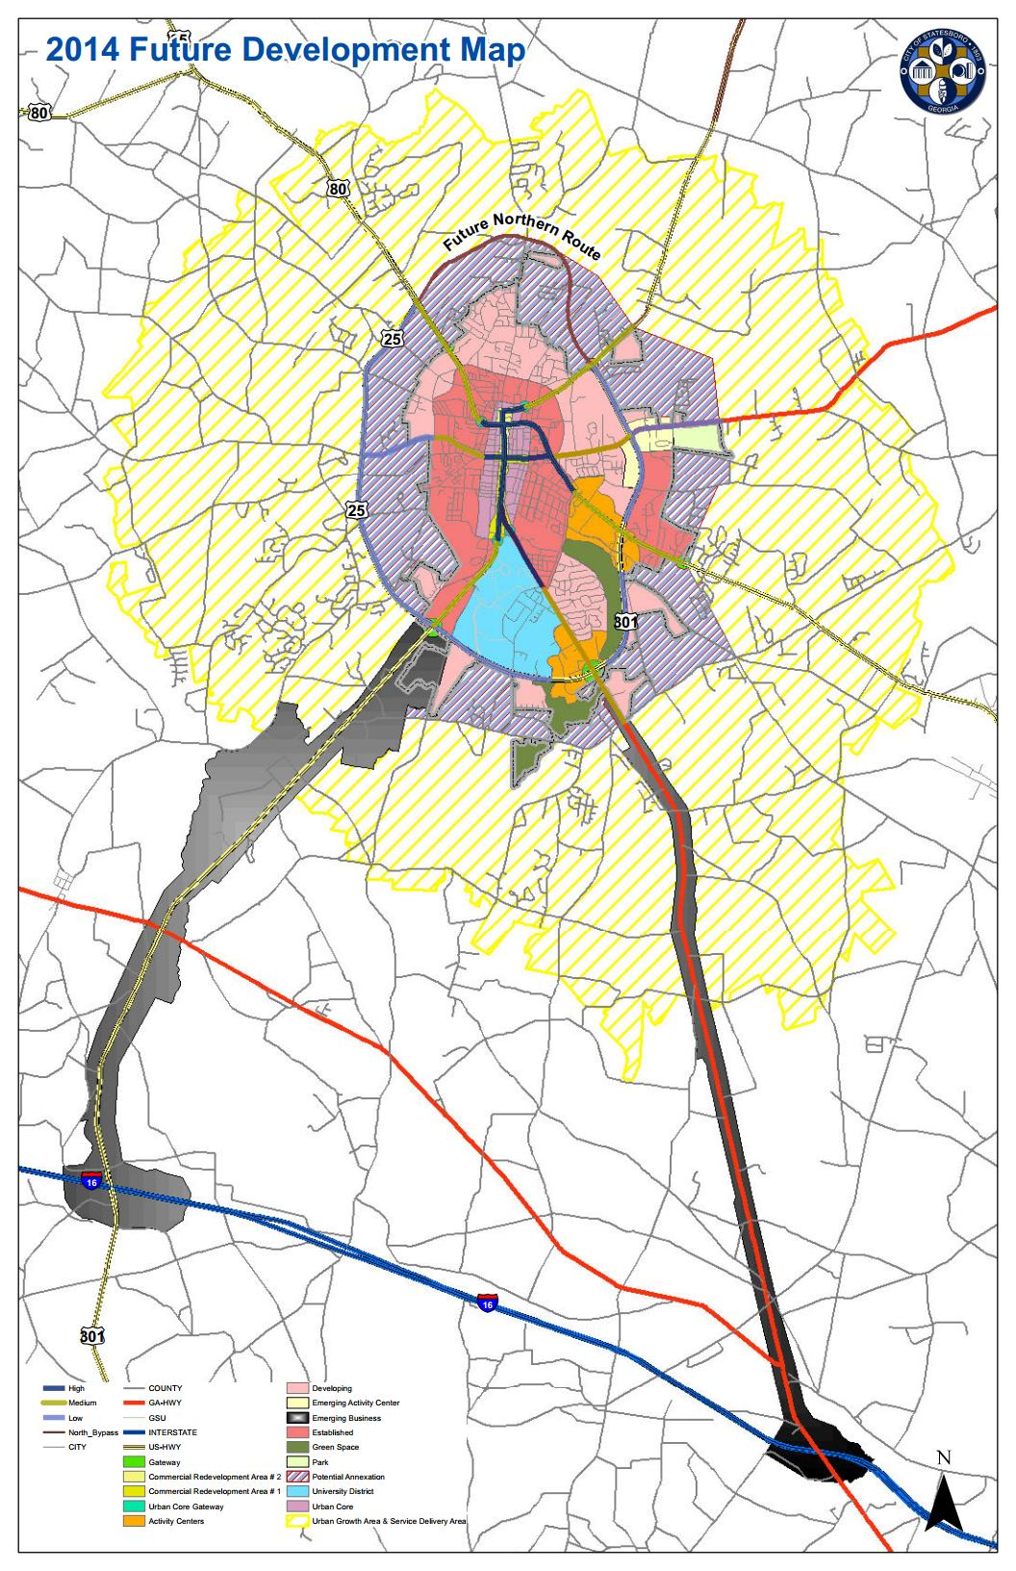

Character Areas
The following section provides specific information regarding the vision and preferred
development strategies for each character area on the future development map, including
appropriate land uses and implementation measures to achieve the desired vision. Each character
area also identifies the Quality Community Objectives to be pursued in that area. More detailed
information about these objectives is found at the end of this section. The highlighted color of
each character area corresponds to the color indicated on the future development map. The character area names printed in red reflect the newly effective suggested character areas from the Department of Community Affairs, January 1, 2014.
Urban Core/Downtown____________________________________________________________

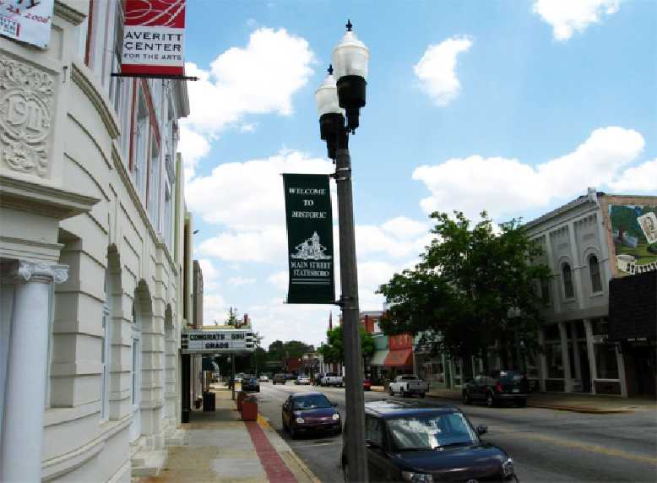
Vision:
Downtown is the historic core of the city and should remain the activity and cultural hub of the region. In the Urban Core, Traditional development patterns of
buildings along the sidewalk and a lively streetscape should be respected and promoted. Historic buildings should be protected from demolition or inappropriate restoration which can degrade the architectural details of the structures. Additional residential opportunities, especially in the form of lofts or other residential over retail, should be promoted. Street-level uses should be reserved for retail, entertainment, or similar high-activity uses.

It is envisioned that the existing central business district may extend beyond its current
boundaries to accommodate more commercial and high density residential development.
Promoting walkability and vibrant street life should be a high priority in downtown and can be
enhanced through continuing the existing interconnected street grid with small blocks, providing
wide, well-maintained sidewalks, encouraging retail uses with large store front windows at the street level, and appropriate building design, scale, and placement.
There are numerous infill and redevelopment opportunities within the urban core. As a major
gateway into downtown, one of the highest priority areas for redevelopment should be the South
Main corridor, between Georgia Southern University and Grady Street. Streetscape
improvements should include moving the sidewalks back from the main travel lanes and
providing a buffer from traffic, through vegetation and/or on-street parking. Trees, benches,
lighting, and similar improvements would also greatly improve this corridor. As redevelopment
occurs, buildings should be brought closer to the sidewalks, in keeping with downtown
development patterns. Parking should generally be placed to the rear or sides of buildings. This
corridor has already lost many historic structures; care should be taken to avoid the loss of
others. Housing should be strongly encouraged and supported in the Downtown area to increase downtown destination points and night time population.
The intersection of Highway 80 (Northside Drive West) and
Highway 301 North (North Main Street) is another significant
gateway into downtown, but is currently underdeveloped and
poorly maintained. Infill development should be targeted at
corner properties and then to adjacent parcels. Streetscaping enhancement and proper signage/way finding should accompany redevelopment efforts as the intersection transitions into a more attractive downtown gateway.
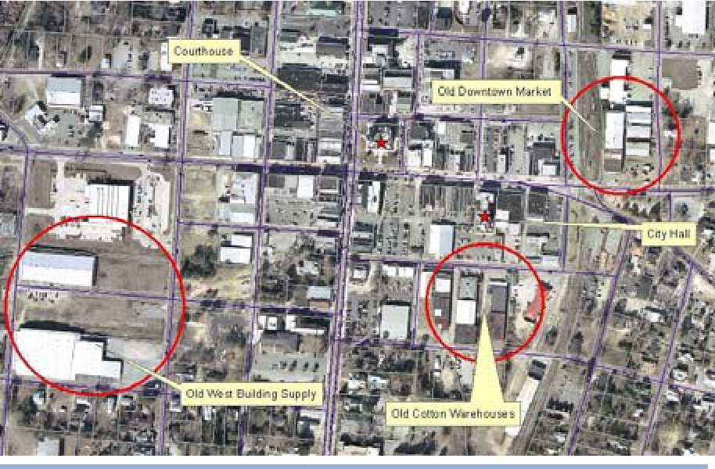
Infill development opportunities: Warehouse districts
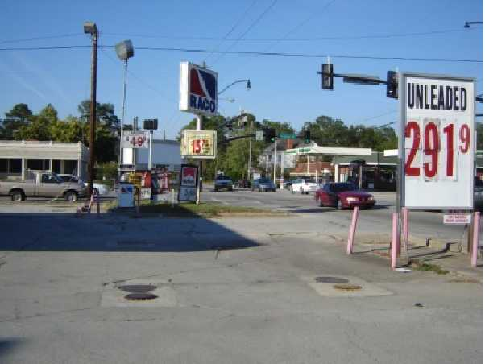
This gateway is visually cluttered and
does not provide a welcoming sense.
There are also three former warehouse areas
within downtown which offer great opportunity
for redevelopment and adaptive reuse. These
warehouses could provide the ideal site for
locating major employers in the downtown area
and for introducing more live/work units or loft-
style residential units. Specific visions and redevelopment strategies could be identified
through the creation of a downtown master plan.
Maintaining a diverse balance of office, commercial, and residential development is a key factor for the continued success of downtown. The city will need to continue to encourage more development in the downtown core as the region continues to grow.

Appropriate Land Uses
- Neighborhood-scale retail and
commercial, especially niche market
stores which serve as a destination
- Arts and entertainment venues
- Civic uses
- Office
- Neighborhood services
- Range of housing styles & price points
- Multifamily Residential
- Loft, mixed use, and urban
residential, including small lot
single-family residential along
secondary streets
- Multi-story buildings with retail on the street and office/residential above
- Government offices & services
Suggested Development & Implementation Strategies
- Maintain/enhance integrity of interconnected grid and pedestrian circulation interconnectivity.
- New development should respect historic context of building mass, height and setbacks.
- New developments that contain a mix of residential, commercial and/or community facilities at small enough scale and proximity to encourage walking between destinations should be encouraged.
- Historic structures should be preserved or adaptively reused wherever possible.
- Encourage mixed-use infill and redevelopment. Uses should typically transition across
the rear of properties instead of across the street to soften the transition and maintain
appropriate streetscapes.
- Create local historic districts.
- Economic development strategies should continue to nurture thriving commercial
activity.
- Enhance tree planting to include more shade trees and ornamental streetscape plantings.
- Ensure that future phases of streetscape enhancements are developed in harmony with
previous efforts as well as economic development goals of the City and the Downtown
Statesboro Development Authority (DSDA) / Main Street program.
- Develop architectural guidelines to guide new development and renovations of historic
buildings.
- As downtown continues to grow, consider the construction of parking garages with retail
uses on the street level. Sites for parking garages should be considered as early as
possible, due to the importance of a central location and the large building footprint of
such structures. Shared parking and rear of building parking should be encouraged.
- Encourage downtown merchants/DSDA to work together in marketing downtown.
- Redevelop warehouses for major employer/tenant to build critical mass downtown.
- Create a downtown master plan to identify infill/redevelopment opportunities, enhance
public/private partnerships, and develop a detailed strategy for a sustainable downtown.
- Update sign ordinance to be consistent with downtown architecture and pedestrian scale.
- Utilize unifying hardscape elements which identify the downtown area.
- Continue to locate government agencies, such as city and county offices, in downtown to
maintain its viability.
- Construct/convert major thoroughfares in a manner that promotes dense, urban and
pedestrian-friendly development patterns. Adopt Context Sensitive Solutions (CSS) that
reduce vehicle speeds, facilitate the use of a variety of transportation options, and
enhance the aesthetics of the character area.
- Develop sites within the southern portions of the character area (especially along South
Main, generally from Grady Street to Fair Road) in a manner that promotes the functional
and aesthetic objectives of the character area while providing a greater physical linkage
between Georgia Southern University and downtown.
- Seek Greyfield redevelopment that converts vacant or under-utilized commercial strips to mix use assets.
- Revitalization of existing neighborhood commercial centers to capture more market activity and serve as community focal points.

Established/Existing Traditional Neighborhood__________________________________
Vision:
The traditional residential neighborhoods in the Established area were developed from the late 19th to
mid 20th century, and feature connected street grids linked with downtown. Sidewalks should be located on both sides of major streets; lesser streets may have limited facilities. Major corridors in this area may support a mix of residential and commercial uses. As corridors transition from residential to commercial, the original structures should be maintained and renovated whenever possible. Any new structures should respect the existing fabric of the neighborhood, through similar front, side, and rear setbacks.
Some neighborhoods within this area are facing decline issues with blight. These neighborhoods may require extra attention to return them to viable neighborhoods. Strengthening the urban core thorough additional commercial, retail, and office development can benefit the neighborhoods surrounding the urban core by providing residential opportunities within walking or cycling distance to downtown.
Appropriate Land Uses
- Neighborhood-scale retail and • Neighborhood services
commercial • Small-lot single family residential
- Small-scale office • Garage apartments
Suggested Development & Implementation Strategies
- Ensure that new development and land uses do not encroach upon or detract from the
character of the recognized National Historic Districts within this area.
- Consider creating local historic districts to protect Savannah Avenue and other historic
residential areas from inappropriate development and to restrict the demolition or
substantial alteration of recognized historic structures.
- Enhance existing pedestrian connectivity by repairing/replacing sidewalks and adding
new ones, where necessary.
- Plant shade trees along streets and sidewalks.
- Develop architectural guidelines to guide new development and renovations of historic
buildings within historic districts.
- Residential developments that incorporate “corner commercial” sites such as dry cleaning or convenience grocery or similar retail services.
- Enlisting significant site features (view corridors, water features, farm land, wetlands, parks, traits, etc.) as amenity that shapes identity and character of development.
- Retrofitting existing residential communities to improve pedestrian and bicycle access and connectivity with nearby commercial areas.
- Revitalization of existing neighborhood commercial centers to capture more market activity and serve as community focal points.
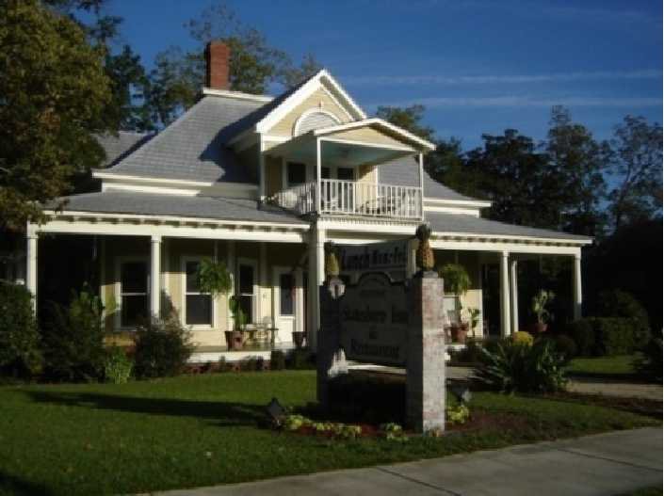
- Infill, redevelopment, and new development should promote lot sizes and setbacks appropriate for each neighborhood. Neighborhood redevelopment should promote a tight grid of small lot single family development which utilizes more efficient lot and block
layouts. New structures should respect the existing architectural fabric of the neighborhood.
- Foster the establishment of public/private partnerships to redevelop large tracts as appropriate for the character area.
- Promote an interconnected street grid through appropriate revisions to development regulations.
- Streets, especially thoroughfares, should incorporate Context Sensitive Solutions (CSS) to provide traffic calming and protect community character.
- In areas that are or were residential but may now be more appropriate for commercial uses, adaptive reuse of the residential structure should be encouraged to maintain the character of the area and to maintain appropriate scale. Excellent examples of adaptive reuse can be seen along Zetterower Avenue.
- Uses should typically transition across the rear of properties instead of across the street to soften the transition between uses and maintain appropriate streetscapes.
- Pocket parks* should be provided within walking distance of homes.
- Promote redevelopment of underutilized or vacated properties, such as the old hospital site and the old Darby Lumber site along Zetterower Avenue.
- Consider the inclusion of pocket parks as part of an overall redevelopment plan on appropriate sites.
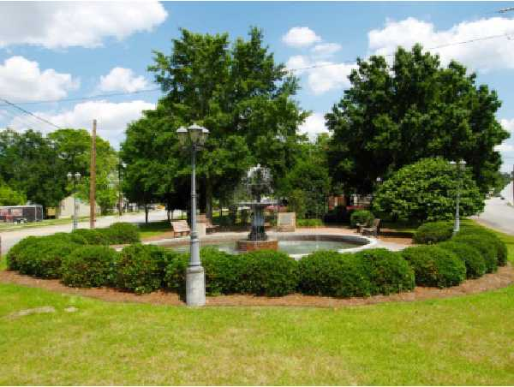
Pocket park in downtown
- Establish pocket parks on vacant lots and establish an Adopt-A-Park program. Add crosswalks and pedestrian signals along busy streets, including Savannah Avenue, Johnson Street.
- Evaluate the benefits and potential of urban redevelopment plan(s) for declining neighborhoods. Such plans can provide incentives and access to resources to revitalize these neighborhoods.
- Provide support for the creation of neighborhood associations and provide continued support for these organizations once established through the development of initiatives to address unique neighborhood issues/characteristics.
- Strengthen enforcement of code violations for private property, including property
maintenance, parking, and structural conditions with a determined focus on health and safety issues.
- Adopt Neighborhood Commercial Zoning district to encourage reuse and mix use where appropriate or where transitions in use are being experienced or expected.
Developing/Developing Traditional Neighborhoods______________________________________
Vision:
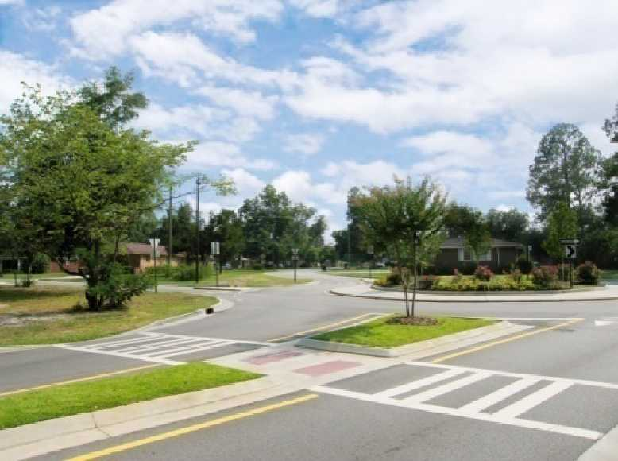
The Developing area is primarily residential
consisting largely of single-family homes, although
nodal commercial development should also be
included to serve the needs of residents. Although
the current street network has limited connectivity,
new development should strive to increase
connectivity within developments, to existing
streets, and to adjacent undeveloped properties. Sidewalk facilities should be located along major roadways and along neighborhood streets. Commercial development in this area may range from small-scale neighborhood stores to larger retailers. Regardless of the size, pedestrian access should remain a priority.

Some areas are currently undeveloped or minimally developed but are under pressure to grow in a suburban manner, which has conventionally featured separate land uses, primarily single-family residential uses, and strip mall development along outparcels. These developing areas can be found at the periphery of the city, adjacent to existing suburban development and highway corridors. Although this area will likely contain the largest lots of residential development within the city, interconnectivity and provisions for all forms of transportation should remain a priority. Development patterns should also be evaluated to maximize opportunities for appropriate blending of residential, office, and commercial development.

Appropriate Land Uses
- Small to mid-size retail and
commercial
- Office
- Services
- Single family residential
- Multi-family residential

- Some areas (such as redevelopment
of the old Packinghouse) may
support mixed use development
incorporating retail, office,
commercial, and residential

Suggested Development & Implementation Strategies
- Large new developments should be master-planned to include mixed-uses wherever
appropriate. These developments should blend residential uses with schools, parks, recreation, retail businesses, and services, linked together in a compact pattern that
encourages walking and minimizes the need for auto trips.
  - New developments that reflect traditional neighborhood design principles, such as smaller lots, orientation to street, mix of housing types, pedestrian access to neighborhood commercial center.
  - Residential development that offers a mix of housing types (single-family homes, town homes, live/work units, lofts, over the shop, and apartments), densities and prices in the same neighborhood.
  - Residential development with healthy mix of uses (offices, corner groceries, barber shops, drug stores) within easy walking distances of residences.
  - Addition of new uses to single use sites (restaurants and shopping added to office parks).
  - New development that contains a mix of residential, commercial uses and community facilities at small enough scale and proximity to encourage walking between destinations.
  - Residential development that incorporate “corner commercial” sites, such as dry cleaning or convenience grocery, or similar retail services.
  - Clustering development to preserve open space within site.
  - Enlisting significant site features (view corridors, water features, farm land, wetland, trails, parks, storm retention, etc.) as amenity that shapes identity and character of the development.
  - Site plans, building design and landscaping that are sensitive to natural features of the sites, including topography and views.
  - Using infrastructure availability and planning to steer development away from areas of natural, cultural, and environmentally sensitive resources.
  - Allow infill multi-family residences to increase neighborhood density and income diversity.
  - Promote mix of housing types, options, and styles to create character and neighborhood diversity.
- New developments should provide recreational facilities and open space to meet the
needs of their residents.
- Promote walking and bicycling as an alternative means of transportation through the
provision of safe, accessible and connected networks and bike storage facilities at
destinations.
- There should be strong connectivity and continuity between each subdivision.
- There should be good vehicular and pedestrian/bike connections to retail/commercial
services as well as internal street connectivity, connectivity to adjacent
properties/subdivisions, and multiple site access points.
- Wherever possible, connect to the existing and proposed network of bicycle paths and
multiuse trails (such as the McTell Trail and SS Geenway Trail).
- Promote street design that fosters traffic calming such as narrower residential streets, on-
street parking, and addition of bicycle and pedestrian facilities.
- Identify places of natural beauty and sensitive natural resources (such as wetlands) and
protect these areas from development.
- New development should be designed with respect to the existing landscape and strive to
minimize impacts to the mature tree canopy coverage. Land clearing activities should be
staged appropriately as part of the overall construction sequence and phased as needed.
- Create neighborhood focal points by locating schools, community centers or well-designed small scale commercial activity centers at suitable locations, within walking distance of residences. Especially areas of concentration for regionally marketed commercial and retail centers, office, and employment areas.
Activity Centers/Regional Centers_________________________________________

Vision:
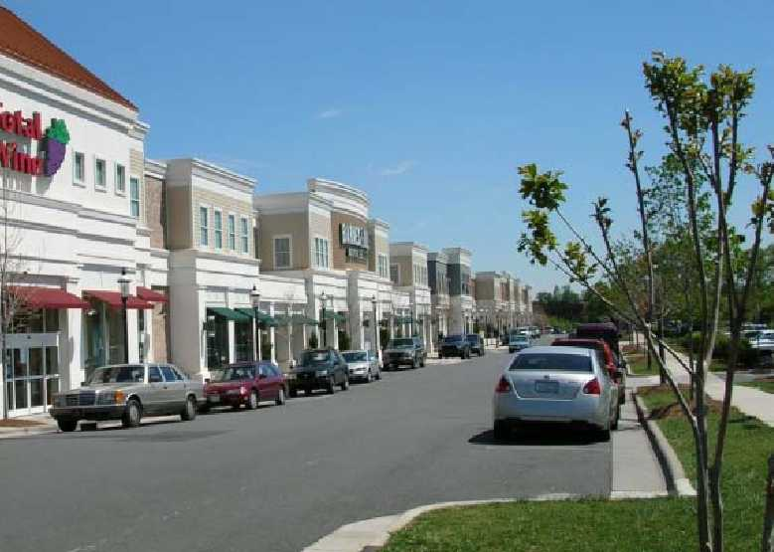
Currently dominated by auto-oriented design and large surface parking lots, the Activity Centers will evolve into pedestrian-oriented shopping, office, and entertainment places that may also accommodate high-density residential development. Where excess parking is located, infill development can break up large surface lots. Tree plantings and landscaping will be generous to soften the development intensity in these areas. Access to these activity centers will be easily achieved for pedestrians, cyclists, and drivers alike.

Appropriate Land Uses
- Small, mid-size, and regional retail and commercial, including big box stores.
- Redeveloped shopping center should be encouraged to include diverse uses and pedestrian-scaled elements.
- Diverse mix of higher density housing types, such as multi-family, town houses, apartments, lofts, and condos.
- Entertainment
- Services

- Employment Centers
- Office
- Medical
- Multi-Family

Suggested Development & Implementation Strategies
- Infill and redevelopment in these areas should occur according to a master plan that
allows for mixed uses, transportation choices and urban design that mitigates the
appearance of auto-dependence (such as screening parking lots or locating parking areas
primarily to the sides and rear of buildings).
- Encourage infill, new, and redevelopment to build close to the street.
- Future developments and highway improvements within these areas should include
pedestrian and bicycle access to surrounding neighborhoods.
- Connect these areas with existing and proposed networks of bicycle paths, sidewalks and
multiuse trails (such as the McTell Trail, the Julius Abraham Trail, and the S&S Greenway Trail).
- Require shade trees to be planted in parking lots and along highway corridors.
- Evaluate parking ordinances for appropriate standards, including maximum standards and shared parking provisions.
- Focus on redevelopment in areas of disinvestment (such as those that have become or are
in danger of becoming greyfields). Development strategy should encourage uses and
activities that are suitable for the immediately-surrounding character areas.
- Incorporate inter-parcel connectivity, especially along major thoroughfares.
- Include community gathering places, such as squares, plazas, etc. into commercial and
mixed use developments.
- New residential development that reflects traditional neighborhood design principles, such as smaller lots, orientation to street, mix of housing types, pedestrian access to neighborhood commercial centers.
- New developments that contain a mix of residential, commercial uses and community facilities at small enough scale and proximity to encourage walking between destinations.
- Use infrastructure availability to steer development away from areas of natural, cultural, and environmentally sensitive resources.

Commercial Redevelopment Area___________________________________________

Vision:
The Commercial Redevelopment areas are currently in decline with vacant or underutilized properties. These areas are characterized by a high degree of access by vehicular traffic; onsite parking; and a low degree of open space. It is the desire of the community to identify and target these areas for redevelopment and investment, thus returning these areas to their intended state of a thriving commercial and/or mixed use district.

Appropriate Land Uses:
- Medium/High density residential
- Single-Family residential along arterials
- Major employers
- Commercial, including big box

Suggested Redevelopment and Implementation Strategies:
- Retrofit buildings to be more aesthetically appealing, and therefore, more makeable to perspective tenants.
- Building new commercial structures at the street front, taking up a portion of the oversized parking lot and creating a shopping “square” around a smaller internal parking lot.
- Upgrading the appearance of existing older commercial buildings with façade improvements, new architectural elements, or awnings.
- Reconfigure the parking lot and circulation routes for automobiles.
- Provide pedestrian and bicycling amenities including walkways, benches, lighting, and bike racks.
- Adding landscaping and other appearance enhancements, trees and landscaping in parking lots to provide shade and help reduce storm water runoff.
- Building in centers architecturally integrated with the site and one another, and developed at a scale sufficient in size, bulk, and height to provide image identification for the center and the surrounding community.
- Location of higher density housing near commercial centers or along arterial roads, and single family detached housing elsewhere in the neighborhood.
- Accommodation of big box retail in a way that complements surrounding uses, such as breaking up the façade to look like a collection of smaller uses.
- Improvement of sidewalk and street appearance and amenities of commercial centers.
- Redevelopment of older commercial centers in lieu of new construction further down the corridor.
- New development matching the typical densities of the older center of community.
- Infill development on vacant sites closer in to the center of community. These sites, with existing infrastructure in place, are used for new development, matching character of surrounding neighborhood in lieu of more development on greenfield sites.
- Street layouts that match those in older parts of the community and connect to the existing street network at many points.
- Clustering high density development at nodes along major corridors, separated by areas of open space or attractive residential development.
- Driveway consolidation and inter-parcel connections between parking lots.
- Developments that have easy access to nearby transit, shopping, schools, and other areas where residents travel daily.
- Developments with mid-block crossings and alleys.
- Structures (shopping, warehouses, offices, etc.) located near street front, with parking in rear of buildings, making the corridor more attractive and more pedestrian friendly.
- Distribution of affordable priced homes.
- New housing opportunities that are created out of former undeveloped commercial, warehouse, or industrial spaces.
- Landscaping of parking areas to minimize visual impact on adjacent streets and uses.
- Location of parking at rear or side of buildings to minimize visibility from the street.
- On street parking.
- Reduced parking requirements for commercial and residential developments, particularly when nearby parking alternatives or transit is available.
- Shared parking arrangements that reduce overall parking needs.
- Parking areas that incorporate onsite storm water mitigation or retention features, such as pervious pavements.
- Use landscaped tree islands and medians to break up large expanses of paved parking.
- Clustering development to preserve open space within the development site.
- Enlisting significant site features such as view corridors, water features, etc., as an amenity that shapes identity and character of the development.
- Site plans, building design, and landscaping that are sensitive to natural features of the site, including topography and views.
- Revitalization of existing neighborhood commercial centers to capture more market activity and serve as community focal points.
- Reuse of existing vacant or underutilized structures (e.g. commercial centers, office spaces, warehouses) to accommodate new community facilities.

Emerging Activity Center_________________________________________________________
Vision:
The Emerging Activity Center around Mill Creek Park and Splash in the 'Boro will be a
family-oriented area, to include additional opportunities
for restaurants, retail, and family entertainment. The area
will evolve into a pedestrian-oriented environment to
facilitate safety and accessibility for all ages. Future
transportation alternatives will allow visitors to arrive by
other options than just automobile.
The largest public recreation facility in the city and county,
Mill Creek Park has a variety of playing fields, playgrounds,
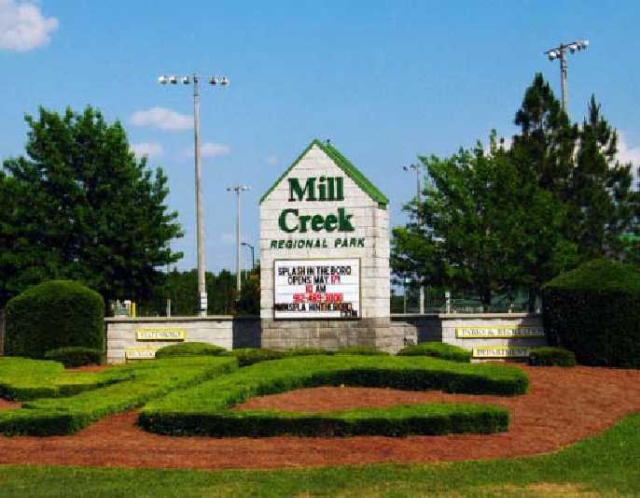
walking paths, and passive open spaces. The park also features a water park and indoor
swimming facility. Parking areas are consolidated behind the playing fields, with vehicular
circulation on the periphery. The park occupied land that was annexed by the city and is abutted
by the county on three sides. These areas in the surrounding county are directly influenced by
the park; land uses in this area will need to be considered as annexation becomes a possibility.

Appropriate Land Uses
- Small and mid-size regional retail
and commercial.
- Office
- Entertainment

- Services
- Multi-family
- Mixed use retail/office/residential
buildings

Suggested Development & Implementation Strategies
- New development should be master-planned and carefully linked to surrounding
developed areas through a network of streets.
- Wherever possible, connect new development with existing and proposed networks of
bicycle paths and multiuse trails such as the McTell Trail, Julius Abraham Trail and the S&S Greenway.
- Future developments and highway improvements within these areas should include
pedestrian and bicycle access to surrounding neighborhoods and the greater Statesboro
community.
University District _________________________________________________________
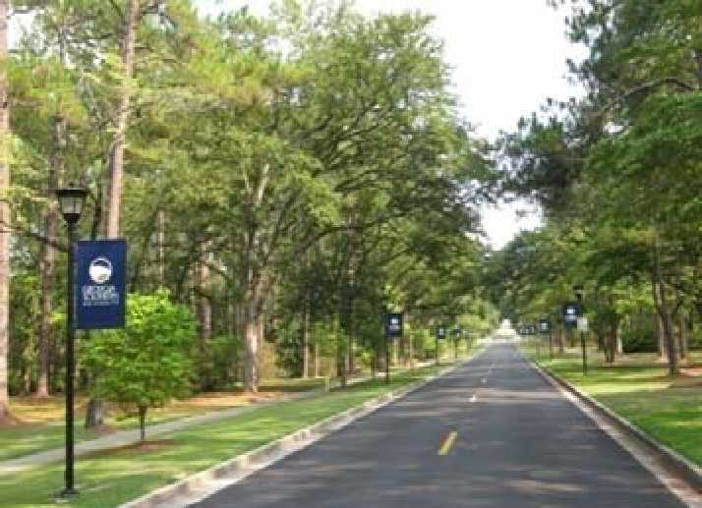
Vision:
The University District is anchored by Georgia Southern University, a traditional four-year college campus. Academic and administrative buildings, residence halls and dorms, student activity centers, cafeterias, performing arts venues, and ancillary buildings are found in the campus core, which is organized around an internal pedestrian circulation system. Pedestrian and bicycle connectivity within the campus is excellent. Parking lots are found along the periphery,
allowing students, faculty and staff to park and walk to buildings and facilities in the core, but this has caused the City exterior circulation issues.
Development within this area, whether on campus or nearby, should focus heavily on pedestrian and bike accessibility, as well as transit. Transitioning the area along the northern side of campus into more active uses, such as residences, educational buildings, activity centers, etc. could significantly bridge the physical gap between downtown and the university.

Appropriate Land Uses
- Neighborhood-scaled retail
- Higher education facilities
- Services
- Multi-Family

- Single-family
- Mixed use retail/office/residential
buildings

Suggested Development & Implementation Strategies
- Encourage future growth within the academic core.
- Host formal discussions between GSU and the City on how to strengthen physical "town
and gown" connections between the campus and adjacent commercial and residential
areas.
- Consider the pros and cons of the greenbelt around campus, which physically separates
the campus from the greater community.
- Continue to preserve open spaces such as Sweetheart Circle and areas of natural beauty,
including Herty Pines.
- Collaboratively address parking needs on campus that affects public and private property in surrounding areas.
- Consider the installation of parking structures on campus as a parking solution. Potential
sites include the existing parking areas near the Hwy 67 entrance, along Old Register
Road, and along Chandler Road.
In addition to the GSU campus, there are residential areas within this area, primarily oriented to
student housing. Multi-family, duplex and single-family housing types are all found in this
district. Student-oriented commercial uses are found along primary arteries, including
restaurants/bars and nightclubs. Interspersed throughout this area are GSU properties including
residential halls.
- Strengthen enforcement of code violations for private property, including property
maintenance, parking, and structural conditions.
- Ensure adequate bicycle and pedestrian facilities for students commuting to and from
GSU campus.
Green Space ______________________________________________________________

Vision:
Large areas of Green Space will be conserved for active and passive recreation, as well as protection of environmental sensitive areas, such as wetlands and floodplains.
Appropriate Land Uses
- Open space
- Passive recreation & tourism use
- Multi-purpose paths/trails

Suggested Development & Implementation Strategies
- Within these areas, identify places of natural beauty and sensitive natural resources (such
as wetlands) and protect these areas from development; consider the use of conservation
easements for increased protection in perpetuity.
- New development should be master-planned and carefully linked to surrounding
developed areas through a network of streets
- Incorporate passive recreation, such as multi-purpose trails, in green space areas to
increase access to natural areas and increase transportation alternatives.
- To allow for greater design flexibility, consider the use of net density instead of
minimum lot sizes in areas adjacent to sensitive natural lands or green space.
Emerging Business_________________________________________________________
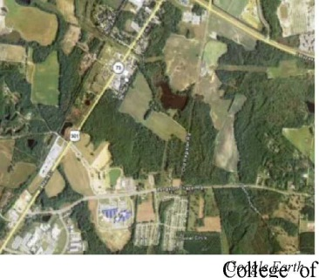
Vision:

The Emerging Business area will support the creation of a park to support office and business development opportunities. This area is ideally situated adjacent to the Veteran's Memorial By-pass, Highway 301, the rail line, and near Georgia Southern, Ogeechee Technical College, and the AgriBusiness Center. This business incubator center is well-positioned to coordinate with the College of Information Technology at Georgia Southern University.

This area is currently outside the city limits, but water and sewer is readily available. This
character area is shown as a gradient on the future development map to indicate that the
boundaries of this area are not specific.
Character Area Overlays
The future development map also includes character area overlays for major corridors and
gateways, which are described below. These overlay areas are highly visible areas and have a
significant impact on the quality and character of the public realm. Therefore, these areas may
have additional design considerations governing the form of development. The underlying
character area district provides the foundation defining the general character and identifies the
appropriate land uses
Gateways – City Limits____________________________________________________________
Vision:
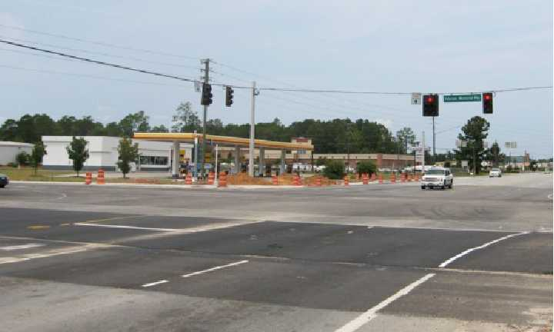
The current "gateway" does little to announce
arrival into the City of Statesboro.
Gateways into Statesboro, which are primarily located
on major arterials at their intersections with the by-
pass, should make it clear to residents and visitors that
they are entering into the incorporated area of the City
through careful attention to development standards, signage, landscaping, and similar elements.

Suggested Development & Implementation Strategies
- There should be good vehicular and pedestrian/bike connections to retail/commercial
services as well as internal street network connectivity, connectivity to adjacent
properties/subdivisions, and multiple site access points.
- Encourage compatible architecture styles that maintain regional character.
- Screen parking areas from view through attractive landscaping, low fencing, etc. Where feasible, locate parking beside or behind buildings.
- Install streetscape improvements which reflect the character of Statesboro through special treatment of sidewalks (such as pavers, scored concrete, etc.), pedestrian-scaled lighting, street trees, hardscape, seasonal plantings, etc.
Gateways – Urban Core________________________________________________________
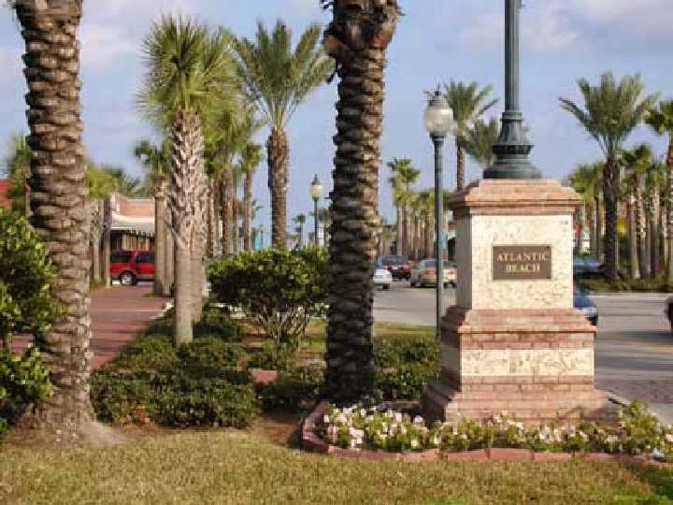
Image Source: www.ci. atlantic-beach.fl.us
Vision:
Gateways into the Urban Core should make it clear to residents and visitors that they are entering into the heart of the City and the central business district. Changes in the street design, streetscape elements, building types, and paving materials can all serve as gateway elements.

Suggested Development & Implementation Strategies
- Promote street designs that denote entrance to a city and foster traffic calming, such as narrower travel lanes, on-street parking, and prominent bicycle and pedestrian facilities.
- Locate parking beside or behind buildings.
- Install streetscape improvements and hardscape elements which reflect the character of Statesboro through special treatment of sidewalks (such as pavers, scored concrete, etc.), pedestrian-scaled lighting, street trees, hardscape, seasonal plantings, etc.

Major Corridors
As mentioned earlier in this document, major thoroughfares should consider Context Sensitive Solutions. This section provides initial guidance for existing major corridors in the City of Statesboro by addressing both the adjacent development patterns as well overall guidance for the street cross-section.
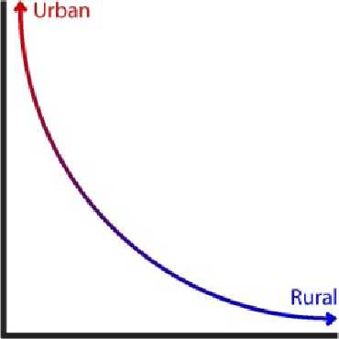
Speed
There is an inverse relationship between access and travel speed for
major corridors. In other words, those areas that provide the highest
amount of accessibility to adjacent properties will generally have the lowest travel speeds and support a more urban character; conversely,
those streets with the highest travel speeds provide the lowest amount of
accessibility (think "interstate") with a more rural character.

Each of the corridors below is described in terms of development patterns to convey the
development patterns immediately adjacent to and accessible from the corridor right-of-way.
Each corridor may support the same use, such as commercial, but the scale and intensity of the use will vary. For example, in the Urban Core, buildings typically line the entire block front and are often multi-story, so the development is very concentrated along the corridor. Moving out from the Urban Core, lot sizes generally increase and breaks in the urban fabric are introduced from parking lots, buffers, etc., so development along a block becomes more fragmented, thus lowering the overall development intensity. While development along the corridor may be very concentrated in some areas, the corridor as a whole is less urban in nature.
Urban Corridors_____________________________________________________________

Vision:
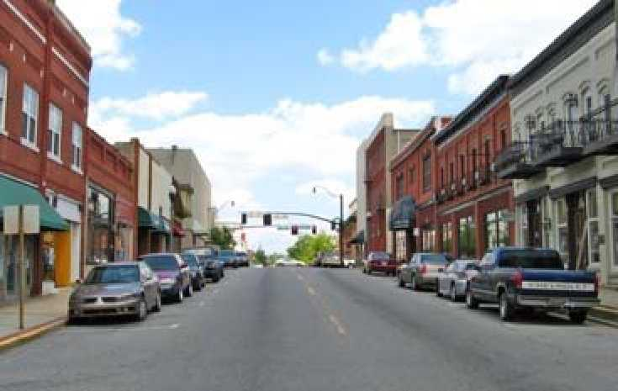
Urban Corridors provide highly visible access to
the most intensely developed properties in
Statesboro. As connectors through and between
downtown and the major activity centers, these
corridors should place a high priority on
pedestrian and bicycle accommodations. Transitions to Urban Corridors should serve as a
gateway into the Statesboro Urban Core.

Suggested Development & Implementation Strategies
- Infill and redevelopment along these corridors should occur according to a master plan that allows for mixed uses, transportation choices and urban design that mitigates the appearance of auto-dependence (such as screening parking lots or locating parking areas
primarily to the sides and rear of buildings).
- Encourage infill, new, and redevelopment to build close to the street. Build-to lines are
typically more appropriate than setback lines.
- All development along these corridors should be oriented to the street.
- Future developments and highway improvements within these areas should include
pedestrian and bicycle facilities. Sidewalks should be generous in width, especially within the Urban Core.
- Connect these areas with existing and proposed networks of bicycle paths, sidewalks and multiuse trails (such as the McTell Trail, Julius Abraham Trail, and the S&S Greenway Trail).
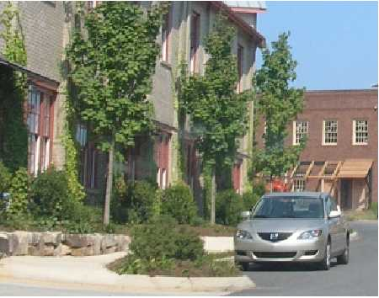
Example of a bulb out
- Plant shade trees along corridors and adjacent to sidewalks.
- On-street parking should generally be provided within the Urban
Core and in other areas where appropriate.
- Traffic calming should be achieved through narrow travel lanes,
bulb outs, on-street parking, street trees, etc.
- Bicycle facilities should generally be provided as on-street,
dedicated bike lanes.
- The use of vegetated medians can provide pedestrian refuge for those crossing the street.
Medians should be kept narrow in general to minimize crossing distance.
- Manage the size, design and placement of signs in the corridors in a manner that reduces
visual clutter by promoting the uniformity of on premise signs while restricting the use of
billboards and other off-premise signs.

Transitional Corridors
Vision:
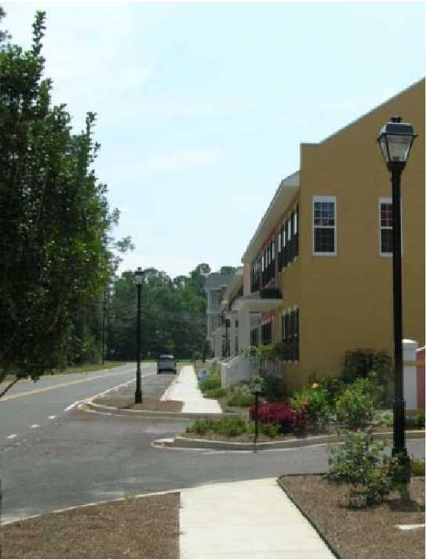
Transitional Corridors provide a gradient from the urban
corridors into suburban commercial and predominately
residential areas. Pedestrian and bicycle facilities remain
important, but may be accommodated in less urban settings.
Suggested Development & Implementation Strategies
• Infill and redevelopment along these corridors should occur
according to a master plan that allows for mixed uses,
transportation choices and urban design that mitigates the
appearance of auto-dependence (such as screening parking
lots or locating parking areas primarily to the sides and rear of buildings)
- Infill, new, and redevelopment may be built close to the street or set back with a
vegetated area between the street and development.
- Future developments and highway improvements within these areas should include
pedestrian and bicycle facilities.
- Connect these areas with existing and proposed networks of bicycle paths, sidewalks and
multiuse trails (such as the McTell Trail and the S&S Greenway).
- Any development which does not front on these roads (such as residential
neighborhoods) should be screened completely from public view so the backs of homes,
businesses, or other structures are not visible from the public right-of-way.
- Plant shade trees along corridors and adjacent to sidewalks.
- Bicycle facilities may be provided through on-street bike lanes, shared road facilities, or a
multi-purpose trail.
- Vegetation medians, shared driveways, and other access management features should be
incorporated into the roadway design to maintain mobility in the corridor.
- For multi-lane streets, the use of vegetated medians can provide pedestrian refuge for
those crossing the street. Medians should be kept narrow in general to minimize crossing
distance.
- Manage the size, design and placement of signs in the corridors in a manner that reduces
visual clutter by promoting the uniformity of on premise signs while restricting the use of
billboards and other off-premise signs.
Access Corridors_________________________________________________________________

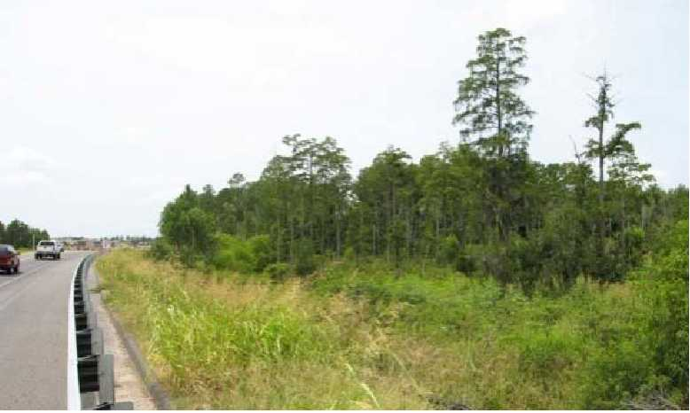
Vision:
The primary purpose of the Access Corridors is to move traffic efficiently. In order to achieve this goal, access will be limited and properties will be served primarily through frontage roads and inter-parcel connectivity.
Suggested Development & Implementation Strategies
- Infill and redevelopment along these corridors should occur according to a master plan that allows for mixed uses, transportation choices and urban design that mitigates the appearance of auto-dependence (such as screening parking lots or locating parking areas primarily to the sides and rear of buildings).
- Encourage the use of frontage roads along the By-pass, with development built close to
the frontage road streets to maximize pedestrian accessibility.
- Connect these areas with existing and proposed networks of bicycle paths, sidewalks and
multiuse trails (such as the McTell Trail, Julius Abraham Trail, and S&S Greenway Trail).
- Sidewalks along these corridors should be separated from the curb/edge of the road by a
landscaped buffer to provide a sense of safety to pedestrians.
- Any development which does not front on these roads (such as residential
neighborhoods) should be screened completely from public view so the backs of homes,
businesses, or other structures are not visible from the public right-of-way.
- Vegetation medians, shared driveways, and other access management features should be
incorporated into the roadway design to maintain mobility in the corridor. Medians along
these corridors may be wider and integrated into the stormwater management system.
- Manage the size, design and placement of signs in the corridors in a manner that reduces
visual clutter by promoting the uniformity of on-premise signs while restricting the use of
billboards and other off-premise signs.

Connectivity Map
The purpose of the "connectivity map" shown on the next page is to stress the importance of
connectivity without specifically identifying new facility routes (which should be done through
the development of a city plan with public participation). Only existing and programmed multi-
purpose paths are indicated. There is a need to identify multi-purpose paths within the urban core
and established neighborhood areas, as well as within new development areas. The city should
establish a multi-use trails network that supports a greater degree of bike/pedestrian
interconnectivity within the city and supplements the on-street network. This multi-use trails
network should be a key transportation resource as well as a recreational resource.
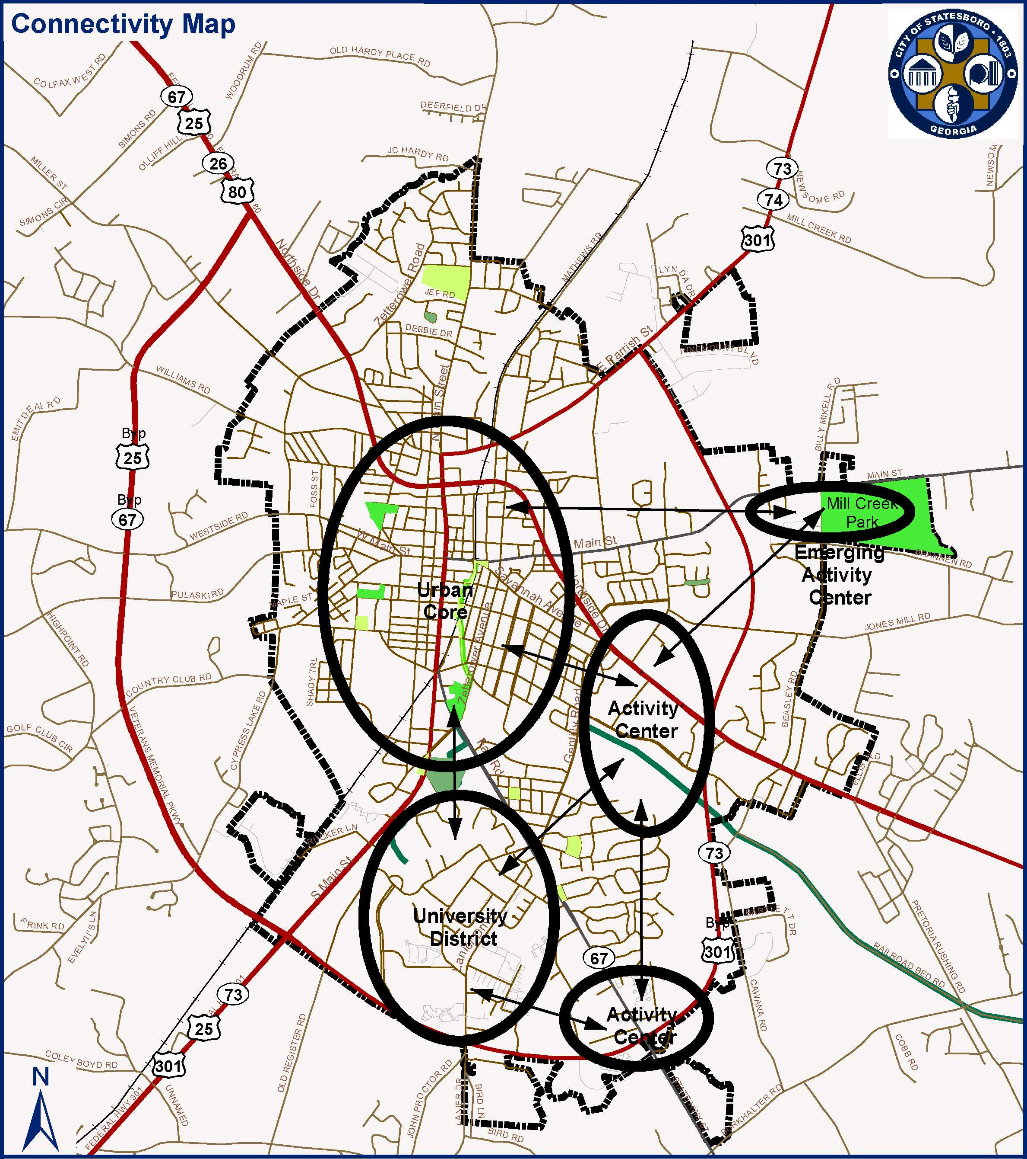
Miles
0.5
1.5
0
1
2
Activity Centers
Athletic Park
Passive Park
Conservation Area
City Limits
- Planned Trails
- McTell Trail

Source: Bulloch County, City of Statesboro, Lott + Barber, RS&H
CITY OF STATESBORO
Comprehensive Plan
2009 Quality Community Objectives
The Board of the Department of Community Affairs adopted the Quality Community Objectives
(QCOs) as a statement of the development patterns and options that will help Georgia preserve
her unique cultural, natural and historic resources while looking to the future and developing to
her fullest potential. The following chart is intended to illustrate which QCOs will be pursued
in each character area.
Quality Community Objective | Character Areas |  |  |  |  |  |  |  | Overlays |
 | Urban Core | Established | Developing | Activity  Centers | Emerging  Activity Ctr. | University  District | Greenspace | Emerging  Business | Gateway | Corridors
Regional Identity  Regions should promote and preserve an "identity," defined in terms of traditional  regional architecture, common economic linkages that bind the region together, or  other shared characteristics. | • |  |  |  |  | •
As the heart of Statesboro, the urban core is arguably the most recognizable area in Statesboro, anchored by the historic downtown. The
historic character of downtown should continue to serve as a model for defining the community. Downtown Statesboro should continue to
serve the needs of the region in cultural, business, and community activities. The university district is also well-tied to the region, providing
services to students as well as surrounding communities.
Growth Preparedness  Each community should identify and put in place the prerequisites for the type of  growth it seeks to achieve. These may include housing and infrastructure (roads,  water, sewer and tele-communications) to support new growth, appropriate training  of the workforce, ordinances to direct growth as desired, or leadership capable of  responding to growth opportunities. | • | • | • | • | • | • |  | •
The urban core and established areas should seek opportunities to retrofit existing roads and infrastructure which may be aging or inadequate
to meet Statesboro's growing population. As the developing area expands beyond the current city limits, this growth must be coordinated with
Bulloch County and the City must be prepared to handle such growth prior to annexation. The existing activity center, emerging activity
center, and emerging business areas all are well-suited to accommodate additional workforce development opportunities. As discussed
throughout this plan, growth of the university district will have direct impacts on the community which should be coordinated to ensure growth
preparedness.
Appropriate Businesses  The businesses and industries encouraged to develop or expand in a community  should be suitable for the community in terms of job skills required, linkages to  other economic activities in the region, impact on the resources of the area, and  future prospects for expansion and creation of higher-skill job opportunities. | • |  |  | • | • | • |  | •
The central business district of the urban core should serve as an employment center for a viable downtown. As the activity centers continue to
grow and develop, these areas will also provide opportunities for business development, including the development of additional medical
support services around the hospital. The creation of an emerging business area has been identified specifically for the purpose of fostering
the development of appropriate businesses in Statesboro. Training opportunities in partnership with the University also strengthen economic
development opportunities.

Quality Community Objective | Character Areas |  |  |  |  |  |  |  | Overlays⁶
 | Urban Core | Established | Developing | Activity  Centers | Emerging  Activity Ctr. | University  District | Greenspace | Emerging  Business | Gateway | Corridors
Educational Opportunities  Educational and training opportunities should be readily available in each  community - to permit community residents to improve their job skills, adapt to  technological advances, or to pursue entrepreneurial ambitions. | • |  |  |  |  | • |  | •
The predominant educational opportunities existing within the university district in conjunction with Georgia Southern University and
Ogeechee Technical College. The emerging business area is also strategically located to capitalize on the close proximity of these educational
institutions. Educational opportunities should also be provided within the urban core to strengthen the central business district.
Employment Options  A range of job types should be provided in each community to meet the diverse  needs of the local workforce. | • |  |  | • | • | •
The urban core provides a wide range of employment opportunities, including government, services, professional office, and retail. The DSDA
should continue to strive for increasing the employment options in downtown. The activity center serves as the medical hub of the region and
also provides entry-level jobs in service in retail. As a major employer, the presence of GSU in the university district provides jobs for faculty,
staff, and operations. The emerging business area seeks to further diversify employment options available in the community.
Heritage Preservation  The traditional character of the community should be maintained through  preserving and revitalizing historic areas of the community, encouraging new  development that is compatible with the traditional features of the community, and  protecting other scenic or natural features that are important to defining the  community's character. | • | • | • |  |  | • | • |  | •
The role of historic preservation should be strengthened in the urban core and established area in order to protect the character of these areas.
As new development continues in the developing areas, it should respect the historic fabric of the community and strive to maintain the
character of Statesboro. The university district continues a tradition of portraying a college campus feel with tree-lined avenues leading into
campus and both formal and informal gathering spaces for students. The gateways should be retrofitted to portray a stronger sense of arrival
into the greater Statesboro and downtown areas.
Open Space Preservation  New development should be designed to minimize the amount of land consumed,  and open space should be set aside from development for use as public parks or as  greenbelts/wildlife corridors. |  | • | • |  | • | • | •
Within the established areas, there are numerous opportunities to retrofit existing lots into pocket parks or redevelop sites into mixed use
developments with dedicated open space. As residential development continues within the developing area, open space and tree protection
requirements should be incorporated into development requirements to ensure both environmental protection and access to open space for new
residents. The greenspace area is the only significant wetland area currently within the city limits and also lies within a floodplain. Steps
should be taken to minimize the impacts of development on this remaining greenspace. The campus of Georgia Southern University provides
diverse open space within the university district through active and passive open space as well as preservation of natural areas, such as the
Herty Pines Preserve.
Environmental Protection  Air quality and environmentally sensitive areas should be protected from negative  impacts of development. Environmentally sensitive areas deserve special  protection, particularly when they are important for maintaining traditional  character or quality of life of the community or region. Whenever possible, the  natural terrain, drainage, and vegetation of an area should be preserved. |  |  | • |  | • |  | • | •
Issues of stormwater management and tree protection should be addressed collectively as part of environmental protection efforts for the city.
Area facing rapid development, such as the developing area, emerging activity center, and emerging business area are particularly
vulnerable to significant loss of tree cover and changes in stormwater management patterns. As mentioned above, the greenspace area
contains the largest contiguous wetland within the city limits and also provides a vegetated buffer for Little Lotts Creek.

Quality Community Objective | Character Areas |  |  |  |  |  |  |  | Overlays⁶
 | Urban Core | Established | Developing | Activity  Centers | Emerging  Activity Ctr. | University  District | Greenspace | Emerging  Business | Gateway | Corridors
Regional Cooperation  Regional cooperation should be encouraged in setting priorities, identifying shared  needs, and finding collaborative solutions, particularly where it is critical to success  of a venture, such as protection of shared natural resources.  Regional Solutions  Regional solutions to needs shared by more than one local jurisdiction are  preferable to separate local approaches, particularly where this will result in greater  efficiency and less cost to the taxpayer. |  |  |  |  |  |  |  |  |  | •
Regional cooperation is of paramount importance for the Statesboro community as a whole. The city, county, school board, and university
system already work collaboratively on various services and this collaboration should continue and potentially expand where feasible.
Cooperation will be especially important along the bypass, which passes through both the city and the county, to maintain mobility in the area.
Transportation Alternatives
Alternatives to transportation by automobile, including mass transit, bicycle routes
and pedestrian facilities, should be made available in each community. Greater use
of alternate transportation should be encouraged.
This planning process demonstrated very strong support for the development of transportation alternatives in Statesboro, especially for bikes
and pedestrians. The urban core and established areas are generally pedestrian friendly, although there is room for improvement of
pedestrian and bike facilities, especially along some of the primary corridors. The developing area provides one of the greatest opportunities
to integrate transportation alternatives as new development occurs. The activity centers are predominately auto-oriented, but could be
retrofitted to increase their accessibility and safety for pedestrians and cyclists. The corridors and gateways of Statesboro should be planned,
retrofitted, and constructed as multi-modal facilities that will accommodate all types of users safely.
Housing Opportunities  Quality housing and a range of housing size, cost, and density should be provided in  each community, to make it possible for all who work in the community to also live  in the community. | • | • | • |  |  | •
The urban core provides urban-style housing opportunities through live-work and loft housing, but there is an opportunity to greatly expand
housing options in downtown. The urban neighborhoods of the established area provide detached single-family homes in close proximity to
downtown. Infill and redevelopment within the established area can increase the availability of this housing stock. The developing areas
provide substantial housing alternatives, although the city has struggled with the abundance of multi-family developments driven by student
housing needs. In the future, more innovative approaches to multi-family housing through mixed use developments may help to alleviate some
of the current problems associated with garden-style apartments. Within the university district, the city and university need to work together to
address issues of student housing in traditional single-family neighborhoods.
Traditional Neighborhood  Traditional neighborhood development patterns should be encouraged, including  use of more human scale development, mixing of uses within easy walking distance  of one another, and facilitating pedestrian activity. | • | • | • |  |  | • |  |  | •
The urban core and established areas were designed and built around the principles of traditional neighborhood development, including well-
connected tree-lined streets, compact lot sizes, and a mix of compatible uses. These patterns should serve as a model to the developing area to
ensure long-term viability of these newer developments. The gateways can also incorporate many of these principles to provide a welcoming
entry to those arriving in Statesboro. Given the high level of student activity, the university district should also strive to incorporate traditional
neighborhood development patterns to reduce reliance on the automobile.
Infill Development  Communities should maximize the use of existing infrastructure and minimize the  conversion of undeveloped land at the urban periphery by encouraging development  or redevelopment of sites closer to the downtown or traditional urban core of the  community. | • | • |  | • |  | • |  |  | •

Quality Community Objective | Character Areas |  |  |  |  |  |  |  | Overlays⁶
 | Urban Core | Established | Developing | Activity  Centers | Emerging  Activity Ctr. | University  District | Greenspace | Emerging  Business | Gateway | Corridors
As with many communities, the older areas of the urban core and established areas provide numerous opportunities for infill development.
Reinvestment though infill development strengthens the tax base while reinvesting in the existing community. Infill development in the activity
centers, university district, and gateways should strive to increase accessibility for all modes of transportation (bike, pedestrian, potentially
transit). Redevelopment within these areas should also occur at a human scale to increase the vibrancy and walkability of these areas.
Sense of Place  Traditional downtown areas should be maintained as the focal point of the  community or, for newer areas where this is not possible, the development of  activity centers that serve as community focal points should be encouraged. These  community focal points should be attractive, mixed-use, pedestrian-friendly places  where people choose to gather for shopping, dining, socializing, & entertainment. |  |  |  | • | • |  |  |  | •
The urban core contains numerous signature buildings, including the Courthouse, City Hall, Averritt Arts Center, and more. These buildings
all work together in the urban fabric of downtown to define a strong sense of place. New development in downtown should be careful planned
and designed to reinforce, rather than erode, this sense of place and urban fabric. The activity centers and gateways are in need of retrofitting
to differentiate these areas from those found in any other community. Care should be taken to balance economic development efforts to ensure
that the development of activity centers plays a supporting, rather than competing role, with downtown.

2014 QUALITY COMMUNITY OBJECTIVES
These ten objectives and best recommended practices are adapted from generally accepted community development principles to fit the unique qualities of Georgia’s cities and counties and have been adopted as suggested Quality Community Objectives by the Georgia Department of Community Affair effective January 1, 2014. . Although these objectives are only recommendations, we are convinced that implementing these principles will result in greater efficiency and cost savings for local governments and a higher quality of life for their citizens.

DCA Quality Community Objectives & Recommended Best Practices for Implementation

Quality Community Objective: Economic Prosperity
Encourage development or expansion of businesses and industries that are suitable for the community. Factors to consider when determining suitability include job skills required; long-term sustainability; linkages to other economic activities in the region; impact on the resources of the area; or prospects for creating job opportunities that meet the needs of a diverse local workforce.

Applicable Character Areas
Commercial Redevelopment Area; Urban Core Center; Activity Centers; University District; Emerging Activity Center

Recommended Best Practices
- Economic Development Strategy:
Develop a collaborative, public/private local economic development strategy by involving stakeholders such as local business owners, the Chamber of Commerce, Development Authority, and Downtown Development Authority. Enlist stakeholder input to reveal what training or expertise exists within the community workforce, what types of businesses or industries need to be developed, and what constraints exist on business growth within the community.
- Business Incubator:
Develop a business incubator to give local entrepreneurs a useful location to support a fledgling business.
- Community Improvement District (CID):
Form a community improvement district (CID) to enhance the business development potential of a particular section of your community, such as a declining strip mall or older warehouse district. A CID can levy a small tax on businesses within the district to finance a range of needed facilities and services to enhance the attractiveness of the area.
- Tracking Business Needs:
Conduct periodic formal surveys, or use more informal means to track and remain attentive to the needs of existing businesses, as these otherwise tend to be overlooked while local economic developers search for new companies to attract. Develop strategies for addressing their issues, such as future infrastructure needs, workforce skills, etc. This is frequently done in conjunction with a business retention and expansion program (BREP) or an Existing Industry Program (EIP).
- Communication Strategy:
Identify your message and promote your community for economic development through available media outlets. Use social media sites as a no cost means to increase your community’s exposure to new visitors and businesses.
- Downtown Program:
Actively support and participate in programs that promote healthy business downtown such as Downtown Development Authorities, Better Hometown, and Main Street Programs.
- Opportunity Zone:
Consider adopting an Urban Redevelopment Plan and apply for opportunity zone designation to take advantage of tax incentives available to businesses locating within the zone.
- Professional Development:
Enhance knowledge and skills of economic development staff by ensuring they participate in trainings or information sharing events such as the Georgia Academy for Economic Development, Georgia Economic Developers Association (GEDA) events, etc.
- Tourism Strategy:
Plan a tourism initiative and marketing campaign based on your community’s existing heritage and cultural resources. The strategy might also entail employing well-designed logo and tourist-oriented directional signage systems, to help tourists find the services they need. Heritage and Cultural tourism are big business in Georgia.
- Workforce Training:
Provide access to training opportunities for the local workforce. These can include formal educational institutions, private providers, and specialized programs from a department of labor. Such training resources are especially critical in this era of technology and rapid change.

Quality Community Objective: Resource Management
Promote the efficient use of natural resources and identify and protect environmentally sensitive areas of the community. This may be achieved by promoting energy efficiency and renewable energy generation; encouraging green building construction and renovation; utilizing appropriate waste management techniques; fostering water conservation and reuse; or setting environmentally sensitive areas aside as green space or conservation reserves.

Applicable Character Areas
Commercial Redevelopment Area; Urban Core; Established; Developing; Activity Centers; University District; Emerging Activity Center; Greenspace; Emerging Business

Recommended Best Practices
- Stormwater Management:
Develop and implement a local stormwater management plan that includes:
- Incentives for low impact development (LID) which uses innovative site design techniques to collect and drain or evaporate stormwater runoff onsite, rather than routing it into a typical stormwater collection system. LID techniques include bioretention, permeable pavers, tree box filters, rain barrels, disconnected downspouts, narrower streets, infiltration swales, rooftop gardens, bioretention cells and rain gardens.

- Requirements that impervious surface not exceed a certain maximum percentage of total lot size, in particular sections of the community, particularly those that drain most directly into water supply streams or reservoirs.
- Pervious Paving:
Encourage the use of pervious paving materials throughout the community, including on sidewalks, parking lots and minor streets. Their use decreases the amount of stormwater runoff and therefore the amount of pollution of streams resulting from runoff.
- Conservation Easements:
Encourage owners of key properties (such as those in environmentally sensitive areas, included in the local greenspace plan, or designated for agricultural use in the comprehensive plan) to utilize conservation easements or sale of development rights to preserve their land from future development. Conservation easements allow private landowners to donate the development rights of their property to a qualified conservation organization or government agency, in exchange for tax savings. Sale of development rights is an arrangement whereby private landowners sell the development rights of their property to a qualified conservation organization or government agency. In both cases above, giving up the development rights permanently protects a property from development and thereby ensures that it remains as green space or farmland.
- Greenspace Plan:
Develop, adopt, and implement a green space plan that provides for connectivity of permanently protected green space throughout the community. Setting aside the greenspace can be done through direct purchase by the local government, purchase of the development rights to the land only, or by working with local land trusts to focus their efforts to acquire conservation easement in the areas identified in the local greenspace plan.
- Tree Protection:
Adopt a tree ordinance that requires preservation of a significant portion of the trees on a new development site, particularly the larger, more mature specimens.
- Recycling Program:
Offer a curbside recycling program for community residents. This should include collection of traditional recyclables, such as paper, glass, aluminum. Your community may also want to add organics and yard debris collection for creating compost that can be made available to the public. You may also hold regular events in the community to collect non-traditional recycling materials such as ink cartridges, batteries, compact florescent lights and electronics, for recycling.
- Water Resource Protection:
Adopt water resource management policies such as requiring use of WaterSense certified high efficiency toilets and faucets in all new buildings, use of greywater for irrigation, use of drought tolerant landscaping.
- WaterFirst:
Work with DCA to become a WaterFirst Community. This program helps communities establish an effective local program and strategy for protecting and appropriately managing water resources in the community.

Quality Community Objective: Efficient Land Use
Maximize the use of existing infrastructure and minimize the costly conversion of undeveloped land at the periphery of the community. This may be achieved by encouraging development or redevelopment of sites closer to the traditional core of the community; designing new development to minimize the amount of land consumed; carefully planning expansion of public infrastructure; or maintaining open space in agricultural, forestry, or conservation uses.

Applicable Character Areas
Commercial Redevelopment Area; Urban Core; Established; Developing; Activity Centers; University District; Emerging Activity Center; Emerging Business

Recommended Best Practices
- Adaptive Reuse:
Create incentives such as tax breaks, code changes or other regulatory tools to encourage property owners to rehabilitate underutilized or vacant structures so that they can be put to new uses.
- Strategic Public Infrastructure Policy:
Plan carefully for location and timing of new public facilities, or coordinate with other public agencies that build facilities in the community, to help ensure that these facilities contribute to achieving the community's desired development patterns, and provide for a gradual expansion of developed areas contiguous to areas that have already developed. Such a strategy will eliminate the need for expensive extensions of facilities to serve "leap-frog" developments.

One effective strategy is to delineate an urban service area where the local government will provide urban services, such as water supply or sewage treatment, in the future. This will encourage higher density infill development within the urban service area, while helping to maintain the rural character of areas lying outside the urban service boundary. This urban service area may be expanded gradually over time if the community's population continues to expand.

Another element of an effective infrastructure strategy is a "Fix It First" policy that gives top priority to repair and reinvestment in existing infrastructure (roads, bridges, water, sewer, power, etc.) by fixing and maintaining what already exists. Such a strategy can help communities avoid subsidizing sprawl.

- Cluster Development:
For specified areas of the community, adopt regulations that require a significant portion of a site to be set aside as undivided, permanently protected open space, while the buildings (houses, shops, etc.) are clustered at higher density on the remainder of the property.
- Creative Design for Higher Density:
Provide design options for higher density development that blends well with the surrounding neighborhood, perhaps by masking the high-density aspects of the development through landscaping or architectural details. For example, multi-family housing can be designed to appear as a single family residence from the street, or heavy landscaping can be used to hide parts of the development.
- Flexible Parking Standards:
Provide design options for higher density development that blends well with the surrounding neighborhood, perhaps by masking the high-density aspects of the development through landscaping or architectural details. For example, multi-family housing can be designed to appear as a single family residence from the street, or heavy landscaping can be used to hide parts of the development.
- Greyfield Redevelopment:
Provide assistance and incentives for redevelopment of greyfield areas. A greyfield is a declining or abandoned shopping mall or strip, and has the advantage that infrastructure is already in place and lacks the environmental cleanup issues of a brownfield. Ideally these areas can be converted into walkable, higher density, mixed-use developments.
- Infill Development Program:
Develop a comprehensive strategy for encouraging infill development in particular areas of the community, while also regulating this development to ensure protection of quality of life in affected neighborhoods. This strategy should include:
a) Development incentives, improvements to public facilities and services, and streamlined regulations to encourage infill development.
b) Guidelines for appropriate design, density and location of new infill projects.
- Land Assembly for Redevelopment:
Institute a program to purchase key land parcels and offer these for private redevelopment. This can encourage revitalization of declining areas of the community by reduce the cost and difficulty for developers to assemble these sites.
- Planned Unit Developments:
Revise land development regulations to encourage developers to propose planned, mixed-use developments for sites they choose in the community. Developer's plans are approved only if they meet specified community standards.
- Rehabilitation Codes:
Adopt building codes with standards appropriate to the renovation of older buildings. Typical building codes were written with new construction in mind, and strict application of these codes to older buildings will significantly increase renovation costs. Rehabilitation codes help keep costs down, thereby encouraging rehabilitation of older properties.
- Tax Allocation District (TAD):
Implement a tax increment financing program by establishing a tax allocation district (TAD). With TAD, the local government usually issues bonds to pay for improvements such as infrastructure to make the district more attractive for new development. The added tax revenues that result for new development in the district are used to pay off the bonds.
- Mixed Use Zoning:
Ensure your zoning or land development regulations allow for a mix of uses in appropriate areas of the community. In contrast to traditional zoning techniques, mixed-use zoning allows different types of uses (such as housing, commercial and office) to locate within the same area, provided the uses are reasonably compatible. This creates a more diverse and dynamic community setting, makes it easier for people to carry out some daily activities by walking, and typically results in more compact development patterns, thereby reducing infrastructure costs to the local government.
- Urban Redevelopment Plan:
Establish an urban redevelopment plan (and appoint an authority to implement this plan) for areas with high concentrations of underutilized buildings and infrastructure.
Quality Community Objective: Local Preparedness
Identify and put in place the prerequisites for the type of future the community seeks to achieve. These prerequisites might include infrastructure (roads, water, sewer) to support or direct new growth; ordinances and regulations to manage growth as desired; leadership and staff capable of responding to opportunities and managing new challenges; or undertaking an all-hazards approach to disaster preparedness and response.

Applicable Character Areas
Commercial Redevelopment Area; Urban Core; Established; Developing; Activity Centers; University District; Emerging Activity Center; Greenspace; Emerging Business

Recommended Best Practices:
- Evaluate Ordinances for Consistency:
Update your local land use ordinances so that they are consistent with the goals and intent of the comprehensive plan. This will help insure that the ordinances are used as a tool for implementing the comprehensive plan.
- Streamlined Development Permitting:
Arrange for the different local agencies that give development permissions and approvals to coordinate their activities through a unified, easy to understand system. Easing the development process is a valuable incentive to entice development into a community. This may include removing or combining unnecessary approval steps or publishing a step-by-step guide to the review process.
- Alternatives to Conventional Zoning (DCA Model Code):
Pick from this menu of typical development regulation components to personalize and enact ordinances that specifically fit your community's needs. The DCA Alternatives to Conventional Zoning provides a full range of ordinance options from animal control, to street/sidewalk standards, to land use guidance system.

- Impact Fees:
Enact a local program to charge impact fees, which are one-time fees charged to new developments, and are meant to cover part of the cost of providing the public facilities that support these developments. Such facilities include infrastructure such as water, sewer and roads, and services such as police, EMS, libraries and parks. If properly applied, impact fees can encourage infill development while discouraging scattered leapfrog development.
- Public Nuisance Ordinances:
Adopt and enforce regulations to protect neighboring residents and property owners by controlling nuisances such as, loud noises, stagnant water, abandoned vehicles, accumulation of junk, and tall weeds and grass.
- All-Hazards Strategy:
Adopt an all-hazards strategy for disaster preparedness and response. Being prepared for All-hazards includes not only natural disasters such as floods and tornadoes, but also technical disasters such as fires or supply chain failure and human based disasters like hostage situations or pandemics.

Quality Community Objective: Sense of Place
Protect and enhance the community’s unique qualities. This may be achieved by maintaining the downtown as focal point of the community; fostering compact, walkable, mixed-use development; protecting and revitalizing historic areas of the community; encouraging new development that is compatible with the traditional features of the community; or protecting scenic and natural features that are important to defining the community's character.

Applicable Character Areas
Commercial Redevelopment Area; Urban Core; Established; Developing; Activity Centers; University District; Emerging Activity Center; Greenspace; Emerging Business

Recommended Best Practices:
- Building Siting Requirements:
Amend local regulations to establish maximum setback and minimum building frontage requirements in commercial districts where more walkability, traffic calming, and a more traditional "downtown-like" feel are desired. A maximum setback requirement sets the allowable distance between the right-of-way and the front of the buildings at a maximum distance rather than a minimum distance, as is typical for most subdivision regulations. This results in development being located closer to the street, which encourages walkability, traffic calming, higher density and a more traditional urban feel. Mandating a minimum building frontage requires that a building stretch further across its lot, resulting in a more continuous line of side-by-side buildings along the street. This is the typical development pattern in a traditional downtown area, so the result is a walkable district with more urban feel.
- Landscaping Ordinance:
Adopt a landscaping ordinance that establishes consistent standards for:
1) Providing plant materials in new developments
2) Breaking up parking lots and other large paved areas with plantings
3) Requiring planted areas to mask unattractive land uses (such as parking lots, dumpsters) or to provide a visual and sound barrier between incompatible adjacent uses.
Landscaping requirements will substantially improve the aesthetic appearance of the community.
- Traditional Neighborhood Development Standards:
Amend your local development regulations to permit traditional neighborhood development (TND) in your community. TND's typically include small lot single-family homes, multi-family residences, and neighborhood commercial developments, all within easy walking distance of one another. Your local regulations may either require all new developments to incorporate TND principles, require adherence to TND principles only in certain districts of the community, or you may allow TNDs upon request by the developer, as an option under your Planned Unit Development requirements.
- Corridor Study:
Conduct a Corridor study to identify and plan for improvement needs along a strip commercial corridor. The study typically involves key stakeholders (property owners, businesses, neighborhood leaders, and service providers) to achieve consensus on improvements to be made along the corridor.
- Design Guidelines:
Develop design guidelines for specific areas of the community that establish aesthetic and development standards for all properties. These guidelines are intended to achieve an architecturally and physically cohesive character for the area, through setting standards for the appropriateness and impact of new buildings or rehab of existing buildings. Illustrations of desired building characteristics are perhaps the best way to communicate design guidelines to citizens and developers. Communities that want their design guidelines to be more than just advisory in nature may choose to establish a design review board to implement the design guidelines. This board will review architecture, aesthetics, and site characteristics of proposed projects to achieve compatibility with the design guidelines.
- Flexible Subdivision Regulations:
Revise subdivision regulations to enable development of more innovative types of subdivisions that better match the character of the community and physical constraints of the development site. Revisions may include adjusting specific physical development standards or encouraging greater use of discretionary site plan review for new subdivisions. There is probably no other regulation more important than subdivision regulations, because the resulting designs and patterns of land subdivision establish the geography and geometry of the community and in turn influence the entire character of the city or county.
- Right-of-Way Improvements:
Undertake public improvements in the right-of-way to enhance the physical appearance and walkability of selected districts of your community. Right-of-way improvements are any type of public improvement made in a roadway's "right-of-way," which is the strip of land that includes the road itself and the narrow band of publicly owned property on either side of the road where sidewalks, curbing, and utility lines are typically located. These improvements may include adding or upgrading sidewalks, planting trees or other landscaping, adding street furniture, such as benches and attractive trash receptacles, or working with the local utility companies to relocate overhead utility lines either below ground or at the rear of lots.
- Sign Ordinance:
Enact a sign ordinance that regulates the size, height, placement, materials and design of signs throughout the community or in selected districts of the community. Sign regulation is important, because excessive or inappropriate signage can seriously detract from the aesthetic appeal of the community and create a bad first impression for visitors to the community. On the other hand, requiring compatible and consistent signage can be very effective in promoting the community's identity, history and culture.
Quality Community Objective: Housing Options
Promote an adequate range of safe, affordable, inclusive, and resource efficient housing in the community. This may be achieved by encouraging development of a variety of housing types, sizes, costs, and densities in each neighborhood; instituting programs to provide housing for residents of all socio-economic backgrounds; or coordinating with local economic development programs to ensure availability of adequate workforce housing in the community.

Applicable Character Areas
Commercial Redevelopment Area; Urban Core; Established; Developing; Activity Centers; University District; Emerging Activity Center; Greenspace; Emerging Business

Recommended Best Practices
- Accessory Housing Units:
Allow, by ordinance, the inclusion of accessory housing units such as in-law suites or carriage houses in residentially zoned areas of the community. Encouraging accessory housing units is one means to bring affordable housing into all neighborhoods of the community.
- Cottage Zoning:
Create an ordinance to allow very small single-family houses ("cottages") of 600-1,000 square feet in appropriate districts of the community. A cottage takes up a lot about half the size of a conventional new house, and its impact, in terms of traffic, stormwater, etc., is also about half. Cottages fill a need for affordable housing, especially for empty-nesters, retirees, young couples, or any 1-2 person household.
- Mixed-Income Housing:
Adopt zoning requirements that specifically allow for a range of housing sizes and types (multi-family, attached, single family) in particular neighborhoods. This will permit people of a range of incomes and backgrounds to find suitable housing choices in these areas.
- Code Enforcement:
Utilize code enforcement as a tool to require property owners to properly maintain their residential units and thereby prevent neighborhood blight and foreclosed properties.
- Land Bank:
Establish a local land bank empowered to acquire and assemble available properties in areas of the community in need of redevelopment, then offer these properties to private developers as sites for new development of affordable or infill housing. Land banking is a proven strategy for effective revitalization of declining areas of the community.

Quality Community Objective: Transportation Options
Address the transportation needs, challenges and opportunities of all community residents. This may be achieved by fostering alternatives to transportation by automobile, including walking, cycling, and transit; employing traffic calming measures throughout the community; requiring adequate connectivity between adjoining developments; or coordinating transportation and land use decision-making within the community.

Applicable Character Areas
Commercial Redevelopment Area; Urban Core; Established; Developing; Activity Centers; University District; Emerging Activity Center; Greenspace; Emerging Business

Recommended Best Practices
- Improving Street Connectivity:
Promote connectivity in local road systems in order to reduce the traffic load on collector and arterial streets and improve the walkability in your community. Typical approaches to improving connectivity include requiring subdivisions and office parks to have multiple ingress and egress points, disallowing cul-de-sacs and other closed street networks, encouraging use of interconnected grid street network designs, and establishing maximum block length standards.
- Safe Routes to School:
Participate in the Georgia Safe Route to School program. The program works with elementary and middle schools to create opportunities for children to safely walk and bicycle to school.
- Traffic Calming:
Employ physical improvements designed to decrease traffic speed and increase the pedestrian-friendliness of roadways. Typical traffic calming improvements include raised crosswalks, narrower traffic lanes, fewer lanes, on-street parking, bump-outs, pedestrian refuges, and landscaped medians.
- Traffic Impact Studies:
Require each major new development project in your community to provide a study that projects the transportation demands of the development proposals and thereby allows the local government to plan in advance for reduction of adverse impacts on the transportation system.
- Transportation Enhancement Program:
Apply to the Transportation Enhancement Program of GDOT to acquire grant funds to enhance facilities in your community to support alternative transportation. These facilities may include sidewalks, bike trails, rail depot renovations, and streetscape improvements.
- Bicycle Facilities:
Ensure safe, adequate and well-designed facilities are provided for bicyclists, including pavement markings, signage, and intersection crossings.
- Complete Streets:
Adopt a "Complete Streets" philosophy in designing and building local streets that specifies that “users” of a street includes pedestrians, bicyclists and public transportation passengers of all ages and abilities, as well as trucks, buses and automobiles. This approach should be applied to both new and retrofit projects, and involves use of sidewalks, street trees, etc.
- Maximize Use of On Street Parking:
Identify and take advantage of opportunities to add on-street parking in areas where additional parking is most needed. This may include changing parallel parking to angle parking, converting underused medians, loading areas, turn lanes, or traffic lanes for parking, or narrowing wide sidewalks to add parking. Also adopt measures that encourage frequent turnover of the high-demand on street parking spaces in busy commercial districts. This may include enforcing strict parking time limits or installing parking meters.
- Sidewalk/Trail Network:
Promote physical activity in your community by creating or improving sidewalks and trails that connect to important destinations such as schools, public facilities, employment centers, parks, recreation areas.

ISSUES & OPPORTUNITIES

The following section is derived from the initial list of potential issues and opportunities
identified in the Community Assessment section of the Comprehensive Plan. This is the final,
locally agreed upon list of issues and opportunities the community intends to address, based on
analysis of data and community input. Each item is followed up with a corresponding
implementation strategy as identified in the next
section of the Community Agenda (forthcoming).
The Issues and Opportunities are categorized
according to the following eight community
elements, derived from the DCA Standards, as
well as general "Quality of Life" issues that might
not be reflected in any of the other categories for 2009.

Population
Economic Development
Natural and Cultural Resources
Community Facilities and Services
Housing
Land Use
Transportation
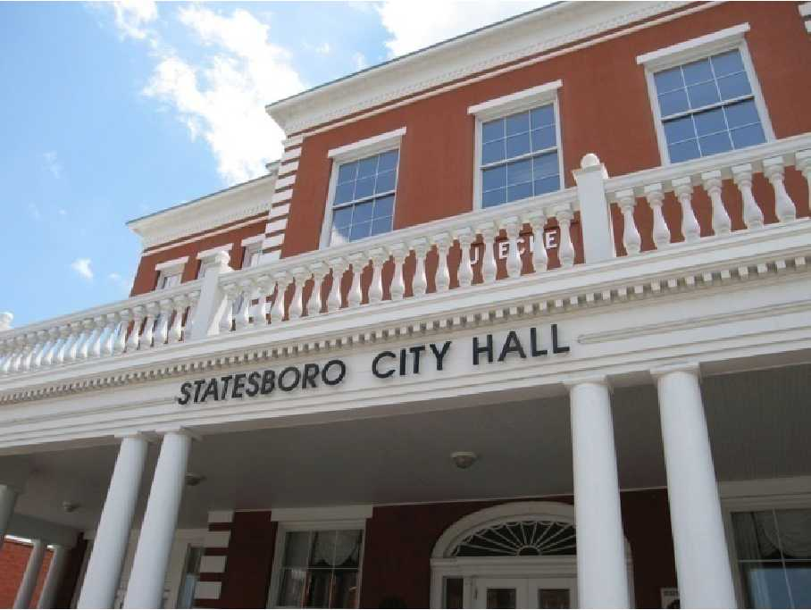
Intergovernmental Cooperation
Quality of Life
Financial Stewardship
Governmental Administration
NEEDS & OPPORTUNITITS 2014 UPDATE
A review of the City of Statesboro’s Community 2009 Assessment; newly acquired data; Quality Community Objectives and Supplemental Planning Recommendations of the Department of Community Affairs and local experiences over the last five years have informed this update. The needs and opportunities identified for 2014 restate and adopt all those integrated into the 2009 plan adoption and also address new identified issues and opportunities in Fiscal Stewardship and Government Administration.
POPULATION
Population Increase
The population of Statesboro is projected to continue to increase, doubling the 2000
population by 2030. Much of this growth will occur in the 18 to 24 age range, which is
not surprising given the presence of a major university. While this population growth
presents great opportunities, rapid development and lack of direction can erode
community character. Growth should be guided to ensure Statesboro maintains
its defining character.
Student Population
As Georgia Southern University continues to grow, communications between the City
and the University will become increasingly important, especially in dealing with issues
such as transportation and housing. GSU is predicting 25,000 students by 2020 and by
2030 there may be 27,000-30,000 students. There is a real advantage and opportunity to
take advantage of the additional dollars generated, but there will also be issues to
resolve related to this growth.
Prospected growth rates at Georgia Southern University which are reinforced with the recent move to the Athletic Sunbelt Conference; the addition of an Olympic grade Archery & Shooting Sports Facility; and the opening of the only Fabrication Laboratory & Innovation Center in our region. We are also expecting significant growth at the community’s other two post-secondary institutions. East Georgia State College has begun offering four year bachelor degrees and has rapidly outgrown its new Statesboro Campus. Ogeechee Technical College has also expanded its offerings and expects to receive its SACS Accreditation at the time of this update. These opportunities bring additional growth to Statesboro, as well as additional quality of life issues and service burdens.
Population Count
Additionally, some data sources estimate that Statesboro’s mature population (55 years and older) is also increasing at rapid rates. This indication calls for further study and possible preparation. It is imperative that the City take action to more fully understand the compensation of its population. It has long been thought that Census Bureau undercounts the city population. Fully preparing for the next count and identifying the student population; the full time residential population; as well as the day time work population is imperative to ensure proper service delivery

Economic Development
Household and per capital income
Due to the high percentage of post-secondary students who live off-campus, the student population is averaged with the entire city by the US Census Bureau, creating skewed statistics abouttrue income. The City, Georgia Southern, and economic development agencies should
continue to work together to discern the 'true' household income and actively disseminate
this information to economic development prospects. Additionally, the City of Statesboro must discern and distribute the “spendable” income of its populations with the special recognition of the student population. This is very different than the per capita income primarily used by economic development prospects and is likely a truer representation of our city’s potential. Continued research in this area is a must.
Lack of Higher-Quality Retail and Grocery Stores
As Statesboro continues to grow, opportunities for new retail will continue to increase. However, when retailers evaluate the market, evaluation of buying power (and related household income) is a critical factor. This issue is therefore directly related to the item above. Although there are many factors which influence a retailer's decision on where to locate, the customer base, often referred to as "rooftops", is another important consideration that can be influenced by community leadership. More compact development forms located closer to existing development can provide more rooftops within a closer geographic distance to potential retail sites.
In 2013, the City of Statesboro initiated important efforts to properly discern necessary economic data to attract higher quality retail opportunities and to inform local businesses toward higher rates of success. We also utilized this opportunity to assist the private development community with recruiting prospects to Statesboro. It is imperative that we tell our story accurately and everywhere.
Competitiveness Factors
Continuation of the 2013 implementation of the City’s Project Management Services for expedited permit reviews is also important for continued success in the competitive world of site location decisions. Additionally, appropriate regulatory schemes and taxing environments are also competitive factors for site location decisions. It is also important that the City of Statesboro closely monitor State rule making bodies, their impact on home rule authorities and imposition on local development standards and their operations that may effect local permitting speeds. Examples include the Coastal Georgia Regional Plan and the Operations and Jurisdiction of the State Fire Marshall’s office.

Consistency in interpretation and application of development regulations by staff and the governing body must be employed to foster a sense of confidence in private development.
Avenues to address dilapidated structures and other public nuisances through funding, accountability courts, etc. to protect the private and public investments already made in Statesboro and to encourage new investments should become a higher priority.
Infill and Redevelopment
There are a number of vacant sites available for infill and redevelopment located within
the City of Statesboro (see Community Assessment, pages 19 - 20). These vacant or
underutilized sites can become an eyesore and also lead to problems with vandalism or
other criminal behavior. The benefits of infill and redevelopment are many, including:
- Utilizing existing infrastructure, including water, sewer, and roads
- Maximizing local government investment in infrastructure
- Increasing the value of such properties and in turn the overall tax base
- Supports existing surrounding businesses which have already invested in the area
- Creating community pride in seeing a detriment turn into an asset
- Reinvestment of capital in established areas
- Enhancing opportunities for employment, shopping, residential, etc. in established
neighborhoods
- Preserving greenspace and minimizing or negating additional storm water runoff
associated with new development
- Particular opportunities to address infill and redevelopment include participation in the South Main Street Revitalization Effort and partnering with Habitat for Humanity’s New Home & Neighborhood Revitalization Programs. Additionally, better utilization of the Statesboro Bulloch County Land Bank should be sought.

Maintaining the Downtown Core
Downtown should continue to recruit small entrepreneurs and coordinate with other
economic development initiatives to ensure that downtown's development efforts are not
in conflict with other areas of the City and vice versa. There should be a targeted effort
to identify the types of businesses that would enhance the downtown experience. The
development of niche markets, such as specialty stores and services, cultural event
venues, etc. can create regional attractions to draw people to the downtown area.
Housing local government offices, as well as encouraging other major employers, in
downtown are also components for the success of the urban core.
Attention should also be paid to Statesboro Main Street Programs, the Statesboro Arts Council, and the Farmers Market and their ability to bring events, people, and business downtown. The question should be addressed whether the Main Street Program should be separated from the Downtown Development operations and focus.
Workforce Training
With the presence of Georgia Southern University and Ogeechee Technical College,
there are tremendous opportunities to provide diverse training and continuing education
opportunities. In particular, these institutions can provide workforce training to address
the decline in manufacturing jobs and present new opportunities for green and
technology-based industries. With the continued expansion of the Georgia Ports
Authority - Savannah Port, Statesboro is well-positioned to capitalize on other new
opportunities, such as logistics.

East Georgia State College’s new four year bachelor degree and two year degrees in applied skill sets and Georgia’s Work Ready Programs at Ogeechee Technical College are also important opportunities in workforce training. Also to be considered is the Bulloch County Board of Education’s Strategic Plan and mission to prepare our K-12 students to be college and career ready upon graduation.

Land for Industrial Development
There are approximately 400 acres currently available in existing industrial parks, but
there is a sense that additional lands are needed. The economic development community
should continue to work together to ensure that appropriate sites are available for
attracting new business and industry to the community.
Investment in the infrastructures of tomorrow that attracts and retains quality employers and encourages economic investments should be explored. Opportunities to expand the new Industrial Park at interstate I16 should also be sought.
Regional approach and collaborative efforts
There is great opportunity for a regional approach to economic development. Companies
and site consultants typically look more at the strength and resources of a region rather
than individual cities and counties. Statesboro and Bulloch County are well-positioned to
be the center of this region, working with Evans, Emanuel, Bryan, Candler, Jenkins and Screven Counties. This collaborative approach can pool resources and assets in order to improve the region as a whole.
Additionally, continuation and stronger development of local resources and partnerships should be encouraged. The City of Statesboro should be consistently engaged with local economic development partners, including Bulloch County, the Development Authority of Bulloch County, the Downtown Statesboro Development Authority, Georgia Southern University, the Herty Center, Fab Lab, Board of Education, Ogeechee Technical College, Bulloch County Chamber of Commerce, and East Georgia State College.

Support of agriculture
Agricultural land use in the city is very limited and is not likely to continue at a
significant scale. However, there is an excellent opportunity to support continued
agricultural uses in the county and surrounding areas by bringing people into Statesboro
to purchase fresh, locally-grown produce. As concerns continue to grow about food
production and safety, this is an ideal economic development opportunity for Statesboro.
Past farmers' markets have been successful and provide a solid foundation for continuing
these events.
Finalizing the location of the Farmers Market and strengthening the long term operating ability of that entity is necessary for its long term success.
Natural and Cultural Resources
Conservation of Sensitive Lands
There are three primary areas of remaining forest land within the city limits (see
Community Assessment, page 56), including a large portion of Georgia Southern
University's campus. Since much of the land within the city limits is already developed,
care should be taken to maximize retention of mature trees where possible. In particular,
the forested wetland in the southeast portion of the city (associated with Little Lotts
Creek) should be a high priority for protection. In addition to being the largest forest
wetland in the city limits, this area is also a floodplain and serves as an excellent buffer
between single-family residential neighborhoods and heavy commercial development.
Little Lotts Creek is also a central component of the county greenway plan.

Stormwater Management
As development occurs, the volume of stormwater typically increases due to the increase
of impervious surfaces, such as roads, parking lots, roofs, etc. Innovative stormwater
management techniques, such as low impact development practices, can help mitigate the
impacts of both stormwater quality and quantity. Proper stormwater management is
essential in order to prevent flooding, protect natural resources, and enhance property
values. The two primary watersheds in Statesboro are also part of the coastal estuarine
ecosystem, which depends on good water quality for its vitality. The Canoochee
watershed, which covers approximately 1/3 of Statesboro, has been recognized as a
priority watershed by the US Environmental Protection Agency and the State of Georgia.
The 2013 Storm Water Study is imperative to informing and addressing this need. Implementation of a Storm Water Utility should be strongly considered.

Historic Preservation (General)
Currently, Statesboro does not have an adequate inventory of all of Statesboro's historic
resources. This is an important first step in establishing a successful historic preservation
program. These resources should be identified throughout the city with criteria identified
in a survey plan prior to conducting the formal survey activity.
Historic Preservation (Downtown)
Established in 1803, downtown Statesboro has significant cultural and historical value.
In the late 1980s, the Downtown Statesboro Development Authority sponsored a survey
of National Register places, bringing the total listing to 15 properties and districts. There
are many other sites and properties eligible for listing (see above). Previous efforts to
establish guidelines and/or requirements for downtown have not been successful.
However, the comprehensive planning process revealed strong community support for
pursuing this effort again. Protecting the historic fabric and architectural integrity of
downtown is a critical component of downtown's continued success.
Historic Preservation (Neighborhoods)
Among the districts listed on the National Register, along with those eligible, there are
several neighborhoods with historic significance. Improper renovations and additions
can incrementally deteriorate the historic fabric of these neighborhoods. Many times,
theses inappropriate changes simply result from a lack of knowledge. Design guidelines
can be a very useful education tool for protecting community character and property
values.
Neither attention nor resources have been applied to historic preservation efforts by the City of Statesboro during this plan’s lifetime. However, the City has been well served by and supportive of the efforts of the Statesboro Historical Society. The question of community support, appropriate regulations, and funding sources should be asked and how this responsibility should be bourn.
Trees and Vegetation
Throughout this process, very strong support has been shown for both the protection of
existing trees and the planting of new trees. The city does currently have a tree
ordinance, it is reviewed on a regular basis to ensure it is meeting community needs. There are also good existing programs, such as Tree City USA from the National
Arbor Day Foundation, which can provide benefits and resources to assist in
development of a comprehensive urban forestry program. In addition to trees, general
landscaping can serve to enhance property values and beautify the community.
Regulations and/or guidelines related to trees and landscaping should be coordinated to
ensure they work together.

The City of Statesboro Tree Ordinance has recently been revised and strengthened. In addition, the Tree Board has been refreshed and the City earned a 20 year recognition as a Tree City USA. However, a current inventory of public trees is needed for improved maintenance and lowering of the City’s liabilities associated with public trees. Funding for these efforts should be addressed.
Performing Arts, Fine Arts, and Community Events
The establishment of the Averitt Arts Center in 1999 introduced a significant anchor for
performing and fine arts in downtown Statesboro. In addition to performances and
exhibits, this facility also offers classes and activities for the general public. The DSDA
is also active in sponsoring special events in downtown, thereby increasing awareness
and availability of cultural opportunities to the community. Maintaining and increasing a
viable cultural arts program is important for quality of life and fostering economic
development.
Tourism programs through the Statesboro Convention & Visitors Bureau and Main Street Programs should also be continuously supported and strengthened. Additionally, the cultural amenities offered by Georgia Southern University’s Wildlife Center & Museum, Botanical Gardens and Performing Arts Center should all be highlighted as community assets for residents and visitors alike.

Community Facilities and Services
Note: Transportation facilities, including sidewalks and bike facilities, are addressed in Section
VII: Transportation.
Parks and Greenspace
The National Recreation and Parks Association (NRPA) recommends 10 acres of
recreational space per 1,000 residents. Statesboro currently maintains a ratio of
approximately 4.4 acres per 1,000 residents, less than half the national standard. The city
will need to add more greenspace and parkland as the population grows or it will
continue to fall further behind the national standard. As new parks are added, a variety of
parks in scale and use should be evaluated, such as pocket parks, dog parks, community
parks, etc. The City needs to be proactive in working with the recreation department to
ensure that the needs of city residents are met, including the appropriate types and
locations of parks and facilities. The Recreation Department is facing a shortage of
indoor athletics facilities, such as a gymnasium and indoor basketball courts, which will
need to be met in order to avoid overreliance on the facilities of other institutions. The
City should also evaluate the proposed greenway system and adopt a mutually agreed-
upon system for the City.
The need for additional trails and multi-use paths to enhance both greenspace and quality of life have been recognized. The addition of greenspace and passive recreation areas is also recognized as positive amenities which drive economic development, increase quality of life, and increase surrounding property values. A strong support for these developments is evident. However, funding has been an issue which should continue to be addressed.
Recycling
The main recycling center, operated by Bulloch County, is currently operating above capacity.
As the city grows, the recycling center and collection stations, as part of its expansion,
could also be upgraded to include more types of recyclable materials. The city will also
need to begin researching the feasibility of increasing curbside recycling services and educating
residents about the recycling process.
The City of Statesboro has implemented optional curb side recycling services. Continued development of this program is needed and single stream recycling; smaller polycarts; and other new ideas should be seriously explored for environmental stewardship and to sustain the life of the landfill. Recycling efforts may also bring potential non tax revenue streams to the City of Statesboro. These efforts may be operated in an environmentally sensitive fashion; cost effective manner; and highly efficient manner if natural gas fueling systems and mobile applications are fully utilized.
Continued development is needed to address the disposal and recycling of certain items and materials that are difficult or expensive to dispose of and/or recycle such as furniture and tires.
Fire Protection
The fire department currently operates two facilities, both of which are in need of repair.
In addition, current needs of the community necessitate two new fire stations, additional
staffing and training, and new equipment. Currently, the City currently maintains a Class
3 ISO rating. However, there is no standard identified or benchmark by which fire
protection needs are being addressed. As the community grows, each house and business
places a measurable demand on fire protection. As the city continues to expand, this is a
critical element for responsible growth.
At the time of this plan, both City of Statesboro Fire Stations are being renovated and/or expanded and plans are in place for Station III. Although staffing has been enhanced and necessary equipment has been placed into operations, it is imperative that the City of Statesboro keep pace with growth and maintain or improve the city’s ISO levels for public safety, quality of life, and continued economic growth.
Police Protection
The Police Department is headquartered in a new building completed in 2007, which is
expected to meet the department's needs for at least 15 years. Staffing is meeting the
minimum recommended ratio recommended by the International Association of Chiefs of
Police. As the community continues to grow, more officers and equipment will be
needed to meet the future needs of the community.
Recent evaluations indicate that the Statesboro Police Department suffers from lower than recommended staffing levels. Although some success has been achieved, it is important to continue to monitor and address staffing and equipment needs. It is also important that the Statesboro Police Department continue their efforts to achieve National and State certifications.
Proper Infrastructure Master Planning
The City of Statesboro has engaged in master planning of its water, wastewater, and compressed natural gas utilities for better than twenty-five years. Long Term Master Planning in these areas has considered system expansions as well as maintenance, longevity, and capacity building in existing systems. This stewardship practice should continue and should continue to coordinate with population projections and land use applications to ensure that adequate and proper infrastructures are being maintained and developed timely and in appropriate locations for long term needs.
The City of Statesboro and Bulloch County jointly developed a long term Transportation Plan in 2009. This plan was never formally adopted by the City governing body; however, its recommendations and findings are regularly utilized by staff to inform both public and private projects. The City has also utilized informal policies in areas such as connectivity and walkability in its transportation network planning. Master planning should continue at least at this level for transportation needs, but more formal planning techniques may need to be considered.
It will also be important for the City to seriously explore new opportunities and needs in infrastructure provision. For example, fiber/ broadband planning had not been considered by the City until recently, but this infrastructure is now considered a necessity for both economic growth and quality of life for today’s citizen and the global economy. There may be other such infrastructures or opportunities that arise in the years to come and the City should be forward thinking and visionary to ensure continued economic investments and quality of life for its citizens.

Employ Proper Right of Way Management
The Rights of Way of the City of Statesboro are a public asset which must be protected and adequately managed. The timeliness of this issue has become more prevalent as new utilities look to enter the Statesboro market. Additionally, more and more the public is requesting the burial of existing aerial utility lines (i.e. power, telephone, cable pole lines) in order to improve the aesthetics of the City. Statesboro has recently begun GIS mapping of its rights of way and identifying associated important information, such as the width of the right of way and the identification and GIS mapping of lines and poles within it. Additionally, many of our right of ways are shallow in width and heavily congested. This is especially true of the rights of way in the City’s high density and commercial areas.

It is imperative that proper mapping of the Public’s rights of way be completed and that this information be cross referenced with the City’s franchise agreements and fees received. The City should also adopt a proper Right of Way Management Ordinance which would require private utilities to participate in the City’s permitting processes and to adequately repair any damage done to the public’s property. It will also be important to explore methods of maximum utilization of the existing right of way and possible expansion of some rights of way in order to provide enough land area for inclusion and burial of private utility systems. One important method for consideration is the City employment of a conduit system.
Schools
Although not under the City's jurisdiction, schools are very important and visible
community facilities. There should be a very open dialogue between the City and the
School Board about locations of new schools and the surrounding land uses. There is
strong support in the community for neighborhood-based schools. In addition, all schools
should be accessible by bike and pedestrian facilities. Programs such as "Safe Routes to
Schools" can help in planning and enhancing these facilities.
City of Statesboro and community support for the Board of Education’s Strategic Plan, as well as the College & Career Readiness Goals & Programs should be applied.

Housing
Housing Balance
In order to meet the demand of the college students, Statesboro has seen an abundance of
multi-family complex construction. In 2000, single units (detached and attached)
comprised less than half of the housing types in Statesboro, while multiple units
comprised a staggering 53% of housing units, which is significantly higher than the State
of Georgia average of just over 20% of housing units. The City implemented a
Residential Subdivision Incentive Program in 2001 to encourage the development of more single-family housing. Beginning in 2005, the City did see a significant increase in
the number of single family building permits issued, which has continued since this time.
The number of Single-Family building permits issued slowed significantly with the economic downturn. Additionally, the numbers of available and properly zoned single-family lots have dwindled to alarming lows in the city. Annexation opportunities should be sought for providing single-family development.
Housing Types
There are excellent opportunities for infill single-family housing in Statesboro. The
redevelopment of existing neighborhoods should include quality single-family housing
following an urban framework, which provides different alternatives to low density,
suburban subdivisions. The city has the opportunity to provide a different product than
that which is typically offered in the county or in new subdivisions, thus minimizing the
perceived competition between the City and County for new single-family development.
The zoning ordinance severely lacks imagination and flexibility in housing options and types; and therefore should be amended to offer variations in housing stock and styles attractive to all elements of the population demographic, especially the young professional and the upcoming generation of property owners.
Encroachment of Student Housing in Traditionally Single-Family Neighborhoods
Given the large percentage of Georgia Southern students who live off-campus, the influx
of these students into the City has had an impact on several historically owner-occupied,
family neighborhoods. Impacts include too many students living in one house,
parking problems (cars parked in yards, etc.), property maintenance, absentee landlords,
noise, and garbage. Although GSU required all freshmen to live on-campus
beginning in fall 2009, this will continue to be an issue that should be addressed
concurrently by the City and the University.
Decline of Multi-Family Housing Units
One of the major problems associated with the construction of new apartment complexes
is that students quickly migrate to the newer units, while the older units fall into disrepair.
The apartments that were formerly occupied by students can help to fill a need for
housing alternatives, but proper maintenance of these structures is very important in
providing quality housing and preventing older units from becoming areas of blight.

Code Enforcement
Both of the issues listed above relate, at least partially, to code enforcement. Proper code
enforcement, that is supported by the City financially, bureaucratically, and politically, is
essential in helping to address these issues. In addition, the regulations must also be such
that the code enforcement officers can legally perform the required actions to address the
problems.
The three issues above continue to exist in our city. The lacks of funding and appropriate court responses continue to hamper efforts here.
Affordable Housing
The Statesboro Housing Authority currently manages four federally-subsidized
residential housing facilities with a total of 148 units. All of these units are over twenty
years in age, with over half of them constructed more than fifty years ago. The Statesboro
Housing Authority maintains a waiting list, which consistently maintains a demand for about 25 units more than what are available. Redevelopment of these units into mixed
use, mixed income neighborhoods can provide multiple benefits, including neighborhood
homes and more productive lifestyles.
The Statesboro Housing Authority is engaged in a campaign to renovate its inventory and the city has continued an annual contribution to this agency despite its lack of operational influence. Waiting List for affordable housing continues to be an issue in 2014. Support to address this should include appropriate partnering with Habitat for Humanity; Letters of Support for Low Income Housing Tax Credit Applications; and proper enforcement responses to affordable housing that lack building code or life safety requirements.
Downtown Housing
Given the anticipated shift in demographics in the next twenty years, there is a great
opportunity to increase residential opportunities in the downtown area, which strengthens
the urban core. A more urban lifestyle in a mixed use environment is frequently
preferred by young couples without kids, recent college graduates, retirees, and empty
nesters. The City will need to evaluate how to balance an increase in downtown
residential opportunities with the abundance of multi-family units. Considerations of
scale and mixed use will be very important in this evaluation.
As discussed, the Zoning Ordinance should be amended to properly address this issue.

Land Use
Mixed Use
As mentioned in the future development map narrative, mixed use developments place a
high priority on scale and design to create places which encourage pedestrian activity
through relationships between buildings, interesting streetscapes, and appropriate
treatment of parking. Simply placing one use next to another does not constitute mixed
use. The components must be evaluated in context with their surroundings for mixed use
to be successful. Allowing mixed use as a right rather than only as part of a planned unit
development will also make it a much more attractive alternative than conventional,
single-use development.
Revitalization of Declining Neighborhoods
Dilapidated housing, vacant lots, and poor maintenance can be elements which lead to the
overall decline of entire neighborhoods. Once a neighborhood begins to decline, the
problems can be self-perpetuating, as there is a lack of security in making investments in
the community. Problems associated with declining areas may include low real estate
values, deteriorated or poorly maintained housing stock, obsolescent buildings or
facilities, high unemployment rates, and a greater percentage of the population below the
poverty level.
Planned Unit Developments (PUDs)
Planned unit developments, or PUDs, typically offer greater flexibility in development
standards than a conventional zoning district. With this flexibility, there is also an
opportunity to include housing diversity, mixed uses, and amenities. A PUD should be viewed as an alternative available for regulating development when existing land use
regulations may not adequately address unique circumstances or opportunities for a
particular development. The City may grant more leeway in the certain areas of the
regulations for a PUD, but in exchange, there are expectations of the development
community for additional design features, amenities, etc. As mentioned previously, an
update of the city's land use regulations can provide better alternatives for producing
quality development without necessitating the use of a PUD.
Schools and other Civic Uses
The siting of schools and other civic uses can significantly impact land development
patterns. Locations for such facilities should follow the recommendations of the
Community Agenda and should reinforce the existing community. Schools and civic uses
should function as nodes to anchor existing neighborhoods rather than serve as drivers for
encouraging growth away from already established areas.
Connectivity
The development patterns that have dominated the landscape (in communities across the
country) typically favor developments that 'face inward' by providing limited entry and
exit points to residential subdivisions, no connectivity to adjacent subdivisions, and street
patterns dominated by cul-de-sacs. The cumulative impacts of this development pattern
can result in increased safety, traffic congestion, an inefficient transportation network, issues of
public safety, and lack of accessibility for pedestrians and cyclists.
Commercial Creep Into Downtown Neighborhoods
Increasing traffic along major neighborhood streets and economic changes can lead to a
transition from residential to commercial uses, especially in neighborhoods in or adjacent
to downtown. Such transitions can frequently be accommodated with careful attention to
the building and site layout in order to maintain continuity in the streetscape and overall
community character.
The zoning map should be comprehensively examined and updated to allow for mixed use, PUDS, and neighborhood commercial areas in order to address these land use issues.
Evaluating Land Use Decisions
New development brings with it both economic opportunity as well as needs for
additional services. The city should ensure that new development pays for itself and does
not place a burden on exiting residents. The review process should require the
appropriate information and analysis, such as traffic studies, to identify any off-site
requirements that may be needed to support the new development. Development
decisions should be fair and predictable, which relies on well-crafted development
regulations. The overuse of variances, zoning with conditions, and other 'exceptions' to the rules increases uncertainty and can be detrimental to encouraging quality development in the City.
Development regulations should be addressed administratively as much as possible in order to provide consistency and reliance in interpretation and application.
The City’s Development Team, Project Management concept and Right Start Meetings have played an important role in Land Use decisions, permitting reviews, and infrastructure expansion. These processes should be continued and continuously strengthened.

Transportation
Pedestrian and Bike
Perhaps no other issue has garnered stronger support during the comprehensive planning
process than that of pedestrian and bicycle facilities. Active citizen advocacy to promote
multi-modal transportation will continue to be important in implementing these
recommendations. Issues related to pedestrian and bike facilities include:
- Additional sidewalks, crosswalks, and bike facilities needed
- ADA accessible curb cuts
- Connectivity of pedestrian and bike facilities
- Sidewalk maintenance
- Bicycle facilities and storage located in appropriate locations (i.e. at destinations)
- Signage for pedestrians and bikes
- Bicycle access to major destinations and activity centers
- Pedestrian and bicycle education and awareness
- "Safe Routes to Schools" (federal program)

In order for walking and cycling to be viable alternatives, equal attention should be given
to these facilities as to roads. Facilities should be safe, maintained, and in the proper
locations. Multi-use trails should serve as a key element of the off-street bicycle and
pedestrian network and should link into (and not compete against) the on-street network.
Public Transportation
Georgia Southern University current offers transit service on campus. Extending this
service to at least provide access to popular student destinations could be a first step in
reducing auto dependency. As the community grows, city transit options should be
explored in order to develop a comprehensive transportation system. Transit is an
important resource for those without a car, such as the elderly, disabled, and teens, and
should also be viewed as an attractive alternative to single-occupancy vehicle travel.
Traffic Calming
Since part of Statesboro's transportation network is comprised of local, neighborhood
streets, traffic calming is a valuable tool in maintaining safe streets. For example, there is
no direct way to go from the shopping mall area to the university district without driving
through residential neighborhoods. Traffic calming can be accomplished through many
different design strategies and may include street trees, on-street parking, short blocks,
roundabouts, narrow travel lanes, etc.

Connectivity with Georgia Southern
The university district comprises a significant amount of land area in southern Statesboro.
As such, an integrated transportation network that works in conjunction with the city's
transportation network can provide benefits to both. As roads on the campus are closed
or rerouted, this can create additional burden on city streets. The City and University
should work collaboratively to address these and other transportation issues that impact
city residents and well as university students, staff, and personnel.
Transportation Network Design and Function
The replacement of center turn lanes with vegetated medians can help to
manage traffic effectively and beautify the City. This and other access management
strategies, such as frontage roads and shared access, may need to be considered in order
to maintain mobility on major arterial roads. Operational systems, such as traffic signal
timing, also need to be evaluated periodically to maintain peak performance.
Context Sensitive Solutions (CSS)
CSS is a collaborative, interdisciplinary approach that involves all stakeholders to
develop a transportation facility that fits its physical setting and preserves scenic,
aesthetic, historic and environmental resources, while maintaining safety and mobility.
CSS is an approach that considers the total context within which a transportation
improvement project will exist. (Source: http://www.fhwa.dot.gov/context/index.cfm.)
CSS is important for balancing sometimes competing needs into one tailored design
solution that functions properly and reinforces the character of the area.
Funding shortages and lack of dedicated funding streams are the serious impediment to addressing the above identified transportation needs and opportunities. Identification and implementation of a dedicated transportation funding mechanism must be addressed by the State. Without this, our existing transportation network will continue to decline and fail, levels of service will be reduced, and quality of life, attractiveness, safety, and competiveness for economic development prospects will all suffer.

Intergovernmental Cooperation
Relationship Between Statesboro and Georgia Southern
As seen throughout this listing of issues and opportunities, there are many complex issues
which relate to both the City and the university. Establishment of a collaborative
dialogue process can help to work through many of these "town and gown" issues. This
collaboration should occur at various levels within the City and university infrastructure.
Models used successfully in other university towns should be evaluated for strengths and
weaknesses to create a model for Statesboro and Georgia Southern University. There
have been regular informal meetings in the past between Georgia Southern and City
leadership. These meetings should continue and other forums should be established to
continue these conversations at the bureaucratic, implementation, and citizen levels.

This has been strengthened in recent years, but continues to have much room for improvement. The City of Statesboro must; however, also recognize, communicate, and plan with other important community partners such as East Georgia State College, Ogeechee Technical College, Board of Education, Bulloch County Development Authority, and the Chamber of Commerce on a dedicated formal and informal basis.

City and County Cooperation
The City and County already cooperate on a number of services, but there may be
opportunities to work together to provide better services which are also more financial
sound. As the city continues to grow and consider annexation, a strong working
relationship will become increasingly important. Cooperation and coordination on issues
of land use and transportation are especially important for both jurisdictions.
Service Delivery Strategies and funding mechanisms must be closely scrutinized to ensure equitable deliveries and eliminate any double taxation issues for City of Statesboro property owners.
Annexation
The establishment of an annexation policy can provide clear guidance to community
leaders in evaluating annexation requests or proposals to extend the city limits.
Annexation should be linked to the ability to provide adequate city services.
An urban growth boundary or service delivery area should be implemented and agreed on to drive annexations and Master Planning for infrastructure development and service delivery should continue.

Coordination with the Board of Education
Schools have historically served as neighborhood anchors in providing a central civic
space and community gathering place in communities across the country. As our land
use patterns began to sprawl, schools have increasingly left the neighborhoods and have
become accessible only by automobile. Close coordination between the City and Board
of Education on the location of new schools can help to address community issues well in
advance, including appropriate surrounding land uses and transportation issues.
Collaboration between the Board of Education and the City is encouraged for the
evaluation of redevelopment of existing schools versus the construction of new schools
since this decision has a significant impact on the community as well as the schools.
When a school is to be closed, a redevelopment plan should be created for the site to
address how the future use of that property will impact the surrounding area.
- The vacant former Sallie Zetterower Elementary School site should be jointly addressed for proper redevelopment.
- Renewal of ESPLOST and impacts on other government services should be examined and evaluated for its community wide impact prior to a decision to public request for a renewal.
- Workforce preparedness issues and competitiveness for Economic Development prospects should continue to be strengthened in our schools.
- The City of Statesboro should closely monitor and appropriately engage in the forthcoming school i.e. zoning to mitigate impacts and appropriately plan and respond to changes this will bring in our city in regards to issues such as traffic patterns, housing demand, and public safety needs.

Community Leadership
Successful communities depend on strong, quality leadership. The City of Statesboro has benefited from strong leadership. However, there is a perception in the
community that many potential City leaders have left the City (or soon will) and now live
in the County. While it is difficult to discern the validity of this perception, this could
raise a concern that the "us versus them" mentality between the City, the University, and
the County is being perpetuated. The entire community must work together to keep the
City of Statesboro vibrant. As the county seat, largest city, and economic and medical
center of the county, Statesboro's vitality and success is critical not only to the City, but
to the County as well.

The City of Statesboro should support Leadership Programs such as Leadership Bulloch, Leadership Southeast Georgia, Leadership Georgia, and the Georgia Academy for Economic Development for continued leadership development of its citizens, workforce and officials. Additionally, annexation of property should also be supported to enlarge and strengthen the poll of people available for elected, appointed, and service positions within the City of Statesboro.

FISCAL RESPONSIBILITY & GOVERNMENT ADMINISTRATION

- Important contracts impacting the City’s fiscal health such as the Service Delivery Strategy and franchise agreements should be reviewed and examined for proper responsibilities and funding mechanisms; and audits should be performed to ensure that the public is receiving just compensation for the private use of its property.
- Both the burdens and the blessings of such a large college population should be addressed and equitable funding mechanisms employed to address the service needs associated with this population and the fact that the land area of the campus is both significant in size and that is exempt from city property tax obligations.

Quality of Life

Downtown as the Core of the Community
Downtown Statesboro is growing in its recognition as the cultural hub of the community
and the region. Initiatives by the City, County and Downtown Statesboro Development Authority, the Averitt Arts Center, and numerous shops and galleries all support the vitality of
downtown. However, there is great potential to expand the role of downtown in offering
more diverse activities and opportunities for retail, office, commercial, residential, arts,
and entertainment. Success of the downtown core will be dependent upon strong
community leaders, economic development agencies, businesses, and the community as a
whole.
- The City should strive to maximize the benefits of a large day time population and high traffic counts in the downtown core.
- Address Main Street Programs and Development Work and examine the joint verses single operations of these functions for greatest success potential.
- The City of Statesboro should work with the business that locate downtown to offer nonfinancial support services that will help to reduce new business failures and tenant turnovers in the downtown area.
Crime
No one likes to think of crime in their community, yet it is a reality for most. Issues of
drugs, violence, and gang activity should be dealt with head-on as early as possible in
order to minimize these negative activities on the good of the community. The City of Statesboro should continue to strengthen the joint task forces recently formed with Bulloch County and Georgia Southern University and continue its practice of officer detachments to State and Federal Agencies.

Public Health and Land Use
There is a growing recognition of the link between land use patterns and public health,
which has been documented in numerous studies related to obesity, air and water quality
issues, and loss of contact with nature. Although identified independently, an evaluation
of the interdependencies of the issues listed above can result in a more comprehensive
approach to efficient land use and better public health. Also, the City of Statesboro has become a medical hub which gives the opportunity for greater success and access to health care. However, public perceptions regarding low quality of care and high costs by local medical care providers should be addressed.
Neighborhoods
Strong neighborhood organizations can be a valuable tool in guiding the provisions ofcity services and fostering community pride. Neighborhoods and the City should work collaboratively in establishing effective neighborhood organizations to address issues and work cooperatively in identifying solutions.

Nuisances
Some business establishments and private properties are suffering from neglect and/or disregard for themselves and their neighbors. Adequate tools to address this issue through ordinance revisions and adoptions; funding; political support; and proper court mechanisms should all be addressed.

Implementation Program

Introduction
The comprehensive plan is a living document and a critical part of its evolution is the implementation. As stated in the DCA planning requirements, the implementation program is the overall strategy for achieving the Community Vision and for addressing each of the Community Issues and Opportunities. It identifies specific measures to be undertaken by the community to implement the plan and realized pits vision. The Implementation Program is guided by the Community Goals, which address many of the issues and opportunities collectively. These goals serve as an umbrella for the implementation plan, providing general guidance and continuity. More specific action items for these goals, as well as the previously identified issues and opportunities, are found in the Policies and the Community Work Program.

- Community Goals
On-going or long range activities are those items which are anticipated to be undertaken beyond the time frame of the planning period.

- Community Work Program
The community work program identifies specific implementation actions that the City of Statesboro and other entities will take in the next five years to meet these goals and realize the vision of this plan. This includes any ordinances, administrative systems, community improvements, capital investments, financing arrangements, or other programs or initiatives to be put in place to implement the plan. This update contains a Report of Accomplishments for the 2009 document, as well as a Community Work Program for the City of Statesboro fop the next five year period (2014-2019).

- Policies
Policies provide ongoing guidance and direction to local government officials for making decisions consistent with achieving the Community Vision or addressing Community Issues and Opportunities.

Community
Goals

Community Goals
In addition to the components of the implementation plan listed above, the following community goals address many of the issues and opportunities collectively. These goals serve as an umbrella for the implementation plan, providing general guidance and continuity. More specific action items for these goals, as well as the previously identified issues and opportunities, are found in the detail of the implementation plan. This document maintains the 2009 goals adopted within the original plan and includes new goals for the 2014-2019 timeframe. These new goals draw from the lessons learned nationally and locally over the last several years and are an important part of building a bright future.

2014 Goal: Financial Stewardship

We recognize that we are financial stewards. Private citizens and companies have the right to fail and go bankrupt, but as trustees of the public dollars, we do not. We recognize that a city is not a business and must provide essential government functions that private enterprises cannot. However, we also recognize that much can be learned and adopted from private enterprise to benefit the taxpayers. As such, we will always strive for effectiveness, efficiency, and professionalism in service delivery and customer service, and commit to operate conservatively and with the upmost fiscal responsibility.

Specific recommendations include:
- City of Statesboro property owners paying their fair share and no more through proper analysis and implementation of new and innovative revenue streams.
- Renegotiation of the Bulloch County/City of Statesboro Service Delivery Strategy and assurance that city tax dollars are being utilized only for services being received within the City of Statesboro.
- Recognition that being a town with three post-secondary institutions of higher learning is both a burden and a blessing. Therefore we must explore equitable means to finance city functions, including the serious examination of implementing a local municipal sales tax.
- Continuously explore and implement responsible employee cost savings.
- Commit to fearless exploration and wise implementation of new user fees and enterprise funds.

2009 Goal: Strengthen Community Involvement

Successful implementation of the comprehensive plan takes strong leadership from elected
officials an active and engaged citizenry, and a dedicated staff. Advocacy groups can play a strong role in
providing support for specific issues in the plan. The city has limited staff and resources and the
involvement of the community can help bridge the gap between the desired state and the status
quo. Similarly, public/private partnerships can be very instrumental in the success of the plan.
Specific recommendations include:
- The City should establish a process for wide range of public involvement.
- Boards and commissions should draw from the whole community and not just appoint the
same people. Term limits on boards and commissions should be established.
- Citizens input boards should make recommendations, not final decisions.
- Appointed boards need to share activities with the public, potentially through websites
and/or newsletters.
- The establishment of comprehensive plan implementation committees to work closely
with the City in following through in the recommendations outlined in this plan.

2014
- The City should employ a public relations/information officer whose duties will concentrate on providing for an informed and educated citizenry. There are a number of opportunities for interaction, involvement, engagement, and influence that are currently not being fully maximized.
- City staff and governing body should actively participate in community activities, serve in local organizations, and engage in leadership development opportunities. The City’s Personnel Policy and managers should support this goal.
- The City should continue to enhance its website and social media presence.

2009 Goal: Foster Collaboration & Efficient Services
The city and the county already collaborate on a number of community services. Opportunities
to continue and expand collaborative efforts can provide services more effectively and
efficiently. However, the city should remain vigilant in maintaining the appropriate facilities and
services for their residents. In addition to working with the county, the city should also be
proactive in working with the school board and universities in meeting community needs as well
as ensuring that community services keep pace with new growth.
Specific recommendations include:
- Address the city's long-term recreational needs through the appropriate parks (such as
pocket parks and urban parks) and facilities through the reestablishment of the recreation
board or other formal city involvement.
- Establish metrics to ensure public safety services (fire, police, EMS, etc.) are not
outpaced by growth. Coordinate fire protection with GSU especially with regard to new
buildings.
- Evaluate the potential to partner with the school board to strengthen schools as
community anchors through the use of facilities at off times.

2014
- Maintain goal of appropriate parks and outdoor space within the City of Statesboro, but we will not seek higher involvement in programmed recreational facilities or activities as this is a service offered very well to our citizens through their county government.
- We will avoid duplication of services and double taxation on our citizens by negotiating and respecting the best qualified service provider for each service.
- We will remain committed to communication and collaboration with our public partners in order to best serve our citizens.

2009 Goal: Focus on the Vitality of Downtown

Downtown should continue to be the heart of the greater Statesboro community. The
establishment of the Averitt Arts Center in 2004 introduced a significant anchor for performing
and fine arts in downtown Statesboro. Maintaining and increasing a viable cultural arts program
is important for quality of life and fostering economic development. A vibrant downtown offers
diverse assets, including arts, retail, office, entertainment, restaurants, and residential
opportunities.
Specific recommendations include:
- Develop a master plan for downtown to catalogue redevelopment and infill opportunities,
identify tools for promoting downtown development, define the vision for downtown, etc.
- Actively promote appropriate redevelopment of the warehouse sites.
- Continue activities of the DSDA such as First Fridays.
- Recruit and retain major employers in the downtown area.
- Increase residential living opportunities in downtown

2014
- Utilize Retail Strategy and other data to inform good business location choices downtown.
- Repair zoning issues downtown to allow mix uses, address setbacks, and broaden residential opportunities.
- Support South Main Street revitalization efforts and recognize the link this corridor serves between Georgia Southern University and downtown.
- Maintain appropriate Incentive Packages.
- Continued enhancement of City Campus and opening of the Fablab/Innovation Center.
- Work with Georgia Southern University on a design for the South Main Street corridor into the City and the campus.
- Adopt proper Fire Life Safety Options for older buildings in downtown that open opportunities for redevelopment and reuse.

2009 Goal: Diversify Transportation Options
Walking and cycling should be viable alternatives to driving in the City of Statesboro. Equal
attention should be given to these facilities as to roads. Facilities should be safe, maintained,
and in the proper locations. Multi-use trails should serve as a key element of the off-street
bicycle and pedestrian network and should link into (and not compete against) the on-street
network.
Specific recommendations include:
- Establish a greenway and trails master plan for the City.
- Develop a detailed implementation program to identify exact locations, types of facilities,
design parameters, costs, etc. for bike and pedestrian facilities, similar to a long range
transportation plan and transportation improvement program for roadway facilities.
- Install traffic calming measures into retrofitted roads and new roads where appropriate.
Conduct a comprehensive evaluation to determine the appropriate techniques and where
traffic calming needs to occur.
- Bike and pedestrian facilities need to focus on quality of service and quality of
experience for users, not just presence of facilities.
- Explore the potential for transit

2014
- Continued exploration of linking Georgia Southern University transportation options to commercial areas within the City.
- Continued exploration of serious, dedicated and adequate transportation funding sources.
- Continued exploration of grant and outside funding sources for development of trails, etc.
- Incorporate bike lanes and sidewalk requirements into development regulations.

2009 Goal: Promote Infill & Redevelopment
There are numerous key redevelopment sites located in the city limits of Statesboro, including
three former warehouse sites, the former hospital site, the old Darby lumber site, the
Packinghouse Road property and more. The city should actively encourage redevelopment of
these sites. Redevelopment of these properties invigorates neighborhoods, brings vitality into
currently underutilized areas, and contributes positively to the tax base. Infill development,
which consists of developing vacant lots dispersed in developed areas, strengthens
neighborhoods and reinvests money into infrastructure which is already in place.

2014
- Support of the South Main Revitalization effort initiated in the 2013 Community Leadership Conference and recommitted in the 2014 conference.
- Revise the Zoning Ordinance to promote a stronger mix of permissible uses in districts.
- Seek LIHTC, Habitat for Humanity opportunities and CDBG grants to assist with infill and redevelopment.

2009 Goal: Protect Community Character
The character of a community is largely defined by the combination of the natural and built
environments. In Statesboro, the character of downtown Statesboro and the surrounding in town
neighborhoods is in jeopardy due to the lack of inventory of historic resources and lack of
protection from demolition and inappropriate restoration. Protecting the historic fabric and
architectural integrity of downtown is a critical component of downtown's continued success.
Specific recommendations include:
- Establishment of a historic preservation ordinance for downtown.
- Establishment of a historic preservation ordinance or design guidelines for historic
neighborhoods.
- Develop a comprehensive tree and landscaping ordinance.

2014

Statesboro is special because of its unique community attributes, significantly the arts and cultural environment of our City.

In recognizing this, 2014 specific recommendations include:
- Continued support of the Averitt Art Center.
- Continued service and engagement with the Statesboro Bulloch County Convention & Visitor Bureau for marketing efforts and bringing film industry opportunities to Statesboro.
- Continued partnerships that bring unique and fitting opportunities like the Fablab and the Shooting Sports Center to Statesboro.

2009 Goal: Establish Formal Dialogue with Georgia Southern University
Due to the significant impact of Georgia Southern University on the City of Statesboro, a formal
dialogue should be established between the two entities to foster a continual dialogue. Informal
and 'as needed' conversations will remain important, but regularly scheduled meetings which
include diverse representation of both the city and the university can help to address long-range
and chronic issues as well as those that are issue-specific and more acute.
Specific recommendations include:
- Establish a Town and Gown Committee or task force to encompass all levels and
experiences to work on issues and to foster collaboration.
o Incorporate all levels of input, from the staff level to the policy level.
o Hold regularly scheduled meetings between the City and GSU between both staff
and administration.
o Structure dialogue to involve all stakeholders, including students and faculty
(Student Government Association, Faculty Senate, etc.).
- Increase understanding between the city and GSU of fiscal, operational, and maintenance
impacts and considerations.
o City of Statesboro - Appreciate the fiscal impacts of GSU.
o GSU - Understand the additional services needed to serve the university and the
university population and the fiscal impacts of such on the City of Statesboro.
- Create a GSU external affairs position to coordinate with city (currently the responsibility
of the Vice President for Business/Finance).
- Host city events (City Council workshops, meetings, etc.) on the GSU campus
- Host GSU events in downtown Statesboro
- Establish a process where students actually feel like they are part of the process and are
not just "sitting in."
o City of Statesboro - Better community tolerance of the student population.
o GSU - Increase student conscientiousness as members of the community.

2014
- GSU created the position of Vice President of Government Affairs & Community Relations.
- Continuation of the recently established working relationships exploring methods of meeting the financial burdens and sharing the successes of being a university town. Examples include MOST, the Shooting Sports Center, and the Fablab & Innovation Center.
- City Campus and Fablab Innovation Center is being built downtown.
- Continue to host development forum on shared important issues.
- Continued relationship development between students and the community.
- Continue City meetings on the campus of Georgia Southern University.
- The City of Statesboro assigned staff liaison role with Georgia Southern University to the Director of Planning & Development.
- Continued staff level exchanges on a committed, calendared basis.
- Continued strengthening of dialogue at administration level.
- Engage in more long term joint and strategic planning, particularly in the areas of campus expansions, student population projections, and transportation issues.

2009 Goal: Strengthen Neighborhoods
As the university student population grows, neighborhoods can be impacted as homes transition
from owner-occupied to student rentals. Other neighborhoods face issues of substandard
maintenance and slow economic decline. Historic neighborhoods can struggle with how to
maintain the integrity of their urban fabric as homeowners work to renovate and restore homes,
sometimes without the awareness how to make improvements that are historically accurate.
While different issues will require different approaches, there are some general strategies to
consider for the overall strengthening of neighborhoods.
Specific recommendations include:
- Establish a task force to address issues related to student housing encroachment into
predominately single-family residential neighborhoods. This task force should include
representatives from neighborhood residents, students, and the city.
- The city should assist in the creation, and continued support, of neighborhood
associations through the development of initiatives like neighborhood plans, traffic
calming programs, code enforcement programs and special neighborhood overlay
districts to address unique neighborhood characteristics/issues.
- Consider the use of urban conservation areas which are zoning overlay districts that
includes specific zoning requirements and/or general code amendments which apply to
specific neighborhoods, with the intent of addressing issues specific to that neighborhood.

2014
- Offer attractive student oriented housing options in non-traditional neighborhood areas.
- Initiate “Welcome to Statesboro” Program for sophomores moving off campus and into homes for the first time.
- Fund nuisance abatement activities for dilapidated structures and establish appropriate court and enforcement mechanisms to address this issue..
- Work with state agencies to allow fire training and burns on structures to assist with community upkeep, provide fire fighter training, and reduce cleanup cost to the property owners.
- Encourage the return of the neighborhood to the family at affordable price points.
- Encourage citizen participation and clean-up activities in their own neighborhoods.

2009 Goal: Coordinate Growth

As the City of Statesboro and Bulloch County continue to grow, the line between city and county
can become increasingly blurred. The city and county should work together to coordinate long-
range planning activities, particularly for land use and transportation, that will enhance the
character of both jurisdictions. Planning tools such as urban service areas can provide clear
guidance to the community and decision-makers about the intended nature of future growth. The
city and county should also work together to establish an annexation policy to clearly articulate
the conditions and requirements for annexation into the city limits. The City should be proactive
in fostering a strong relationship with both the County and the Board of Education. These three
entities are the leaders in shaping the community and should work collaboratively in
coordinating growth for the benefit of all.
Specific recommendations include:
- Coordinate with Bulloch County to determine the advantage and challenges associated
with establishing an urban growth boundary or urban service area where targeted
infrastructure investment and expansion may be focused.
- The city and county should consider the recommendations of the pending Statesboro-
Bulloch County Long-Range Transportation Plan when determining which transportation
improvements should be incorporated into future intergovernmental agreements related to
annexation, growth management, infrastructure, etc.
- Establish regularly-scheduled joint meetings between all three entities to address both
long-range needs as well as short-term issues and opportunities.

2014
The City of Statesboro increased its population 25% in the 2000 – 2010 decade. In 2011, the City of Statesboro was the sixth (6th) fastest growing micropolitian city in both nationwide population numbers and population percentage. These are amazing numbers, and yet we strongly believe that these numbers don’t truly represent all of our population and growth due to the nature of being a university town.

Additionally, all three of our community’s post-secondary institutions have spent the last five years advancing their own positions, attractiveness and competiveness in the market for higher education and are primed for growth. Therefore, it is obvious that with the improving of the national economic climate, the City of Statesboro is likely to once again experience significant population growth in the near future. We must be prepared. Therefore, in addition to restating the 2009’s specific recommendation for growth, we also offer these 2014 recommendations:
- Continue the calendared consistent communication that the City of Statesboro has been engaging in with the critical community growth contributors, including Georgia Southern University, East Georgia State College, Ogeechee Technical College, The Board of Education, Bulloch County Development Authority, and others.
- Continue to annex property into the City of Statesboro in order to provide housing options and opportunities, and urban services for current and future residents.
- Continue to master plan land use and infrastructure extension to prepare new areas for development that will be required by this growth both in the short and long term.
- Continue to prepare and grow Public Safety staffing and equipping for the expected growth in population and service delivery areas.
- Engage in a Community Wide Strategic Economic Development Plan with important community partners engaged in or contributing to economic development and population growth.
- Engage in joint land use planning with East Georgia State College and Georgia Southern University, especially as campus expansions are considered.
- Continued engagement with the private housing market; especially through formal organizations such as the Statesboro Home Builders Association, the Statesboro Area Apartment Association, and the Statesboro Board of Realtors to monitor economic conditions, inform land use decisions, and engage in long term preparations for population growth and needs.

2009 Goal: Maximize Economic Development Opportunities
The city needs to be involved with economic development and the effort should be a collaborative one with the county and other stakeholders. As the competitive environment evolves, more companies are evaluating regions over specific cities or counties when deciding where to locate a new office or facility. Statesboro and Bulloch County are well-positioned to be the center of this region, working with Evans, Candler, Jenkins Emanuel, Bryan Screven, and even Chatham counties. This collaborative approach can pool resources and assets in order to improve the region as a whole.
Specific recommendations include:
- Investigate the potential to create an economic development corporation that will be a public/private partnership that engages the city, county, private sector and other key stakeholders in a central collaborative economic development initiative. Funding for the proposed new organization should be sought from all engaged entities.
- Create an economic development position at the city to pursue grants, conduct economic studies, etc.
- Continue to adjust population, income, and other Census data to more accurately reflect
the impact and buying power of the university population.
- Increase funding for economic development efforts.

2014
The City has become much more involved in economic development over the last five years and the results are apparent. We have learned lessons regarding the necessity of telling Statesboro’s economic story to the rest of the world and the need to have the data to support our story. Our 2014 goal is to be the best City in the best State in the Nation to conduct business!
We will achieve this by:
- Continued incorporation of economic development opportunities existing position and growing responsibilities in this arena.
- Continued incorporation of grant duties into existing positions (Planning and Development; Purchasing) but we should continue to explore methods of maximizing these opportunities and engaging additional staff.
- Continued development as a regional hub for commercial retail and food services opportunities including continuing the engagement with Retail Strategies for economic data and recruitment assistance.
- Continued recognition that commercial activity is a quality of life issue that impacts industry location decisions and population retention and growth.
- Continued support for industrial growth to the Bulloch County Development Authority through assistance, utility provision, etc.
- Continued engagement and support to all community partners engaged in developing the community and qualifying its workforce especially Bulloch County, Georgia Southern University, East Georgia State College, Ogeechee Technical College, the Board of Education, the Bulloch County Development Authority, and the Downtown Statesboro Development Authority.
- Continued streamlined and project management services for economic development projects.
- Continued development of and wise maintenance of existing infrastructure and capacity building.
- Continued development of infrastructure necessary for private investments.
- Provisions of the necessary regulatory and tax environment that encourages economic development.
- Support Ogeechee Technical College’s Work Ready Program.
- Support the Board of Education’s College and Career Readiness Strategic Plan implementation.
- Support continued development of East Georgia State College’s Statesboro campus.
- Enhance use of the Statesboro/Bulloch County Land Bank Authority.
- Seriously explore creation of a Statesboro Development Authority.
- Incorporate PreK-12 opportunities into the Fablab/Innovation Center.

2014 Goal: Quality of Life

Recognize that quality of life is an issue of singular importance to the long term success of our City and its citizens. We also recognize that quality of life has no single agreed upon definition, but is the organic whole of the atmosphere and offerings of our community and is critical to retaining engaged citizenry and attracting economic opportunities. We hold that for most people quality of life includes:
- A safe community that generates a “feeling” or perception of being safe;
- An educated community;
- Effective community leadership;
- Attractive job opportunities and compensation packages;
- Affordable cost of living;
- Greenspace, parks, recreation, and walking trails;
- Organized recreational programming and facilities;
- Attractive popular shopping and dining destinations;
- A well-kept community with adequate maintenance, landscaping, and lighting;
- Cultural activities and offerings;
Therefore, our goal is to be a small town with a large town quality of life.

Specific 2014 recommendations include:
- Continued support for Public Safety Services that will create and maintain a safe community.
- Employment of a Public Information Officer to assist in educating and engaging the citizenry.
- Continued support of community leadership programs such as Leadership Bulloch, the Citizens Police Academy, and others.
- Continued maximization of economic development opportunities inside the City of Statesboro and in partnership and support of our community partners.
- The provision and maintenance of quality passive parks, greenspace, trails, and the like.
- Community design that provides attractive destinations.
- Assist the Bulloch County Development Authority and others to bring and retain important employers for our community.
- Recruitment of regional commercial retail and resturants to our City.

2014: Protect and Conserve Natural Resources and Existing Infrastructure
We recognize that the continued protection of our natural resources and previously made investments in infrastructure build the necessary strong foundation for tomorrow’s sustainable, quality of life, and economic successes.

Specific recommendation will be:
- Explore implementing a composting program.
- Explore implementation of single stream recycling.
- Expand reuse water system.
- Maximize utilization of natural gas in fleet and other city operations for cost savings and environmental stewardship.
- Adopt storm water utility to protect against flooding and property damage.
- Maintain excellent standards and capacities in water delivery and waste water services.
- Continued application of the Statesboro Tree Ordinance for canopy provision and protection.
- Continued active support of Keep Bulloch Beautiful, The Statesboro Tree Broad, The Beautification Commission and the local garden clubs to enhance, beautify, and conserve Statesboro’s natural resources.
- Properly maintain investments in existing infrastructure and maintain the systems at wise capacities and conditions.
- Enforce land clearing and soil conservation and erosion control regulations.
- Seriously explore other uses of and conservation methods of natural resources.
- Maximization of technologies and mobile applications in City of Statesboro operations
- Provide natural gas fueling station for City of Statesboro fleet; other government fleets; and the public. (This also would meet the financial goal of providing innovative nontax revenue streams.)
- Encourage and assist in the revitalization of existing areas and infill development.
- Serious exploration of conduct system within the public right of way.
- Implementation of a proper Right of Way Management Program including adoption of a dig once policy and proper permitting procedures.
- Implement Flex Net System.
- Implement proper mapping and GIS coordinate system for all City of Statesboro utilities, right of ways, easements, etc.

Short Term Work Program
Report of Accomplishments
2008-2013
This section provides a report on the implementation status of the individual activities which were listed in the State approved Short Term Work Program for the period of 2009 – 2014.

Project/Activity | Status | Comments
Planning Element (i.e. Economic Development)
Implement franchise audit to ensure revenues are efficiently collected. | Underway | Initiated in 2014. Projected completion 2016.
Create an economic development position at the city or incorporate responsibilities into an existing position. | Complete | Incorporated into existing position of Director of Planning and Development.
Continue DSDA activities to promote downtown businesses. | Ongoing | E-zone classes, four (4) Facebook accounts, Pinterest , Blog, Events and newsletter.
Recruit major employers as well as small niche market businesses, and encourage residential living opportunities downtown | Ongoing | Retail Strategy engagement, support to Bulloch County Development Authority and Downtown Statesboro Development Authority.
Promote consolidation of general government facilities in the downtown area. | Underway Completed | Water/Sewer and City Natural Gas offices built downtown. New ITT/GIS (city).
Develop incubator for business | Underway | GSU/COS Fablab and Business Innovation Center funding secured and design process underway.
Historic & Natural Resources
Plant/replace trees specified by inventory. | Ongoing | City is very proactive in the maintenance of existing trees and the planting of new trees within the city. The Tree Bank, Tree Board and Beautification Commission assist in this effort.
Coordinate with the Statesboro-Bulloch County Parks and Recreation Department to identify suitable locations for neighborhood and pocket parks, and new multi-use trail corridors. | Ongoing | City has constructed over 16.5 miles of sidewalks and trails within the city since 1992 and has over 2.5 miles planned for the next 5 years. Two (2) pocket parks and neighborhood parks are currently being rehabilitated with others being considered as funding allows.
Establish pocket parks and urban parks throughout city. | Postponed | Tight budgets in recent years have substantially delayed the creation of additional parks, however, existing parks are being maintained and rehabilitated when possible.
Reestablish recreation board or other formal city involvement in park and recreation facilities planning. | Postponed | Changes in City Council members and City Administration has re-prioritized this action.
Project/Activity | Status | Comments
Develop a comprehensive tree and landscaping ordinance to manage land clearing and promote maintenance of existing tree canopy. | Complete | Tree ordinance revised in 2012. Now based on tree canopy instead of tree quality points.
Amend ordinances to include requirements for open space and recreation facilities in developing areas including PUDs. | Complete | Tree ordinance revised in 2012. Now based on tree canopy instead of tree quality points. Changed parking requirements for less parking, making more greenspace.
Amend city floodplain ordinance to steer development away from flood prone areas and better abate development impacts. | Complete | Flood plain ordinance amended to meet or exceed State's model ordinance. One area of accidence is that FFE in flood zones must now be at least 1' above 100 yr flood elevation instead of at or above.
Prepare a historic resources survey plan to identify historic resources throughout the city worthy of protection and/or National Register nomination. | Postponed | Postponed due to lack of funding and staffing; inventory of 1980’s needed to be updated.
Establish a Statesboro Historic Preservation Commission. | Eliminated | Statesboro Historical Society serves this function
Seek Certified Local Government status with the Georgia Historic Preservation Office. | Eliminated | Postponed due to lack of funding, staffing and Administration.
Prepare updates to existing National Register Districts or surveys for the nomination of new National Register properties | Eliminated | Due to lack of funding and staffing. Not a priority of City Administration; expect to coordinate with the Historical Society to complete.
Community Facilities
Police Department CJIS Computer Network | Eliminated | Acquiring other software, expected FY 2016.
Hire additional Police Officers (14 additional, 4 per year), Records Clerk, and Evidence Custodian | Ongoing | 3 officers hired FY14, 4 officers planned FY15
Vehicles for PD Officers (Take Home) | Complete | FY10 completed fully
Municipal Court Complex (incl. courtroom, offices, and gym) | Underway | Gym complete, building renovations budgeted in FY 15
Relocate and improve Grady Street Fire Station and training  facility | Underway | The training facility will be completed in FY 14. The training tower has been dismantled and is scheduled to be re-erected within the FY 15 year. Phase 1 of the Station renovation is complete and phase 2 has begun.
Construct Fire Stations (3 new) | Underway | This project is pending meetings and discussions with Bulloch County as to the location of the next fire station. There will be 1 addition in FY 15 and 1 addition in FY 16.
Project/Activity | Status | Comments
Fire Department staff (50 additional) | Complete | City Council approved the hiring of three additional firefighters. This will bring the total FD Staffing to 50.5. No additional personnel are planned until construction of Station 3. (6 to 9)
Purchase additional Fire Engines (2) | Complete
Purchase replacement and additional Ladder Truck | Complete | Platform truck purchased.
Purchase fire dept equipment and staff vehicles | Complete
Extend gas service to various locations | Underway | Gas expansions currently to Joe Hodges Hill and I16 Industrial Park. Additional expansions planned for FY 2015 & 2016.
Change gas meters to touch read | Modified | Eliminated due to lack of interest in customer base. Moving to Radio Read, Flex Net system underway.
Gas Main Brooklet Expansion project | Postponed | Funding expected FY 2015 & 2016.
Hwy 301 North river crossing replacement | Postponed | FY 2015
Maintenance/upgrade of city signs | Ongoing | Equipment to analyze and inventory signage has been purchased. Complete signage inventory & condition check underway to meet new requirements.
Purchase equipment for DPW | Ongoing | Recent purchase includes shoulder spreader, asphalt heater, pot hole patcher, heavy duty crew leader vehicles, CNG garbage trucks and yard trash trucks.
Inert LF Expansion | Complete | Purchased a compaction to expand the existing inert landfill on site and is estimated to last another 15 years.
Transfer Station Expansion | Postponed | Reduced garbage intake (competition, bad economy, increased recycling) has delayed the need to expand the TS for an estimated 5 years.
City Warehouse/Purchasing Building | Postponed | Administrative changes have delayed the construction of this type facility.
Parking Lot PW (old sign room) | Complete | Old sign room demolished in 2013 and replaced with parking area.
Locate suitable area for farmer's market | Ongoing | No place for permanent farmer's market has been identified. Several sites are being considered.
Water and Sewer Rehab Projects | Ongoing | Completed: Lakeview/Whitesville and several other projects. We have also completed several emergency up-grades to the water and sewer system.
Project/Activity | Status | Comments
Extension of Water and Sewer to Unserved Areas (WWD-32) | Ongoing | The Department has extended water and sewer to several new undeveloped areas for development. The City has also added several new Residential Subdivisions within the City over the last several years. We are currently extending water and sewer to the Cawana Road area which will allow in excess of 700 acres to develop.
Merrywood SD Sewer Extension | Eliminated | This project was determined to be cost prohibitive.
Loop 12" Water Main from Well #9 | Complete | This project was completed in 2010 and also included the addition of a new 2,000gpm well.
Phase II Backflow Prevention Program | Modified | The Department is currently up-grading all water meters to Flex-Net, an automated meter reading system. With this project, we will be installing back flow devises at every meter location.
Hwy 301 North Water Tank | Postponed | Project is contingent on the funding being provided by the Development Authority of Bulloch County.
Hwy 301 North Widening Relocation | Postponed | Postponed due to funding limitations. TSPLOST did not pass in our district.
Retrofit Pump Stations with Generators | Ongoing | We have installed several generators at the pump station sites and will continue this project until all pump stations have emergency power generators.
Change out to Touch-Read Meters | Eliminated | Again, we are currently up-grading all water meters to Flex-Net, an automated meter reading system. Therefore we will not be in need of funding for Touch Read meters.
Replace vehicles and equipment for Water/Wastewater Dept | Complete & Ongoing | We have replaced all vehicles and equipment originally submitted in the Comprehensive Plan.
Two new Equipment Shelters | Complete | We completed construction of a new shelter at the Wastewater Treatment Plant in 2012 and also completed the construction of a new shelter at the Water/Sewer and Gas facility in 2013 and at Hill Street and Public Works.
Renovate Water/Wastewater Dept Training Room to Offices | Eliminated | The Department purchased an existing office building next to City Hall in 2010 and located the Water/Sewer and Gas Management offices at that location.
Upgrade 2 LS to Multi-Trode | Complete | We completed the up-grade to all pump stations in FY2014.
Project/Activity | Status | Comments
Install Reclaim Water System | Phase I Complete | We have completed the construction of a Reclaimed Water System in FY2011 and are currently providing reclaimed water to Georgia Southern University. We also have future plans to extend this system to provide reclaimed water to several Apartment Complexes adjacent to GSU.
Water Sewer to I-16 & 301 South Interchange | Underway | We are currently installing water and sewer infrastructure to all four quadrants of Hwy. 301 and I/16. This project should be completed in 2015. It will also include the construction of a million gallon elevated water tank, three sewage pump stations, and one new well.
Well #2 Control Cabinet Upgrade | Complete | This project was completed in FY2012
Airport improvements to runway, aircraft apron, infrastructure | Complete | AWOS upgraded, runway protection zone cleared, runway apron strengthened and restriped, and secondary runway (5-23) rejuvenated.
Negotiate and purchase several parcels on W Main Street | Complete | DSDA and Arts Council. City is managing the renovations.
Transportation
Expand and improve transportation system for all modes of travel consistent with the Capital Improvements Program. | Ongoing | Geometrics of several intersection improved, traffic signals retimed, sidewalks added or extended, traffic signals added, signage & striping improved and turn lanes added.
Coordinate with the Georgia Department of Transportation on intersection improvement projects. | Complete & Ongoing | Several intersections improved including: Hwy 80 E @ Cawana Rd./Beasley Rd, 301 S @ Rucker Ln./Old Register Rd, 301 S @ Bypass and Bypass @ Brampton Ave./Stambuk Ln.
Complete Phases I and II of the downtown streetscape project | Phase I Complete, Phase II Postponed | Phase I (E. Main)Streetscape Completed 2010. Phase II (W.Main) Streetscape delayed until FY 2017 due to lack of funding. Currently finished intersection improvements at W. Main @ College St.
Identify and implement additional streetscape projects in the Urban Core and Gateways character areas. | Complete & Ongoing | W. Main @ College St. intersection improved 2013 geometrically and ecstatically with decorative crosswalks and signal poles. Landscaping or signage added S. Main/Tillman St. and Savannah Ave./Northside Dr.
Participate in a master plan to guide the formation of a network for on- and off-street bicycle/pedestrian travel. | Complete | Transportation Comp Plan completed in 2009/2010. This plan along with City's 6 year CIP used to guide bike/ped. network decisions.
Project/Activity | Status | Comments
Work with DSDA, GSU, Bulloch County BOE, neighborhood associations and other organizations to identify roadways where traffic calming measures may be warranted. | Ongoing | Currently 3 streets within the city have been identified as needing traffic calming measures implemented. Pedestrian crossings with islands were installed on Lanier Dr in FY 2013. Bulbout islands are planned for Savannah Ave. in FY 2015 and a pedestrian crossing being studied for S. Main St.
Amend the CIP to install traffic calming measures into retrofitted roads where appropriate | Ongoing | Traffic calming measures are now considered during all roadway improvement designs. In FY 2013 two speed humps were installed during improvements to Church St.
Incorporate new land development tools into a Unified Land Development Ordinance to provide for on and off-street bicycle and pedestrian facilities as part of new development. | Eliminated | ULDC eliminated
Amend the CIP to install bicycle/pedestrian facilities into retrofitted roads where appropriate. | Ongoing | Bicycle/pedestrian facilities are now considered during the design phase of all roadway projects. Since FY 2009 sidewalks have been installed during roadway improvements on 5 streets.
Housing
Support creation of neighborhood associations and student housing task force. | Ongoing | Staff have assisted with the formation of several neighborhood associations and attend meetings as invited. COS and GSU also partnered to create a Crime Free Housing Program.
Participate in the CDBG/CHIP and other federal/state programs to implement projects aimed at improving housing stock or providing for new low-to-moderate income housing. | Ongoing | CDBG secured in 2013 to improve infrastructure and utilities in low income neighborhood.
Prepare a housing-needs assessment to establish the condition of low-density housing in the city | Eliminated | Lack of staff time and funding
Promote neo-traditional development patterns in urban core and established areas, with appropriate housing densities. | Ongoing | Continue to support housing options and availability through changes in the Zoning Ordinance.
Intergovernmental Coordination/Community Involvement
Appropriate term limits on City boards and commissions, then draw members from the whole community and engage the public. | Ongoing | Planning Commission, Tree Board, Beautification Commission and others have recently experienced reorganization to better reflect the community.
Specific boards and commissions develop and maintain website for public information about ongoing activities. | Ongoing | Boards and Commissions to be more accurately reflected on City website.
Project/Activity | Status | Comments
Establish a Town and Gown committee or task force; hold regular meetings between City and GSU staff and administration to include students and faculty as appropriate. | Ongoing | Several levels of consistent calendared communication occur between COS and GSU Administration and staff on a number of issues and joint ventures.
Create a GSU external affairs position to coordinate with the city. | Complete | Responsibilities incorporated into existing position of the Director of Planning and Development.
Create citizen Comprehensive Plan implementation committee | Eliminated | Administration change. Staff advised Council on plan implementation.
Land Use
Establish metrics to ensure public safety services are not outpaced by growth. | Ongoing | Public Safety utilizes accepted industry formulas to determine needs based on growth.
Evaluate the potential to partner with school board to use facilities at off times. | Complete | COS & BOE have consistent calendared communication on a number of issues.
Develop a master plan for downtown. | Complete | A resource for Implementation & Development.
Actively promote appropriate redevelopment of underutilized warehouse sites and other infill locations. | Ongoing | DSDA is working on 39 West Main Street and Art Center recently purchased 41 West Main as a redevelopment projects. DSDA completed the City Campus renovation.
Update all existing ordinances associated with land development activities through a rewrite and consolidation into a Unified Land Development Ordinance. | Ongoing  Eliminated | ULDO Eliminated based on cost and change in City Administration. Ordinances continually updated and evaluated.
Incorporate new land development tools into a Unified Land Development Ordinance such as overlay districts, traditional neighborhood development, downtown form or transect based districts, etc. | Eliminated | Eliminated based on cost and change in City Administration. Did not reflect determined level of development of community.
Review and revise the residential development incentive program to better promote development patterns presented in the Comprehensive Plan. | Eliminated | Because of very limited funding, the City's residential incentives program has not been funded since FY 2008.
Establish historic preservation ordinance for downtown and historic neighborhoods. | Eliminated/  Postponed | Postponed or eliminated based on lack of priority, funding, and staff time.
City and county to continue to jointly develop policies and draft development standards related to Capital Cost Recovery Fee District #1. | Eliminated | Capital Cost Recovery #1 Fee eliminated by City Council.
City and county to jointly develop cooperative annexation policies. | Postponed | Postponed until next Service Delivery Renegotiations.
Adopt context-sensitive thoroughfare design standards to improve the environment for pedestrian and bicycle travel | Ongoing | Although the City hasn't formally adopted context-sensitive street standards, it has as policy included pedestrian and bicycle needs in all transportation related designs
Project/Activity | Status | Comments
In established areas, develop traffic calming programs, code enforcement programs and neighborhood overlay districts, where appropriate. | Ongoing | Each of these policies are reviewed on a project by project basis and incorporated where appropriate.
Assess potential tools to manage the impact of large developments, including traffic studies, off-site improvements, and impact fees. | Ongoing | Impact Fees are not currently being considered. However, staff has purchased traffic software and other resources to improve their abilities to manage growth by better predicting impacts. In-house staff is also becoming much more experienced with performing studies and reviewing plans.
Amend land development ordinances to improve aesthetics on major corridors and other areas by minimizing the impacts of signage (number, size and location), lighting, utilities, and paved areas. | Eliminated | Each of these issues are analyzed on a project to project basis and applied where appropriate.

COMMUNITY WORK PROGRAM (CWP)
2014-2019
The Community Work Program includes activities which are currently underway and will be
continued in the future. It also includes activities which were scheduled for implementation as
part of the initial programs but have not been accomplished. The new program includes cost
estimates for implementation of the individual activities and sources of funds. The city also
maintains a six-year Capital Improvement Program (CIP). Activities indicated in the CIP
should be considered part of the overall CWP. Specific line items from the CIP are not shown
in the table below for easier readability for the user, but are instead referenced in general.
City | City of Statesboro
BC | Bulloch County
State | State of Georgia
CDBG | Community Development Block Grant
CHIP | Community Home Investment Program
DABC | Development Authority of Bulloch County
DSDA | Downtown Statesboro Development Authority
GDOT | Georgia Department of Transportation
GSU | Georgia Southern University
OTC | Ogeechee Technical College
SPLOST | Special Purpose Local Option Sales Tax
Private | Private entities (market resources)
The full names of some organizations are represented by acronyms or otherwise abbreviated as
shown below.
Note: The entire 2014-2019 Community Work Program is new to this update.

Project/Activity | 2014 | 2015 | 2016 | 2017 | 2018 | 2019 | Responsible Party | Cost Estimate | Funding Source
Economic Development
Revise sign ordinance for appropriate commercial areas. |  | X |  |  |  |  | City | Staff Time | City
South Main Street revitalization effort. |  | X | X | X | X | X | Private, City, DSDA, BC, GSU, others | TBD | TBD
Business Park Development |  |  | X | X | X | X | City, Partners | TBD | TBD
One Stop Shop Permitting & Project Management | X | X | X | X | X | X | City Development Team | Staff Time | City
Land Bank: fully utilize to improve dilapidated properties. |  | X | X | X | X | X | City, BC, Land Bank Board | TBD | TBD
Maintain data necessary to recruit desired commercial & retail development (Retail Strategies) and support DABC in industrial recruitment. | X | X | X | X | X | X | City | $72,000 | City
Assist CVB with Film Ready Program. |  | X | X | X | X | X | City, CVB | Staff Time | Staff Time
Identify a location for Farmer's Market and funding source. |  | X | X |  |  |  | City, DSDA | TBD | TBD
Develop criteria for incentives, subsidies, or other public support of private development such as w/s & CNG extension, sidewalks, streets, etc. |  | X | X | X | X | X | City | Ongoing Evaluation | TBD
Produce and distribute COS commercial marketing materials. | X | X | X | X | X | X | City | TBD | City
Host annual Development Forum. | X | X | X | X | X | X | City | $500 | City
Partner with private developers to recruit & maintain commercial investment. | X | X | X | X | X | X | City,Private | Staff Time | Staff Time
Project/Activity | 2014  2014 | 2015 | 2016 | 2017 | 2018 | 2019 | Responsible Party | Cost Estimate | Funding Source
Infrastructure & Community Facilities
Fiber/internet facilities in high density, commercial and public institution areas. |  | X | X |  |  |  | City, Private | $350,000 | City
Develop ROW Management, Ordinance & Permitting System. | X | X |  |  |  |  | City | Staff Time | City
Review and revise franchise agreements. | X | X |  |  |  |  |  | GMA Contract, Staff Time | City
Adopt and implement storm water management & utility program. | X | X | X |  |  |  | City | Staff Time, Consultant Contract | City
Encourage continued development of pedestrian paths, walking trails, multi use trails and pocket parks. | X | X | X | X | X | X | City | Staff Time | City, State
Extend CNG to Meter Commercial Park. | X | X |  |  |  |  | City | TBD | City
Extend CNG to Joe Hodges Hill/Cawana Road. | X | X |  |  |  |  | City | TBD | City
Extend CNG to BC Industrial Park @ I16. | X | X |  |  |  |  | City, BC | $750,000 | City
Replace CNG crossing @ River/Highway 301 North. |  | X | X |  |  |  | City | $1,100,000 | SPLOST
Extend water and sewer services to Industrial Park @ I16. | X | X |  |  |  |  | City,BC | $10,000,000 Total, $4,000,000 City | City, SPLOST
Extend water services down Westside Road.
Extend and improve reclaimed water system. |  | X | X |  |  |  |  | $1,700,000 | SPLOST
Convert to FlexNet digital read billing and maintenance system for water, sewer and gas utilities. | X | X |  |  |  |  |  | $1,928,500 | SPLOST
Covert city shop for CNG vehicle maintenance. | X | X | X |  |  |  |  | $75,000 | City
Install CNG fueling station at Public Works for city fleet. |  |  | X | X |  |  |  | $900,000 | SPLOST
Project/Activity | 2014 | 2015 | 2016 | 2017 | 2018 | 2019 | Responsible Party | Cost Estimate | Funding Source
Install CNG fueling station in public locations, esp. Industrial Park @ I16. |  | X | X | X |  |  | City | TBD | TBD
Upgrade SCADA System to cellular. |  | X |  |  |  |  |  | $200,000 | City
Implement sludge to compost system. |  |  |  | X |  |  |  | $1,750,000 | City
Add deep well to water system and elevated tank. |  |  | X | X |  |  |  | $1,300,000 | SPLOST
Convert significant portions of city fleet to CNG. |  | X | X | X | X | X | City | TBD | TBD
Extend sewer to areas currently receiving COS water: Ramblewood, Oakcrest, Foxlake, etc. |  | X | X | X | X | X | City | TBD | City
Sewer upgrades to Proctor Street to Parrish St, Savannah Ave, N Edgewood Dr and W Jones/Denmark St. |  | X | X | X | X | X | City | TBD | City
West Main Street Streetscapes |  |  |  |  |  |  | City | TBD | TBD
GIS COS utilities placement, ROW & easements. | X | X | X | X | X | X | City | Staff Time | Staff Time
Drainage Improvements: Gordon St & S College St (Eng 109). | X | X | X | X | X | X | City | $300,000 | SPLOST
Sidewalk construction and improvement: Gentilly Rd, S College St (Eng 109) and Lester Rd (Eng 68). | X | X | X | X | X | X | City | $825,000 | SPLOST
Adopt ordinance to require private sidewalk construction for new development. |  | X |  |  |  |  | City | Staff Time | Staff Time
Intersection improvements: Zetterower Ave @ Tillman (Eng 84), W Gentilly St @ S College (Eng 44), W Main St @ S College (Eng 44), W Main St @ Johnson and W Main St @ College (Eng 41). | X | X | X | X | X | X | City | $1,625,000 | SPLOST
Project/Activity | 2012014 | 2015 | 2016 | 2017 | 2018 | 2019 | Responsible Party | Cost Estimate | Funding Source
Enhance and add to downtown public parking (Eng 41). |  | X | X |  |  |  |  | $210,000 | SPLOST
Seriously explore adoption of Fire Service Fee | X | X | X | X | X | X | City | TBD | TBD
Develop connector roads in transportation system: private developments, public (Eng 88) and Cawana Rd (Eng 102). | X | X | X | X | X | X | City | $200,000 | SPLOST
Rehabilitate street in need such as Savannah Ave., Gentilly and W Parrish (Eng 110). | X | X | X | X | X | X | City | $940,000 | SPLOST
Develop public tree inventory and maintenance program. | X | X |  |  |  |  | City | TBD | TBD
Explore single stream recycling for implementation. | X | X |  |  |  |  | City | TBD | TBD
Improvements to city parks & trails: Parker @ W Jones (Eng-Prk-21), Eaglewood Park (Eng-Prk 22) and McTell Trail Addition (Eng-Prk 23). | X | X | X | X | X | X | City | TBD | TBD
Continue exploring methods to connect GSU students and student transportation systems to COS Downtown and other commercial areas. | X | X | X | X | X | X | City, GSU | TBD | TBD
Enhanced mobile applications in public works and utility operations. | X | X | X | X | X | X | City | TBD | TBD
Continue long term master planning for utilities and other infrastructure. | X | X | X | X | X | X | City | TBD | TBD
Continued improvements and offerings in public portals: IT services, city services and operations. | X | X | X | X | X | X | City | TBD | TBD
Continued operation of Mosquito Abatement Program.
Project/Activity | 2012014 | 2015 | 2016 | 2017 | 2018 | 2019 | Responsible Party | Cost Estimate | Funding Source
Continued prompt identification of problems, issues, concerns with COS infrastructure, safety hazards and prioritizment of repairs and maintenance. | X | X | X | X | X | X | City | TBD | TBD
Continued improvements and updates of COS website. | X | X | X | X | X | X | City | TBD | TBD
Continued operations and maintenance of Eastside Cemetery. | X | X | X | X | X | X | City | TBD | TBD
Continued maintenance and landscaping in traffic islands, city parks and city facilities to enhance the city's appearance and quality of life. | X | X | X | X | X | X | City | TBD | TBD
Land Use
Annex properties in the proposed annexation area or likely to be developed in urban fashion. |  |  | X | X | X | X | City | Staff Time | City
Continue annexation in identified areas of population growth & expected urban development. | X | X | X | X | X | X | City | Staff Time | City
Addition of single family lot availability through infill, zoning and annexation. | X | X | X | X | X | X | City | Staff Time | Staff Time
Amend zoning ordinances to allow and promote smaller lot size. | X | X | X | X | X | X | City | Staff Time | Staff Time
Amend zoning ordinance to promote variety of housing options for next generation. | X | X | X | X | X | X | City | Staff Time | Staff Time
Amend zoning ordinance to allow more flexibility in uses i.e. more mix of uses and smaller lot sizes. | X | X | X | X | X | X | City | Staff Time | Staff Time
Amend zoning ordinance to reduce redudancy in zones. | X | X | X | X | X | X | City | Staff Time | Staff Time
Amend zoning ordinance to create neighborhood commercial zone. | X | X | X | X | X | X | City | Staff Time | Staff Time
Amend sign ordinance articles 15 & 16 | X | X | X | X | X | X | City | Staff Time | Staff Time
Project/Activity | 2202014 | 2015 | 2016 | 2017 | 2018 | 2019 | Responsible Party | Cost Estimate | Funding Source
Population Growth
Census Data: Continue to monitor and seek reliable figures that reflect college community and day time population. | X | X | X | X | X | X | City, GSU | TBD | TBD
Student population: continue to monitor, project, and prepare for student growth at GSU, OTC, and EGSC | X | X | X | X | X | X | City, GSU, OTC, EGSC | TBD | TBD
Provide quality of life amenities to attract new residents and maintain existing residences. | X | X | X | X | X | X | All | TBD | TBD
Continue monitoring and preparation for designation as a metropolitan planning organization. | X | X | X | X | X | X | City, BC | TBD | TBD
Housing
Support low income housing tax credit applications, Habitat for Humanity programs to provide affordable housing options | X | X | X | X | X | X | City | Staff Time | Staff Time
Continue partnerships with Bulloch County Habitat for Humanity to promote affordable housing options. | X | X | X | X | X | X | City, Habitat | TBD | TBD
Support multiple styles and types of housing. | X | X | X | X | X | X | City | Staff Time | Staff Time
Public Safety
Adopt downtown district Fire Safety Program. |  | X | X |  |  |  | City | Staff Time | City
Adopt crime prevention through Environmental Design Housing Program. | X | X | X | X | X | X | City, Private | Staff Time | Staff Time
Implement Crime Free Housing Program. | X | X | X | X | X | X | City, GSU, Private | Staff Time | Staff Time
SHIELDS Program | X | X | X | X | X | X | City | Staff Time | Staff Time
Project/Activity | 2202014 | 2015 | 2016 | 2017 | 2018 | 2019 | Responsible Party | Cost Estimate | Funding Source
Acquire Ga Accreditation for PD and FD. |  | X | X |  |  |  | City | Staff Time | Staff Time
Acquire National CALEA Accreditation for PD. |  | X | X |  |  |  | City | Staff Time | Staff Time
PD meet staffing formulas for population. |  | X | X | X | X | X | City | TBD | City
FD complete Station improvements for station #1 and #2. | X | X | X |  |  |  | City | TBD | City
Achieve ISO rating of 2 or better. |  | X | X | X | X | X | City | TBD | City
Implement a Demo & Fire Training Program with Code Enforcement and FD. |  |  | X |  |  |  | City | TBD | City
Crime Supersession Unit with BC and GSU. | X | X | X | X | X | X | City, BC, GSU | TBD | TBD
FD identify number and best site locations for new fire stations. |  | X | X | X |  |  | City, BC | TBD | TBD
Fire District/5 mile area reviewed | X | X | X | X | X | X | City, BC | TBD | TBD
Construct Fire Station 3 |  |  | X | X |  |  | City, BC | TBD | City, BC
Rehabilitate Municipal Court Complex |  | X | X |  |  |  | City | TBD | City
Develop Live Fire Training Complex. | X | X | X |  |  |  | City, BC | TBD | City, BC
Implement enhanced records management system |  | X | X |  |  |  | City | $1,000,000 | City
Develop and implement Compassionate Compliance Policies & Procedures regarding nuisances and "civil" city ordinance violations. | X | X | X | X | X | X | City | Staff Time | Staff Time
Explore implementation of an "accountability court" system for serious or repeat nuisance and civil ordinance violations. | X | X |  |  |  |  | City | TBD | TBD
Continued public engagement campaigns ie: tipster, Facebook, Nixel. | X | X | X | X | X | X | City | Staff Time | Staff Time
Continued citizen engagement and development such as Citizens Police Academy. | X | X | X | X | X | X | City | Staff Time | Staff Time
Continued improvement and expansion of community policing programs. | X | X | X | X | X | X | City | TBD | TBD
Project/Activity | 2014 | 2015 | 2016 | 2017 | 2018 | 2019 | Responsible Party | Cost Estimate | Funding Source
Intergovernmental Coordination
Continue GSU & City committed calendared communications. | X | X | X | X | X | X | City, GSU | Staff Time | Staff Time
Coordinate with and support local economic development organizations such as DSDA, BC, DABC, OTC, GSU, EGSC, Chamber, CVB, etc. | X | X | X | X | X | X | City , Partners | Staff Time | Staff Time
Continue enhancement of relationships with BC, GSU, OTC, EGSC, DABC, DSDA, CVB, BCCC, Art, Chamber, etc. | X | X | X | X | X | X | All Named | Staff Time | Staff Time
Continue BOE monthly meeting | X | X | X | X | X | X | BOE, COS | Staff Time | Staff Time
Economic Development Professionals monthly luncheon | X | X | X | X | X | X | City, Partners | Staff Time | Staff Time
Continued financial support of Art Center, DSDA and CVB through hotel/motel taxes. | X | X | X | X | X | X | City | TBD | TBD
Support GSU Archery Center through hotel/motel taxes. | X | X | X | X | X | X | City | TBD | Hotel/Motel Tax
Develop Fab Lab/Innovation Center with GSU. | X | X | X | X | X | X | City, GSU | TBD | TBD
Crime Supersession Unit: COS, BC & GSU. | X | X | X | X | X | X | Named Partners | Ongoing TBD | TBD
Fire Service Agreement with BC. |  |  | X | X |  |  | City, BC | TBD | TBD
Continued Emergency Management improvements. | X | X | X | X | X | X | City, BC | TBD | TBD
Renegotiate the service delivery strategy. | X | X |  |  |  |  | City, BC | TBD | TBD
Engage in strategic planning community wide with all partners | X | X | X | X | X | X | Partners | TBD | TBD
Seriously consider an urban service boundary. | X | X | X | X | X | X | City, BC | Staff Time | Staff Time
Fiscal Stewardships & Government Administration
Perform franchise audits and renegotiations. | X | X | X | X | X | X | City | GMA Contract, Staff Time | City
Fearlessly explore and consider innovative non property tax revenue streams; including MOST; user fees; and new enterprise funds. | X | X | X | X | X | X | City | Staff Time | City
Project/Activity | 2014 | 2015 | 2016 | 2017 | 2018 | 2019 | Responsible Party | Cost Estimate | Funding Source
Quality of Life
Explore and identify location for Downtown Signature Park. | X | X | X |  |  |  | City, DSDA | TBD | TBD

POLICIES
Policies are intended to help local governments by providing ongoing guidance for the decision-making process intended to achieve the Community Vision and address the Community Issues & Opportunities. These policies should be utilized as a basis for making decisions in implementing the Comprehensive Plan and recognizing its vision.
Economic Development
- We will support programs for retention, expansion and creation of businesses that enhance our economic well-being by working with the Downtown Statesboro Development Authority and other economic development agencies such as: The Bulloch County Development Authority, Chamber of Commerce, Georgia Southern University, East Georgia State College, Ogeechee Technical College, and others.
- We will encourage redevelopment of vacant, abandoned or underutilized sites to strengthen our tax base and reinvest in our community.
- We will target reinvestment in declining, existing neighborhoods to further encourage private sector redevelopment and accommodate future growth within the Established areas.
- We will encourage the continued development of downtown and the Urban Core as a vibrant center for culture, government, dining, residential and retail diversity.
- We will establish an atmosphere in which entrepreneurial enterprise is nurtured in our community.
- Our community will accommodate new development while enhancing existing local assets.
- We will support the Arts as a critical component of our economic system, particularly through The Averitt Art Center.
- We will support downtown development and success through support of the Downtown Statesboro Development Authority and the Statesboro Main Street Program.
- We will provide data and needed assistance to recruit commercial development.
- We will support the activities and recruitment of the industrial efforts of the Bulloch County Development Authority.
- We will support innovation and entrepreneurship.
- We will work collaboratively with Bulloch County Schools and the College & Career Readiness Programs.
- We will support Work Ready Programs in Statesboro and Bulloch County.
- We will encourage the development of downtown as a vibrant center of the community in order to improve overall attractiveness and local quality of life.
- We will work with Georgia Southern University to promote and maximally utilize the Herty Center, the Fablab and Innovation Center, and other opportunities for economic development and growth.
- We will support an environment of progress and growth.
- We will support an environment of job creation and retention.
- We will project and plan for population growth and prepare through annexations, utility expansions, and housing opportunities.
- We will study and implement incentives, subsidies, and public investments that encourage private development and protect the public dollar.
- We will limit our financial investments to public resources.
- We will take into account impacts on infrastructure and natural resources in our decision making regarding economic development projects.
- We will consider the enhancement to the tax base and employment figures for our city, county and school board when considering an economic development project.
- We will respect all sectors of the employment base.
- We will encourage a highly skilled workforce and strive to provide infrastructure and quality of life that attracts and retains quality employers and compensation packages to our community.
- We will count costs as well as benefits in considering economic development projects.
- We will encourage broadband availability and competition.
- We will respect the cost of time in the permitting needs of our customers.
- We will provide quality, timely, and professional customer service.

Natural and Cultural Resources
- We will ensure adequate supplies of quality water through protection of ground water sources, including the Floridan and surficial aquifers.
- The protection and conservation of our community's resources will play an important role in the decision-making process about future growth and development.
- Land and transportation networks will be developed and managed to ensure the quality of our air, water, and land.
- We will support enhanced solid waste reduction and recycling initiatives.
- We will incorporate the connection, maintenance and enhancement of greenspace in all new development, especially within the Developing areas.
- We will reduce the impact of development on the natural topography and existing vegetation through limiting land disturbance activities and clear cutting.
- We will encourage more compact urban development.
- We will encourage open greenspace and natural resources areas.

Infrastructure and Community Facilities
- Our community will make efficient use of existing infrastructure through encouraging infill and redevelopment.
- We will make investments and expenditures for capital improvements and long-term operation and maintenance costs to protect our existing infrastructure.
- We will coordinate public facilities and services with land use planning to promote more compact urban development and work collaboratively with Bulloch County to promote long-term coordinated growth and service delivery.
- We will ensure that new development does not cause a decline in locally adopted level of service and that capital improvement or other strategies needed to accommodate the impacts of development are made or provided for concurrent with new development.
- We will coordinate development review processes that will protect or enhance public facilities and sites to ensure that they can fulfill their identified functions.
- We will invest in parks and open space to increase our per capital ratio of open space and encourage private reinvestment in urban centers.
- The community will encourage pattern of future development expansion in areas contiguous to developed areas with a utility extension policy that is sequential and phased and a related annexation policy to clearly articulate the service provisions.
- We will limit the amount of urban development within our community to areas that can
be reasonably served by public infrastructure.
- Our community will use planned infrastructure to support areas identified as suitable for development.
- The community will establish regulations that serve as a way for new growth to pay for itself.
- We will protect existing infrastructure investments (i.e. already paid for) by encouraging infill, redevelopment, and compact development.
- We will establish coordination between the issuance of utility permits and building permits.
- We will properly protect and manage the public’s right of way.
- We will actively and properly maintain previously made investments in infrastructure.

Housing
- Development shall provide for a variety of residential types and densities.
- We will work to eliminate substandard or dilapidated housing in our community through code enforcement; by working with neighborhoods to establish neighborhood associations; and through maximum utilization of the Land Bank Authority and court enforced nuisance abatement programs.
- We will support safe neighborhoods through community policing, neighborhood watch, etc.
- We will support dispersion of assisted housing throughout the community to provide diversity in neighborhoods and eliminate pockets of poverty.
- We will stimulate infill housing development in existing neighborhoods by ensuring that development regulations promote the appropriate size lots and types of homes.
- We will assist and facilitate affordable housing opportunities to insure that all those who work or attend school in the community have a viable choice or option to live in the community through regulations, fees, lot sizes, and partnerships.
- Our neighborhoods will be interactive communities where people have easy access to schools, parks, residences and businesses through walkways, bike paths, and roads.
- Our neighborhoods shall be strongly linked to the neighborhood public school concept.
- Our growth strategies and city services will continue to provide resources that support revitalization of neighborhoods and infill development in existing areas.
- We will encourage home-ownership.
- We will accommodate our diverse population by encouraging a harmonious mixture of housing types and uses.
- We will encourage housing policies, choices and patterns that move people upward on the housing ladder from dependence to independence.
- We will increase opportunities for low-to-moderate income families to move into affordable owner-occupied housing.
- We will work with the Statesboro Housing Authority, Habitat for Humanity, and other similar organizations toward programs that disperse assisted housing throughout the community and create incentives for mixed income developments.
- We will encourage efficient urban residential densities in the Urban Core and Established areas.
- We will promote walkable, safe neighborhoods.
- We will work with the Statesboro Area Apartments Association, the Statesboro Board of Realtors, and other similar groups to encourage safety, maintenance, attractiveness, affordability, and high occupancies of high density housing opportunities and to prevent decline of these investments.
- We will support housing options close to commercial offerings and employment centers.
- We will encourage safer crime free housing design and communities.
- We will provide pleasant, accessible public gathering places, especially within the Urban Core and in neighborhoods.
- We will encourage common open space, walking paths and bicycle lanes that are easily accessible.
- We will encourage parks and community facilities to be located as focal points in neighborhoods.
Land Use
- We will respect private property rights, and The Constitutions of the United States and State of Georgia.
- We will promote development that is sensitive to the land and gives consideration to adjoining, existing and planned development as well as the overall community.
- We will promote efficient use of land by promoting well-designed, more pedestrian friendly, development patterns with a mix of uses and an efficient, creative use of land.
- Our community will use land effectively to avoid the costs and problems associated with urban sprawl.
- Recreation and greenspace will become an integral facet of our community's land use.
- We will guide or direct patterns of land development throughout the planning process.
- We will establish meaningful and predictable standards for the use and development of land.
- We will express the community's intent with regard to the future locations of land uses by frequently referencing the future development map and narrative as part of the zoning and development process.
- We will support development where it can be adequately served by public facilities.
- We will encourage innovative land-use planning techniques to be used in building higher quality and mixed use developments as well as infill developments.
- We will provide consistent interpretations and application of land use regulations to permit and license applications.
- We will serve our customers, developers, and constituents with respect, professionalism, and timeliness.
- We will encourage mixed-use development and design standards that are more human-oriented and less auto-oriented
- We will encourage developments that provide a mix of shopping, housing and jobs.
- We will make as a priority the development of mixed uses, redevelopment and revitalization of existing underutilized commercial and industrial areas.
- We will support opportunities for residential and non-residential in-fill development that positively impacts the character of existing neighborhoods.
- We will encourage the use of landscaping, lighting, signage, underground utilities and building design to add value to our community.
- Our regulations will contribute to, not subtract from, our community's character and sense of security.
- Our city and urban core gateways and major corridors will create a "sense of place" for our community.
- We will guide appropriate residential and non-residential in-fill development and redevelopment in a way that complements surrounding areas.
- We will make neighborhoods and business areas more secure.
- We will encourage residential within the Urban Core to add people and variety of uses to the area.
- Green space will be a major component within our neighborhoods, along our streets, parking lots and within commercial and industrial developments.
- Civic buildings will be located, designed and accessible to the public in a manner that enhances the community.
- Commercial nodes should contain business development sites of various sizes to accommodate a variety of businesses.
- We will employ innovative planning concepts to achieve desirable and well-designed neighborhoods, protect the environment, preserve meaningful open space, improve traffic flow, and enhance the quality of life in our community.
- We will review land planning and development concepts that may be new to our area, but have been successful in other places.

Transportation
- We will support the creation, use, and connectivity of sidewalks, paths, and multi-use trails.
- We will encourage context sensitive solutions and "complete streets" in our major transportation corridors to support multiple modes of transportation and enhance the aesthetics of the community.
- We will address the location, vehicular/pedestrian/open space design, landscaping, and furnishing of residential and non-residential streets as one of the community's most important components contributing to the character, structure and development pattern of the community.
- The multi-modal transportation network will be used to support efficient land use, minimize traffic congestion and facilitate community-wide and regional mobility.
- We will work to ensure that vehicular traffic will not harm the residential nature of our neighborhoods by evaluating traffic calming techniques in problem areas and incorporating good design into new neighborhoods.
- Our new and reconstructed roadways will incorporate context sensitive solutions, accommodating multiple functions, including pedestrian movements, parking, alternate modes of transportation and local vehicular circulation.
- We will use the potential for mass transit as a tool to organize the arrangement of higher density land uses, particularly multi-family developments, in the community.
- We will promote alternative transportation modes and mobility access for all citizens, including students and the elderly.
- We will protect or enhance transportation facilities, corridors, and sites to ensure that they can fulfill their identified functions.
- We will promote connectivity of our road network. As well as connectivity of our road network to transit and pedestrian/bike paths.
- We will support the creation of community wide pedestrian/bike path network.

Government Relations/Intergovernmental Cooperation
- We will share services and information with other public entities within the jurisdiction, including Bulloch County, the Board of Education, the Chamber of Commerce, the Development Authority, the Downtown Statesboro Development Authority, Georgia Southern University, Ogeechee Technical College, and East Georgia State College etc.
- We will establish coordination mechanisms with adjacent local governments to provide for exchange of information.
- We will actively pursue joint processes for collaborative planning and decision-making.
- We will engage in consistent calendared communication with our partner government and public entities.
- We will support community wide strategic economic and land use planning and development.

Government Administration and Fiscal Stewardship
- We will act as responsible stewards of the taxpayer dollar.
- We will work to create a self-supporting government from user fees and enterprise funds to reduce the tax burden on the citizen property owner.
- We will consider both short term needs and long term needs in our operations, planning, and budgeting.
- We will respect and adhere to The Constitution of the United States of America and the State of Georgia.
- We will respect the rights of our citizens.
- We will support measures to promote an informed and engaged citizenry.
- We will respect the Laws of The State of Georgia.
- We will actively monitor and engage in discussions and activities regarding State law regulatory movements for consequences on the City of Statesboro and its citizenry and will speak to those issues effecting our community.
- We will support leadership development opportunities for our citizenry, workforce, staff, and public officials.

Public Safety
- We will actively engage and educate the public through programs such as SHIELD; Tipster; Nextel Crime Free Housing for a safer community.
- We will adequately staff and equip our public safety services.
- We will operate within accredited standards.
- We will conduct ourselves with professionalism, excellence, and integrity.

Population Growth
- We will actively monitor and prepare for population growth based on national, state, and local trends.
- We will actively monitor the student population projections at local colleges and universities and make preparation for such.
- We will seek to retain a larger percentage of our university graduates as long term citizens of Statesboro.

Conclusion
This plan was developed during a year and a half process which involved input from thousands of residents, business owners, community leaders, and City of Statesboro officials and staff. The resulting document does not belong to one person, one department, or one agency. It belongs to the community as a whole. As such, the comprehensive plan, and in particular the Community Agenda, should be a document which is embraced and consistently referenced for guidance by elected officials, community leaders, citizens, businesses, and local agencies. The value of a comprehensive plan is in its use, not its stagnation. As the city continues to grow and change, the comprehensive plan should remain a constant in guiding the course for the future.
The City of Statesboro offers its utmost gratitude to all who participated in this important planning process and invites all community members to remain engaged and active in continuing dialogue.

Although bikes are legally allowed on all streets, signage signifying a bike route can increase driver awareness and cyclist safety.
CSS is a collaborative, interdisciplinary approach that involves all stakeholders to develop a transportation facility that fits its physical setting and preserves scenic, aesthetic, historic and environmental resources, while maintaining safety and mobility. CSS is an approach that considers the total context within which a transportation improvement project will exist. Source: http://www.fhwa.dot.gov/context/index.cfm.
* Pocket parks are small (typically an acre or less) passive parks intended for neighborhood use and frequently include benches, shade trees, street lamps, and areas for informal play or gatherings. Pocket parks may include playgrounds, but typically do not include active recreation facilities such as tennis or basketball courts.
Greyfields are vacant commercial shopping centers and are called such because of the large grey parking lots which typically separate the buildings from the street.
Quality Community Objectives Local Assessment, Georgia Department of Community Affairs
"Gateways" includes City Limit and Urban Core Gateways; "Corridors" includes Urban, Transitional, and Urban Corridors.
Interview with Joe Franklin, Vice President, Georgia Southern University, May 14, 2008.
Estimation of Household Income and Per Capita Income Excluding Traditional College Students: An Adjustment to the Census 2000 Data for Statesboro, GA, Bureau of Business Research and Economic Development, Georgia Southern University, May 14, 2003.

